Deciphering the mechanism of action of SHON gene in breast cancer using CRISPR-Cas9 genomic editing technology
Jiawei Li¹, Yan Li¹, Peng Yuan², Dong-Xu Liu¹
¹ The Centre for Biomedical and Chemical Sciences, School of Science, Faculty of Health and Environmental Sciences, Auckland University of Technology, Auckland, New Zealand
² Department of VIP Medical Services, National Cancer Center/ National Clinical Research Center for Cancer/ Cancer Hospital, Chinese Academy of Medical Sciences and Peking Union Medical College, Beijing, China

Abstract
Endocrine therapies currently remain the most effective form of treatment for ER-positive (ER+) breast cancer. However, not all patients will benefit from these treatments. Up to 50% the patients with ER+ tumours are resistant to the therapies either from onset of therapy or soon after therapy, with devastating consequences. SHON, a novel secreted hominoid-specific oncogene, promotes cell proliferation and tumour growth and has also been shown to be a promising biomarker that can accurately predict the response of patients to endocrine treatment in breast cancer. SHON is an estrogen-regulated gene, and the expression of SHON is strongly associated with ER expression in breast cancer. However, the molecular mechanism about how SHON drives breast cancer progression and metastasis and mediates endocrine resistance in breast cancer is still not clear. In this project, we utilized the CRISPR-Cas9 gene editing technology to investigate the mechanism of action. Two ER+ breast cancer cell lines MCF-7 and T47D, and two ER- breast cancer cell lines MDA-MB-231 and BT549, were used to generate SHON-knockout (+/-, -/-) cells. For comparison, SHON-overexpressing stable cells were also created from these cell lines. The status of SHON gene in single-cell clones was confirmed by both genomic PCR and DNA sequencing. SHON-overexpressing cell clones were confirmed by RT-PCR at the RNA level and Western Blotting at the protein level. We have obtained monoallelic SHON+/- knockout single-cell clones and SHON-overexpressing MCF-7 cell clones. We are still screening for biallelic SHON-/- knockout cell clones. Once all the cell lines are established, a variety of in vivo and in vitro functional assays to delineate the signaling cascades in these cells in the presence and absence of SHON gene. This will improve our understanding of the role of SHON in breast cancer cells.

Image
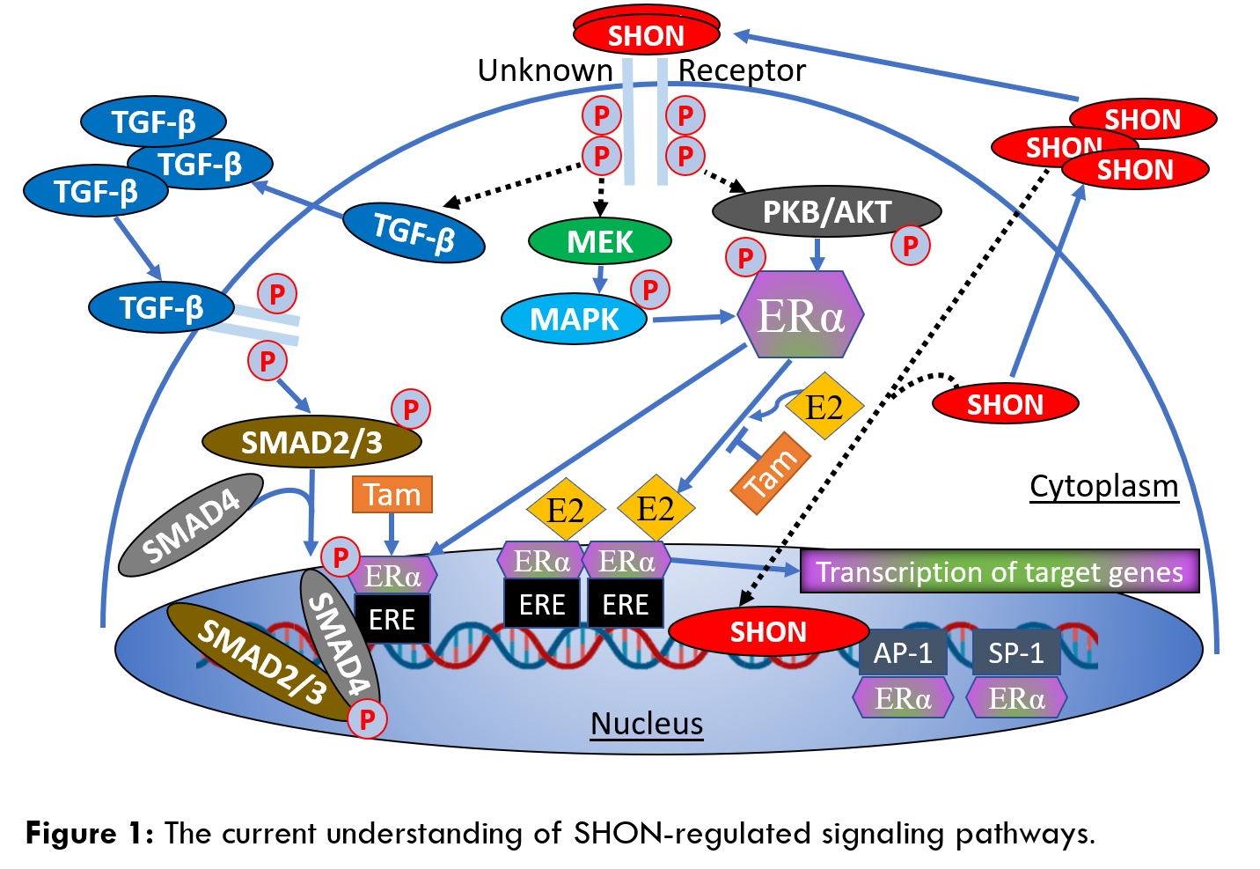
Recent Publications
- Jiawei Li, Xin Guan, Zhimin Fan, Lai-Ming Ching, Yan Li, Xiaojia Wang, Wen-Ming Cao, and Dong-Xu Liu. "Non-invasive biomarkers for early detection of breast cancer." Cancers 12, no. 10 (2020): 2767.
- Ji He, Riya Biswas, Piyush Bugde, Jiawei Li, Dong-Xu Liu, and Yan Li. "Application of CRISPR-Cas9 System to Study Biological Barriers to Drug Delivery." Pharmaceutics 14, no. 5 (2022): 894.
- Ji He, Erika Fortunati, Dong-Xu Liu, and Yan Li. "Pleiotropic roles of ABC transporters in breast cancer." International journal of molecular sciences 22, no. 6 (2021): 3199.
- Liu, Yingqi, Lingling Li, Xiaoqing Liu, Yibo Wang, Lingxia Liu, Lu Peng, Jiayuan Liu, Dong-Xu Liu et al. "Arginine methylation of SHANK2 by PRMT7 promotes human breast cancer metastasis through activating endosomal FAK signalling." elife 9 (2020): e57617.
- Ji He, Andrew R. Green, Yan Li, Stephen YT Chan, and Dong-Xu Liu. "SPAG5: an emerging oncogene." Trends in Cancer 6, no. 7 (2020): 543-547.

Biography

Jiawei (Stacey) Li obtained her MD in Clinical Medicine in 2016 and a Master’s Degree in 2018 from Jilin University, one of the key universities in China under the Chinese Government’s Building World-class University schemes of the “Project 985” and "Project 211". She is now a PhD candidate at the AUT under the supervision of A/Prof Dong-Xu Liu. Her research project is to delineate the mechanism of the SHON breast cancer biomarker using the CRISPR-Cas9 gene editing technique.
Email: wfx2614@autuni.ac.nz

Notes/Comments:

Presenting author details
Full name: Jiawei Li
Contact number: +64 2108494415
Twitter account: none
Linked In account: JIAWEI LI
Session name/ number: Breast Cancer/1
Category: Poster presentation

