
The Spirit of Organizational Cultural Competence: Participatory Action Research

Dr. Heather M Boynton & Sarah McGreer
Strengths Identified

- Staff have diverse cultural backgrounds that reflect the culture of service users
- Staff respect the worldview of others and value
cultural competence
- Staff are informed of the systemic problems experienced by different cultural groups in the area
- Staff recognize it is their job to understand the culture of clients
- Staff evaluation of their own level of cultural
competence could be leveraged along with training and orientation practices
Gaps Identified in Survey

- Low staff knowledge of organizational policies, and resources for cultural competence
- Staff are unaware of culturally diverse services available
- Staff are unaware of processes to incorporate
client feedback regarding cultural aspects in
assessment, treatment, and evaluation of service delivery
- Staff at all levels feel there is much more to address



Challenges with PAR: impacts of COVID 19,
staff turn over, engagement, restructuring
Abstract: CASA Mental Health is an interprofessional organization in Edmonton who partnered with the University of Calgary to conduct a Participatory Action Research study. The aim was to establish baseline knowledge, advance
an understanding of cultural competence, assess policies, procedures, and services, and identify the strengths, gaps, and barriers in meeting the cultural, spiritual, and traditional needs of service recipients.
Strength of PAR process

- Mobilized a team consisting of CASA staff, researchers and collaborators
- Designed and disseminated a staff survey using benchmarks from the literature
- Achieved 53% staff participation in survey
- Management commitment and involvement with PAR process
- Conducted 7 focus groups with various program staff and managers and stakeholders

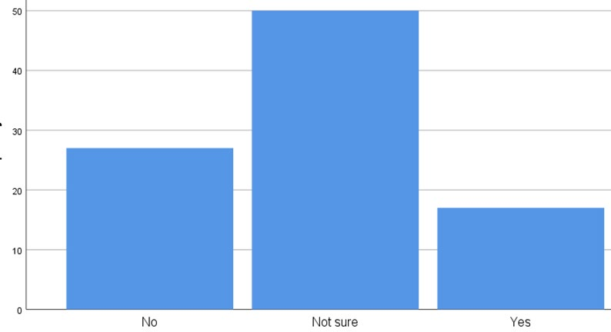
Survey Data
Method: Participatory Action Research
Staff Survey
Focus Thematic Groups Analysis
Does CASA offer optional staff training to develop cultural competence?
Conclusion: The participatory research supported staff in determining the needed methods for research and identifying directions for enhancing cultural competence. A baseline level of knowledge was established for future evaluation. Recommendations for developing policy and procedures, encouraging involvement and ongoing feedback from service recipients, stakeholders, and community in culturally competent decision making and activities, enhancing supports for staff working across cultures, providing staff training regarding culturally competent
organizational practices and procedures, and development of a workplan and cultural competence committee

References
Next Steps: Thematic analysis of focus groups completed with participants at various organizational levels, executive summary and recommendations for a comprehensive workplan to enhance cultural competence at all levels of the organization and services.
Ngo, H.V. (2008). Cultural competence: A guide for organizational change. Calgary, AB: Citizenship and Immigration Canada.

Olavarria, M., Beaulac, J., Bélanger, A., Young, M., & Aubry, T. (2009). Organizational cultural competence in community health and social service organizations: How to conduct a self-assessment. Journal of Cultural Diversity, 16(4), 140–150.

