Maximization of the bioethanol concentration produced from office paper waste using amicon- integrated SPVC-PAMPS polymeric membrane

Tarek H. Taha, PhD, City of Scientific Research and Technological Applications (SRTA-CITY), Egypt
Ahmed E. Mansy, MSc, City of Scientific Research and Technological Applications, (SRTA-CITY), Egypt
M. A. Abu-Saied, PhD, City of Scientific Research and Technological Applications (SRTA-CITY), Egypt
Hamada El-Gendi, PhD, City of Scientific Research and Technological Applications (SRTA-CITY), Egypt
Eman A. El Desouky, MSc, Alexandria University, Egypt
Ranya A. Amer, PhD, City of Scientific Research and Technological Applications (SRTA-CITY), Egypt

Abstract
This work aims to valorize the using of the municipal solid waste as a raw material for the production of bioethanol. The office paper waste with optimum concentration of 6% was pretreated with 15% HCl and autoclaving followed by enzymatic degradation in order to increase the liberated glucose units to its maximum of 15.7 mg/ml. The liberated glucose units were subsequently fermented by Hanseniaspora uvarum (accession number OP800106) into bioethanol. One variable at time (OVAT) optimization process was performed in order to reach the maximum bioethanol production. The optimum conditions revealed that the inoculation of 5% (v/v) of the yeast pre-culture into the waste hydrolysate at pH 5 and temperature 30ºC under anaerobic conditions would result in the production of 5.3 mg/ml bioethanol. The concentration of the produced bioethanol was increased from 31 to 79% using amicon cell-integrated polymeric membrane. The membrane which is a blend of Sulphonated polyvinyl chloride and 2-acrylamido-2-methyl-1-propanesulfonic acid (SPVC-PAMPS) was characterized using FTIR, Raman spectroscopy, and XRD. While its morphological appearance and thermal stability were investigated using SEM and TGA, respectively. After bioethanol purification, the total flux of the permeate was measured as 2530,659 mg/m².h, which indicating that the used polymeric membrane can be effectively used for increasing the bioethanol concentration compared with other applied techniques.

Image
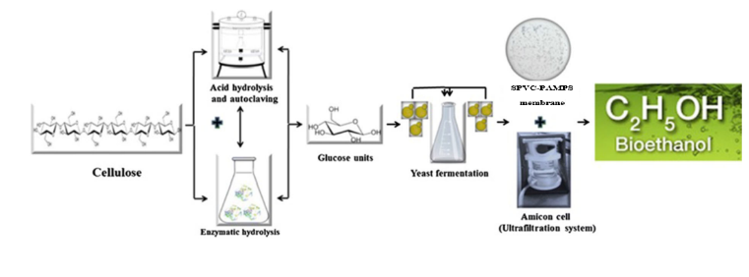
Recent Publications (minimum 5)
- Taha, R. H. (2022). Successful production of bioethanol from olive waste residues followed by its purification using poly (Acrylonitrile-co Methylacrylate) /polymethylmethaacrylate membrane. Biomass Conversion and Biorefinery. 1-15.
- AbdElhsfez, S. E. (2022). Experimental optimization with emphasis on techno-economic analysis of production and purification of high value-added bioethanol from sustainable corn stover. Energies. 15 (17), 6131.
- Taha, R. H. (2022). Maximization of the bioethanol concentration produced through the cardboard waste fermentation by using ethylenediamine-modifying poly Acrylonitrile-co-Methyl acrylate membrane. Biomass Conversion and Biorefinery. 1-19.
- Taha, T. H. (2019). Using starchy waste as a promising raw material for bioethanol production with consequence purification using chitosan/sodium alginate polymeric membrane. Journal of bioscience and applied research. 5(2): 154-166.
- Abu-Saied, M. A. (2018). Green production of bio-ethanol from cellulosic fiber waste and its separation using polyacrylonitrile-co-poly methyl acrylate membrane. Cellulose. 25:6621–6644.

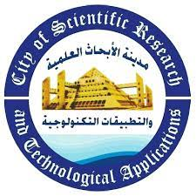Paste your Logo here
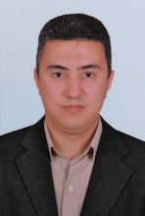

Biography (150 word limit)

Dr. Tarek Hosny Taha is an associate professor at Environmental Biotechnology Department, Genetic Engineering and Biotechnology Research Institute (GEBRI), City of Scientific Research and Technological Applications (SRTA-CITY), Alexandria, Egypt. He is currently a visiting researcher at Newcastle University, UK. He has his expertise in the field of environmental biotechnology. His research interest is concerned by the biomonitoring and bioremediation of environmental contaminants. He is also interested in the biosynthesis of nanoparticles and their applications in biosensors and other environmental fields, and has a great passion with Bioinformatics, molecular techniques and genetic engineering. In addition, he is interested in the production of biofuel from environmental wastes, and finally, the bioconversion of environmental wastes into industrial and pharmaceutical products.
Email: t.h.taha@gmail.com

Notes/Comments:
Presenting author details
Full name: Tarek Hosny Taha Ahmed Ali
Contact number: +201097524476
Twitter account: ----
Linked In account: ----
Session name/ number:
Category: (Oral presentation/Poster presentation)

