Influence of haemoglobin genotype on blood glucose and lipids in neonatal goat kids
Buhari Habibu, Tagang Aluwong, Hussaina Joan Makun, Lukman Surakat Yaqub and Mohammed Umaru Kawu
Ahmadu Bello University, Zaria, Nigeria

Abstract
Statement of the Problem: Glucose and lipids are the most important metabolites in neonatal ruminants and a compromised metabolism could be detrimental to survival. It is unknown whether metabolic variation due to haemoglobin polymorphism exist in goats. The study was aimed at evaluating the influence of haemoglobin genotype on blood glucose and lipids concentrations in neonatal goats. A total of 71 neonatal goats confirmed electrophoretically to be of the AA (n = 35) and AB (n = 36) haemoglobin genotypes were used for the study. Blood samples were collected from the kids at birth, on days 3, 10 and 20 to determine the concentrations of glucose, cholesterol and triglyceride as well as the incidence of neonatal hypoglycaemia. Results revealed that the concentration of blood glucose (81.63 ± 3.70 vs 79.85 ± 3.49 mg/dL) and incidence of neonatal hypoglycaemia (25 vs 20 %) showed insignificant difference (P> 0.05) between the kids with AA and AB genotypes. The kids with AB genotype had consistently higher blood cholesterol than those with AA genotype and values were significantly higher (P < 0.05) on days 0 and 10. Although the kids with AB genotype had consistently higher (P> 0.05) values of blood triglyceride concentration in early neonatal life, the value significantly decreased (P > 0.05) in late neonatal life. No significant difference (P > 0.05) was observed in levels of blood triglyceride between goat kids with different genotypes. Conclusion and significance: Neonatal goat kids with AA and AB genotypes showed similar physiological adjustment in glucose metabolism, but the goat kids with the AB genotype had higher concentration of blood lipids; thus, implying that lipids, not glucose, may account for variation in the metabolic adjustment of goat kids with different genotypes. The implication of this on growth and survival of newborn goats needs to be investigated.
Image
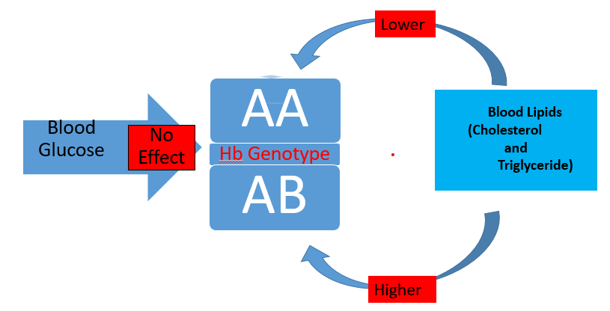
Recent Publications
- Habibu, B., Kawu, M.U., Makun, H.J., Aluwong, T., 2021. Neonatal adjustments in respiratory and pulse rates in tropical breeds of buck‑kids and doelings. Bull. Natl Res. Cent. 45:188, doi.org/10.1186/s42269-021-00646-3.
- Habibu, B., Kawu, M.U., Aluwong T., Makun, H.J., 2021. Postnatal hypoglycemia and blood glucose concentrations in neonatal tropical goat kids. Veterinary Clinical Pathology 50, 525-534. DOI: 10.1111/vcp.13028.
- Habibu, B., Kawu, M.U., Aluwong T., Makun, H.J., 2022. Neonatal thermoregulation and dynamics of serum thyroid hormones in
tropical breeds of goat kids. Journal of Thermal Biology, https://doi.org/10.1016/j.jtherbio.2022.103299. Elsevier-Science Direct®, www.scincedirect.com.
- Habibu, B., Aliyu, A., Idris, S.Y., Buhari, H.U., Galadanchi, F.A., Abdulrahman, M. and Yaqub, L.S. (2022). Thermoregulation in periparturient rabbit does and their neonatal kits with different litter sizes during West African winter. Animal Biotechnology, DOI: 10.1080/10495398.2022.2150200.
- Habibu, B., Aluwong T., Makun, H.J., Yaqub, L.S. and Kawu, M.U., 2023. Role of maternal variables on the development of neonatal hypoglycaemia and influence of neonatal hypoglycaemia on performance of goat kids. Veterinary and Animal Science, 19(7):100287 DOI: 10.1016/j.vas.2023.100287. Elsevier-Science Direct®, www.scincedirect.com.



Biography
Buhari Habibu is a researcher, academic and clinician. He obtained a Doctor of Veterinary Medicine (DVM) in 2010 and bagged a PhD in Veterinary Physiology in 2021 from Ahmadu Bello University. He is an academic staff with the Department of Veterinary Physiology, Ahmadu Bello University, since 2012. He is an animal physiologist, mainly concerned with the role of physiological conditions and genetics in influencing the survival and productivity of livestock, through understanding the adjustments farm animals employ during seasonality and neonatal life. He has contributed to scientific knowledge to improve animal production by publishing more than 30 scientific articles in high quality peer reviewed journals. He has contributed to mentoring younger colleagues in the academia and his home community by leading and participating in academic and societal development programmes. His research work has helped to greatly improve livestock productivity and reduce neonatal mortality of goat kids in the tropics.
.Email: buharihabibu@rocketmail.com; bhabibu@abu.edu.ng

Notes/Comments:

Presenting author details
Full name: Buhari Habibu
Contact number: +2348069092685
Twitter account: @Buhari4habibu
Linked In account: https://www.linkedin.com/feed/
Session name/ number: Glycobiology
Category: Oral presentation

