Reducing the dependence on conventional sources of energy in the hospital using energy from bioomass: case study: pcc general hospital kumba-Cameroon
Paiguy A Ngouateu, RN PhD, University of Buea, Cameroon

Abstract

Currently, at the Presbyterian General Hospital in Kumba, the cost of conventional energy has been on the rise and this has equally affected the patient-care system. However, by virtue of being a public place, the hospital possesses large quantities of biomass, which is being mismanaged. These resources remain unexploited due to diffidence towards unfamiliar technologies; hence the cling on conventional energy sources. The purpose of this work is to evaluate the current system responsible for wastewater and organic waste management, and propose a model for the design of a biogas septic tank, for the treatment of these various waste streams. In order to achieve this, I used quantitative analysis, exploratory interviews and in-depth studies on the working of various biomass-based technologies. My results showed that, with the proper implementation of the biogas septic tank design, the hospital can generate up to 2052.91m³ of biogas and achieve a cost savings of up to 16.31% in its first year of working, whilst, still properly managing waste flow in the hospital milieu. This study suggests that it is possible to reduce the dependence of the hospital on conventional energy using energy from biomass.

Image
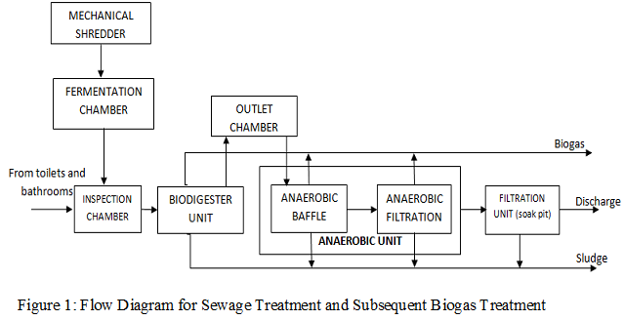
Recent Publications
- Ngouateu Wouagfack PA, Fouodji Keune G, Tchinda R (2017) Local stability analysis of an irreversible refrigerator working at the maximum thermo-ecological functions: comparison. International Journal of Refrigeration 75: 38-51.
- Fouodji Keune G, Ngouateu Wouagfack PA, Tchinda R (2020). Local stability analysis of an irreversible absorption refrigerator powered by a wood boiler. International Journal of Refrigeration 115: 83-95.
- Fossi Nemogne R, Ngouateu Wouagfack PA, Medjo Nouaje BA, Tchinda R (2021) Multi-objective optimization and analysis of performance of a four- temperature-level multi-irreversible absorption heat pump. Energy Conversion and Management 234:113967.
- Medjo Nouaje BA, Ngouateu Wouagfack PA, Fossi Nemogne R, Tiam Kapen P (2021) Exergetic optimisation of a four-temperature-level absorption heat pump based on ﬁnite-time thermodynamics. International Journal of Sustainable Energy 1-33.
5. Talla Kontchou FA, Aloyem Kazé CV, Ngouateu Wouagfack PA (2021) An application of exergy analysis of the energy use in Cameroon. International Journal of Exergy 38(1).

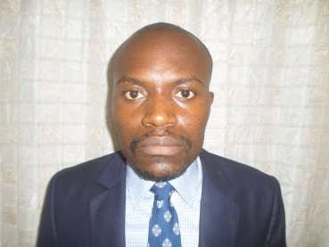Biography (150 word limit)
Ngouateu has completed his PhD in Energetic at the age of 28 years from Dschang University (Cameroon). He is Associate Professor in the Department of Renewable Energy in the Higher Technical Teachers’ Training College, University of Buea (Cameroon). He has published more than 25 papers in reputed journals. Dr. NGOUATEU’s research is actually focused on solar solar thermal energy and bioenergy technologies.
Email: ngouateupaiguy@yahoo.com

Notes/Comments:

Presenting author details
Full name: Ngouateu Wouagfack Paiguy Armand
Contact number: 00237677185871
Twitter account:
Linked In account:
Session name/ number:
Category: Poster presentatio

