Citrus pyrolysis temperature effect on wood vinegar characteristics
Etty Ankona, Department of Chemical Engineering, Ariel University 4, Ariel, Israel

Abstract

Condense biomass pyrolysis smoke is a by-product known as wood vinegar, which was found to have a potential economic value owing to the active chemical compounds contained in it. The biomass pyrolysis process is characterized by four main kinetic stages with different properties of the gaseous compounds emitted at each stage. The hypothesis evaluated in this study is that each of the wood vinegar fractions, collected for the different kinetic stages, is distinct. wood vinegar was collected in four different temperature ranges: 110-170 ℃ (WV 1), 170-250℃ (WV 2), 250-350 ℃ (WV 3) and 350-500℃ (WV4) and chemical properties of each fraction was studied.

The organic phase was analyzed by gas chromatography/mass spectrometry (GC-MS), which was confirmed using Fourier transform infrared (FTIR) spectroscopy and enhanced by nuclear magnetic resonance (NMR) spectroscopy.

GC-MS analysis results indicated that as the pyrolysis temperature increased more organic compounds were identified.

The identified organic compounds (especially in fractions WV4 and WV3) are known valuable compounds in the chemical industries, belonging to the groups of phenols, ketones, acids, alcohols, aldehydes, alkanes, aromatic hydrocarbons and nitrogenous compounds containing a significant number of furan derivatives, and in each of the fractions in particular, a high content of specific compounds was identified, which are widely used in the various chemical industries (19.6% thioacetic acid and followed by 12.2% syringol in WV4, 10.5% syringol in WV3, 34.6 methylacetoin in WV2 and 97.2 methylacetoin in WV1). The research results contribute to the selection of the suitability of the wood vinegar fractions obtained from citrus pyrolysis in the charcoal production process for a specific application in sustainable agriculture (fertilizer, weed control, pest control, etc.) or for a specific treatment to extract valuable compounds in various chemical industries while utilizing biomass waste for resources vital.
Image
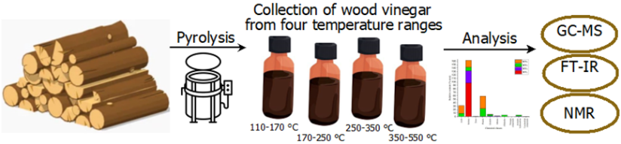
Figure 1. Schematic illustration of the research stages.
Recent Publications
1. Ankona, E. et al. (2021) ‘Investigation of pyrolysis kinetics and gaseous compounds emitted during charcoal production from woods commonly used in the Eastern Mediterranean’, Biofuels, Bioproducts and Biorefining, 2021(1), pp. 1–11. doi: 10.1002/bbb.2188.
2. Ankona, E. et al. (2022) ‘The Eastern Mediterranean Charcoal Industry: Air Pollution Prevention by the Implementation of a New Ecological Retort System’, Earth and Space Science, 9(3). doi: 10.1029/2021ea002044.
3. Billig, M. et al. (2022) ‘Charcoal Production in Palestinian villages - The Paradox of resistance to innovation driving rural development’, Journal of Rural Studies, 89, pp. 25–34. doi: https://doi.org/10.1016/j.jrurstud.2021.11.009.

Biography
Etty Ankona is a PhD candidate in the Ariel University chemical engineering department from where she also received her BSc and MSc. Her research involves wood pyrolysis physio-chemical study, process design, and indigenous-pastoral charcoal production systems assessment.
Email: ettya@ariel.ac.il

Presenting author details
Full name: Etty Ankona
Contact number: 0505951125
Mail id: ettya@ariel.ac.il
Category: Poster presentation

