Proximate and Thermogravimetric Analysis of Tyre-Derived Carbon Black
Gbenga F Oluyemi CEng PhD, Robert Gordon University UK AB10 7GJ
Richard Afolabi PhD, Robert Gordon University UK AB10 7GJ
Richard Hutchins PRG North, 32/3 Shore Road, South Queensferry EH30 9SG
Gray Walter RG North, 32/3 Shore Road, South Queensferry EH30 9SG

Abstract

Proximate analysis was carried out to determine the moisture, volatile, fixed carbon and ash content of Carbon Black derived from waste tyre thermal treatment. The procedure used followed the British Standards for the proximate analysis of coal. From the proximate analysis, it was determined that 8% and 10% of the Carbon Black were moisture and volatile matter. To remove the moisture and volatiles from the Carbon Black, treatment with air at elevated temperatures was recommended. Thermo-gravimetric analysis (TGA) of the Carbon Black was then carried out at 450°C, 500°C and 600°C. The results of the TGA showed that treatment at 450°C would require a long treatment time to remove the volatiles from the Carbon Black while treatments at both 500°C and 600°C were effective in removing the volatiles. However, with weight losses of 23.7% and 35.2% respectively for 30 and 60 minutes, treatments at 600°C were shown to be most effective in removing all the volatiles. Once the residual volatiles have been removed from the Carbon Black, further activation treatment was carried out in air at 850°C and CO2 at 850°C and 900°C to enhance its surface area and potential application as adsorbents for waste removal from fluid streams.
Image
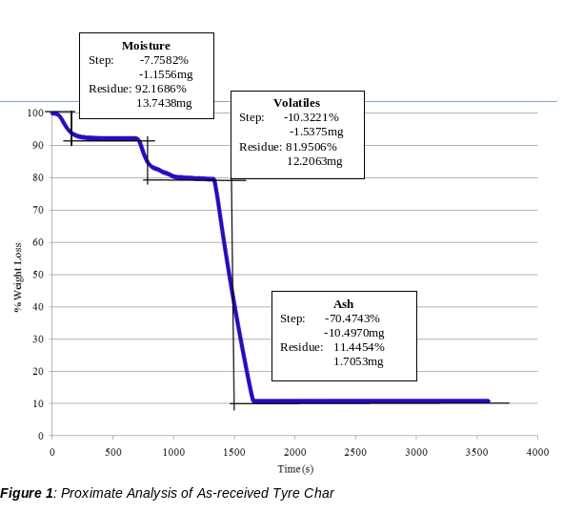
Recent Publications
- Njuguna, J., Siddique, S., Kwroffie, L. B., Piromrat, S., Addae-Afoakwa, K. Ekeh-Adegbotolu, U., Oluyemi, G., Yates, K., Mishra, A. K. Moller, L “The fate of waste drilling fluids from oil & gas industry activities in the exploration and production operations”; Waste Management, 139 (2022); 362-380
- Afolabi, R O., Oluyemi, G F, Officer S. and Ugwu, J O. “A New Approach for Quantitative Mapping of Retention Mechanisms of Associative Polymers in Porous Media,” Journal of Molecular Liquids; Accepted (Sept 2021)
- Anyanwu, U. C., & Oluyemi, G. F., “Effect of Produced Sand Particles and Fines on Scale Inhibitor: A Review.” Colloids Interfaces 2021, 5(3), 35; https://doi.org/10.3390/colloids5030035.
- Balogun Y., Iyi, D., Faisal, N., Mahon R., Oluyemi, G., “Experimental Investigation of the effect of temperature on two phase oil-water relative permeability.” Journal of Petroleum Science and Engineering, 2021, (203) 108645 https://doi.org/10.1016/j.petrol.2021.108645
- Afolabi, R O., Oluyemi, G F, Officer S. and Ugwu, J O. “Determination of a critical separation concentration for associative polymers in porous media based on quantification of dilute and semi-dilute concentration regimes,” Journal of Molecular Liquids; Vol 317, 1 Nov 2020, 114142 https://doi.org/10.1016/j.molliq.2020.114142

Biography

Dr Gbenga Oluyemi is an Associate Professor of Petroleum Geomechanics at Robert Gordon University, UK and the Chair of Sand Management Network UK. He has more than 20 years of experience spanning academia, the oil and gas industry and water/environmental engineering. Dr Oluyemi’s research interests are in process optimisation, life cycle cost and impact analysis, oil and gas production optimisation, formation evaluation, geomechanics, oilfield chemistry and value of information. He has substantial experience and expertise in process optimisation and upscaling studies. He has worked as PI and Co-PI on a range of projects funded by the UK government, EU, and oil companies over the last 14 years and has published more than 70 journal and conference papers.
Email: g.f.oluyemi@rgu.ac.uk

Notes/Comments:

Presenting author details
Full name: Gbenga Folorunso Oluyemi
Contact number: 07456059472
Mail id: g.f.oluyemi@rgu.ac.uk
Category: (Oral presentation)

