Arch Wire Technique with Multi-Loop Edge Wise (MEAW)
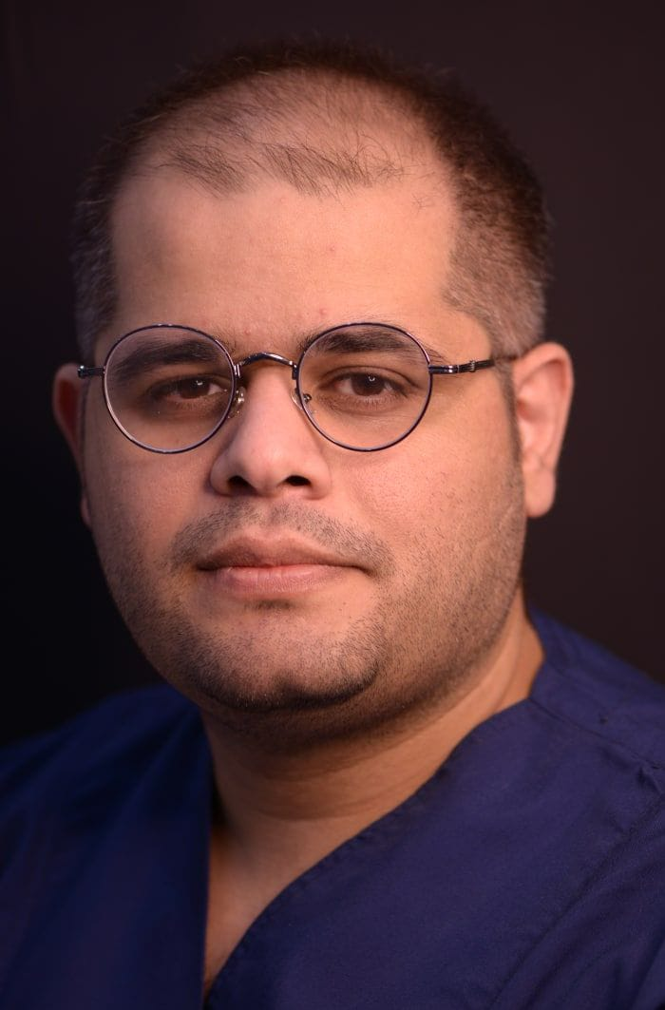

Hamed Nabahat^{1*}
Yevdokimov Moscow State University of Medicine and Dentistry. Moscow. Russian Federation.

ABSTRACT:

Dr. Kim young-Ho developed the Multi-loop Edge wise archwire (MEAW). Young H. Kim presented a therapeutic philosophy based on anthropological considerations concerning the verticalization of the facial skull during the evolution of Homo sapiens' upright walk in 1967. Changes in the inclination of the occlusal plane that have happened in this evolutionary environment can be seen in man's individual growth. In the world of orthodontics, anterior open bite treatment is regarded as a complicated treatment. Orthognathic surgery is frequently used to treat various sorts of malocclusions, however the outcomes are still uncertain. Treatment of open bite has become more effective since the introduction of Multiloop edgewise archwire therapy. MEAW is also versatile in that it can cure malocclusions such as Class II, Class III, deep overbite, and malocclusions with severe midline deviations. Since the MEAW's introduction, its treatment modality has been employed internationally, with several reports of successful outcomes published. The MEAW procedure has been labeled as "magical" or "unbelievable" by certain orthodontists, however it is not. The diagnosis and treatment plan must be correct, and the MEAW must be precisely constructed to deliver the forces required to move the teeth to an ideal, stable relationship. As a result, the purpose of this essay is to go over the multiloop edge wise arch wire approach in depth, as well as its biomechanics.

Biography
Dr. Hamed in Nabahat is a dental graduate from Russian Federation. Despite being young, he has gained a lot of experience in the field of maxillofacial surgery, dentistry various clinics and famous hospitals. In addition, one of his interests is to participate in scientific events.
Email: unaserzadeh@gmail.com
Mobile Number*: WhatsApp No: +7(967)112-06-50

