Improved efficiency & sustainability with novel digital technologies
Dr. Les Kalman
Restorative Dentistry, Western University, London, ON, Canada

Abstract
For all dentists, it is a professional duty to provide safe, quality and competent oral health care to patients. There are many novel dental technologies that provide superior accuracy, improved efficiency and an enhanced experience for the clinician and patient. Employing technological workflows may result in a more sustainable approach for healthcare. This presentation will illustrate four novel concepts: 3D printed zirconia anterior indirect restorations, a digital dental color identification and communication application, 3D printed zirconia lattice implant bars and a dental thermal application. Many technological tools not only maintain the standard of care, but improve accuracy and efficiency, elevate the dental experience and may have a positive impact on sustainability.

Learning Objectives
- Appreciate the importance of sustainability in dentistry
- Recognize novel technologies in digital dentistry and 3D printing
- Understand how to implement these technologies
- Conclude if these novel workflows are a fit for the participant’s practice

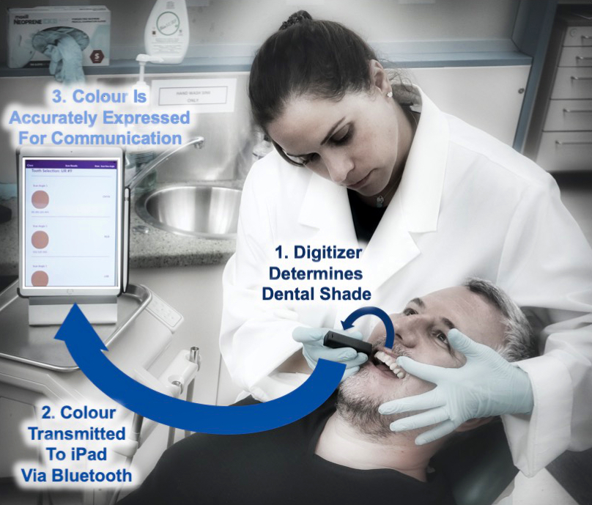
Recent Publications
- Heboyan, A., Kalman, L., Lo, Giudice R., Zafar, MS., Tribst, JPM. Stress Distribution Pattern in Zygomatic Implants Supporting Different Superstructure Materials. Materials. 2022; 15(14):4953. https://doi.org/10.3390/ma15144953
- Kalman, L. A novel workflow for indirect restorations without digital design. 3DPrinting. 2022; 2(1). https://international-dental-show.dental-tribune.com/e-paper/ce-magazines/3d-printing-international/3d-printing-international-no-1-2022/
- Kalman, L. Development of a novel dental thermal imaging application. International Journal of Clinical Images and Medical Reviews. 2022; 1(1): 1054. https://ijcimr.org/articles/IJCIMR-V1-1054.pdf
- Dal Piva, A.M.d.O., Kalman, L., Tribst, J.P.M. Stress Concentration of Hybrid Occlusal Splint-Mouthguard during a Simulated Maxillofacial Traumatic Impact: 3D-FEA. Dent. J. 2022, 10, 65. https://doi.org/10.3390/dj1004006
- Kalman, L. Digital workflow for the colour verification of indirect anterior restorations. Digital. 2021; 2(2): 16-21.
- Kalman, L. A novel workflow for indirect cobalt-chromium restorations using additive manufacturing without digital design. J Dent Res Dent Clin Dent Prospects, 2021, 15(3), 147-151 doi: 10.34172/joddd.2021.02
- Kalman, L.; Dal Piva, A.M.d.O.; de Queiroz, T.S.; Tribst, J.P.M. Biomechanical Behavior Evaluation of a Novel Hybrid Occlusal Splint-Mouthguard for Contact Sports: 3D-FEA. Dent. J. 2022, 10,3. https://doi.org/10.3390/ dj10010003
- Behroozian A, Kalman L and Hemmatiyan M. Inclinometer: a new device for measuring intermolar torque and angle. J Adv Periodontol Implant Dent. 2021; 13(2): 96-98 doi:10.34172/japid.2021.011
https://japid.tbzmed.ac.ir
- Kalman L, Kalman B. Preliminary assessment of dry electropolishing technology on a novel additive manufactured Ti-6Al-4V implant abutment. Japan J Res. 2021;2(4):1-4
- Tribst JPM, DalPiva AMdO, da Silva-Concílio LR, Ausiello P & Kalman L. Influence of Implant-Abutment Contact Surfaces and Prosthetic Screw Tightening on the Stress Concentration, Fatigue Life and Microgap Formation: A Finite Element Analysis. Oral 2021, 1, 88–101. https://doi.org/10.3390/ oral1020009

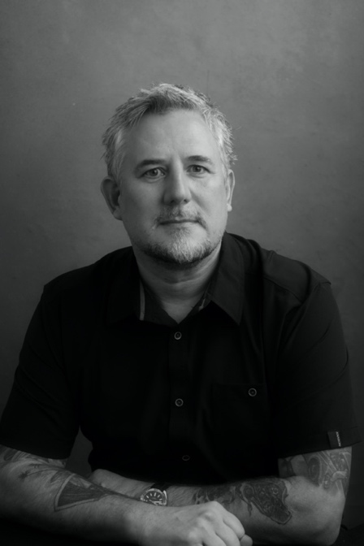

Biography
Kalman is an assistant professor in restorative dentistry with a research focus on medical devices and technologies. He has delivered conference talks, presentations and CE courses locally, nationally and internationally and has more than 60 research publications, reviews, book chapters, editorials and case reports. He holds patents and has translated several technologies to industry. He has served on the Board of Directors for UWOFA & the CAPHD. He has been recognized as an Academic Associate Fellow (AAID), Fellow, Master and Diplomate (ICOI), Fellow (AO), a Schulich Alumni of Distinction and received the Merck Patients First and a CES Innovation award.
Email: ljkalman@icloud.com

Presenting author details
Full name: Les Kalman
Contact number: 519-661-2111 ext 86097
Session name/ number: Dental Materials Science: 13-3 (Digital Dentistry)
Category: Oral presentation

