Primary unilateral incomplete cleft lip repair by a modified rotational advancement technique
Sadam Elayah, MA scholar; Yang Li, PhD ; Bing Shi, PhD

Abstract
Orofacial clefting has significant psychological and socioeconomic consequences for both the patient and the family, involving interruption of psychological adjustment and poor quality of life. Based on our many years of experience at our institute, we observed that the techniques designed for the complete cleft lip (CCL) repair could not be suitable for incomplete cleft lip (ICL) repair.This induced our institute to design a unique method for CCL repair¹ as well as to design this present method for ICL repair, called modified rotational advancement technique (MRA).
Objective: This study aimed to describe a modified technique for primary unilateral incomplete cleft lip repair together with evaluation the postoperative outcomes.
Participants and setting: Photos of 64 consecutive patients with nonsyndromic primary unilateral incomplete cleft lip were reviewed. Among them, 32 patients had received Millard rotational advancement technique (RA), while the other 32 had modified rotational advancement technique
(MRA) with preserving the nasal sill intact, within a university-affiliated tertiary hospital between 2013-2021.
Surgical technique; (Fig. 2.)
A video available upon request.
Main measures: The lip measures were represented by lip height and width, vermillion height, midline-philtrum angle, and angle of Cupid's bow peaks. The nasal measures involved columella length and angle, nostril height and width, and ala width. Both descriptive and comparative analyses were calculated.
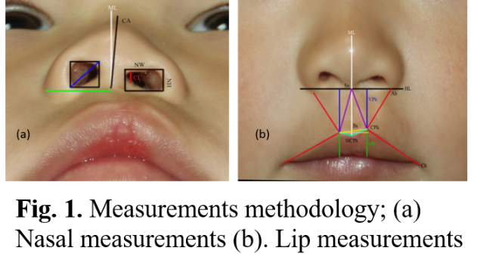
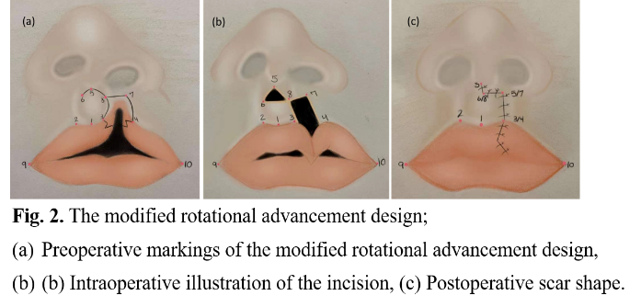
Results: Symmetrical lip height, lip width, philtrum angle, Cupid's bow, as well
columellar length, and alar width were obtained following the MRA technique. No
significant difference was found between the MRA and RA groups concerning the preoperative lip height, Cupid's bow angle, columellar length and angle. However, the postoperative lip height, width and columellar length were greater in MRA group than RA group (P= .001, .004 and .002, respectively). On the other hand, the MRA group had significantly smaller columellar and Cupid's bow peaks angles than RA group (0.53±0.36 vs 1.21±0.91 and 1.34±1.84 vs 3.14 ±2.97, respectively).
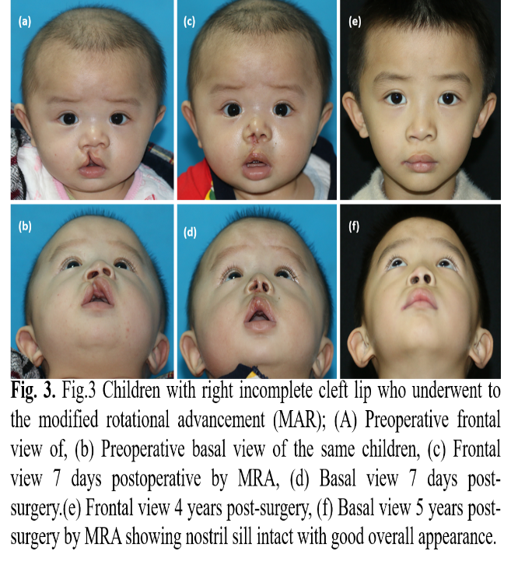
Conclusions: The MRA technique has obtained satisfactory lip and nasal outcomes in terms of lip height, lip width, philtrum angle, Cupid's bow, columellar length, and alar width with keeping the nasal sill intact.


Sadam Elayah, Prof. Shi Bing’s master student, Cleft lip & Palate department - West China Hospital of Stomatology – Sichuan University.
Tel; +86 186 8296 0907
Email; s.elayah90@gmail.com

West China School of Stomatology, known as the birthplace of China's modern dental science education, was started from Ren-Ji Dental Clinic founded in 1907. The clinic, in 1912, grew into the nation’s first dental hospital to serve the local community’s needs for dental services. In 1917, the hospital became the Department of Dentistry under West China Union University and soon evolved into the School of Dentistry. In 1928, the School of Stomatology was officially founded. Since then, the school has experienced several title changes: in 1951, as Stomatological Hospital of West China University; in 1953, as Faculty of Stomatology, Sichuan Medical College; in 1985, as School of Stomatology, West China University of Medical Sciences; in 2001, as West China School of Stomatology, Sichuan after merged with Sichuan University.

