The effect of chlorhexidine mixed with MTA on bacterial Leakage of apical plug in simulated immature teeth
Sayahpour S, Mojabi SM, Savadkouhi ST, Ramezani G
Abstract:
Statement of the Problem: Microbial leakage is one of the main reasons of endodontic failure, especially in immature necrotic teeth that have undergone apexification treatment. Apexfication is a challenging treatment in necrotic open apices teeth and bacterial leakage is the main reason for the treatment failure. The aim of this study is to compare the effect of mixing MTA with chlorhexidine (CHX) on microbial leakage in apexification treatment of simulated immature teeth.
Methodology & Theoretical Orientation: In this experimental study, 44 intact central incisors were selected based on inclusion criteria. The coronal and 2mm of apical part of the specimens were removed till all root segments were 12mm long. The apical parts of the teeth were prepared by using Profile #40/0.06 (Dentsply Maillefer, Ballaigues, Switzerland) in the apical to coronal direction to simulate open apices. The specimens were separated into experimental groups (N=40) and control groups (N=4). Group 1 delivered a 5mm apical plug by (MTA/H 2 O) and group 2 delivered an apical plug by (MTA/CHX 0.12%). The positive control group had no apical barrier; on the other hand the negative control group had an apical barrier and two layers of nail varnish on entire root surface. The microbial leakage assessment done by a dual-chamber apparatus using fresh human saliva after 10 weeks follow up. The turbidity of the lower chamber containing the BHI solution was analyzed based on the McFarland (0.5) standard which utilizes spectrophotometry results. Data analyses were done using Chi Square, Kaplan-Meier and Log-Rank tests.
Findings: MTA/CHX group had lower microbial leakage percentage (P= 0.001) and longer time of leakage (P= 0.002) in compared with MTA/H2O group and the difference was statistically meaningful.
Conclusion & Significance: Based on the results of this study, MTA/CHX mixture can reduce the amount of bacterial leakage.
Key words: Apexification, MTA, Chlorhexidine, Bacterial leakage.

Recent publications:
1.Ramezani G, Savadkouhi ST, Sayahpour S. The effect of chlorhexidine mixed with mineral trioxide aggregate on bacterial leakage of apical plug in simulated immature teeth using human fresh saliva. Journal of International Society of Preventive & Community Dentistry. 2017 Sep;7(5):247.
2.Moeiny P, Sayahpour S, Raofie F, Aminikhah A, Kharazifard MJ. Assessment of the Effect of Fruit (Apple) and Plain Yoghurt Consumption on Plaque pH. Journal of Dental Materials and Techniques. 2017;6(3):117-24.
3.Tavasolihojati S, Haghgoo R, Sayahpour S, Shabani M. Effect of Fluoride Gel and Varnish on Remineralization of Initial Caries Lesion of Enamel (In Vitro Study). J Res Dent Sci. 2017; 14 (1) :34-39.
4.Seyed Akhavan P, Sayahpour S, Momeni H, Kharazifard MJ. Effect of Fluoride Gel and Foam on Salivary Fluoride Concentration. J Res Dentomaxillofac Sci. 2017;2(2):16-22.
5.Hamissi J, Shahsavarani MT, Shahsavarani H, Sayahpour S, Hamissi H. A comparison of the serum lipid level between patients with periodontitis and healthy individuals. Journal of Periodontology & Implant Dentistry. 2011 Jan 13;2(1):29-32.

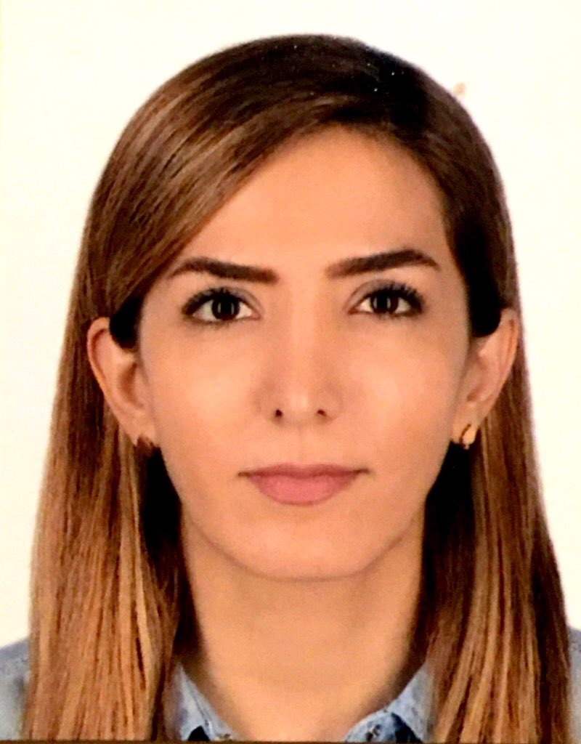

Biography:
Sahar Sayahpour has completed her DDS at Qazvin University of Medical Sciences, Iran in 2009. She has achieved her national board degree in Pediatric Dentistry at Islamic Azad University, Dental Branch of Tehran in 2017. She has published five papers and has presented orally in many international conferences. She received best Researcher award in her university.
Presenting author details:
Full name: Sahar Sayahpour, Pedodontist, Private Practice Contact number: +989125838351
Linked In account: Sahar Sayahpour
Email: sayahpour.dds@gmail.com
Session name: Pediatric dentistry Category: Oral presentation

