What makes the success of the management of Immature Necrotic Permanent Teeth ?

Abstract
The management of immature necrotic permanent teeth (INPT) present a distinctive challenge for the endodontist due to compromised crown root ratio, thin root dentine walls and wide-open apex lacking an apical stop against which root filling materials can be condensed.
Various treatment modalities have been employed to create hard tissue barrier at the apex, which includes non-vital pulp therapy with calcium hydroxide, apexification with mineral trioxide aggregate, pulp revascularisation and regeneration.
The aims of this presentation are:
- to expose different factors influencing the success of the management of immature necrotic permanent teeth
- to compare different therapies available in order to develop guidelines for the dentist for a better outcome.
Image: Protocol of Regenerative Endodontics [5].
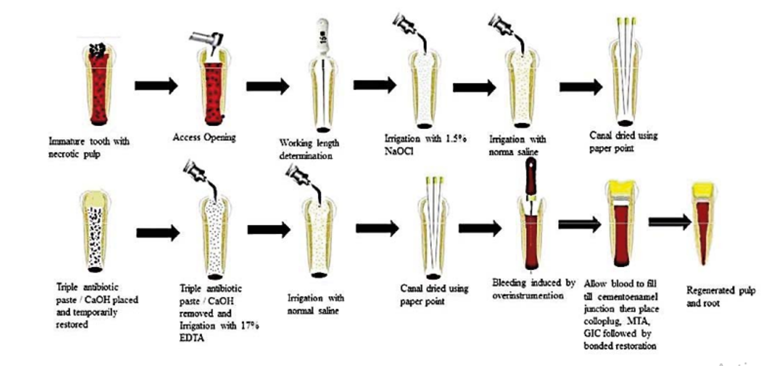
Recent publications
- Shah A. , Peacock R. , Eliyas S. (2022) Pulp therapy and root canal treatment techniques in immature permanent teeth: an update. British Dental Journal volume 232, pages524–530
- Lewis C. J. (2020) Dental Trauma . Oral Maxillofacial Surg Clin
- Chen et al. (2019) Materials for pulpotomy in immature permanent teeth: a systematic review and meta-analysis BMC Oral Health 19:227
- Songtrakul et al.(2019) Modified Apexification Procedure for Immature Permanent Teeth with a Necrotic Pulp/Apical Periodontitis: A Case Series. J Endod 2019:1–8
- Hameed MH. (2019) Management of immature necrotic permanent teeth with regenerative endodontic procedures — a review of literature. LITERATURE REVIEW Vol. 69, No. 10, October 2019
- Lin et al (2017) Regenerative Endodontics Versus Apexification in Immature Permanent Teeth with Apical Periodontitis: A Prospective Randomized Controlled Study. J Endod 2017:1–7.

Bibliography
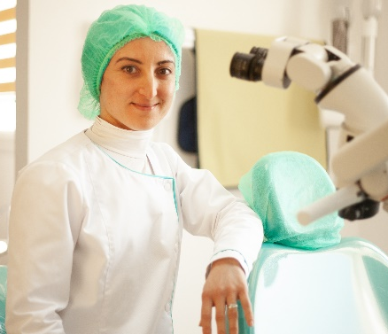
Dr. Salima Bouaziz
Dentist specialized in conservative odontology and Endodontics
After my training in university dental clinic of Monastir for 4 years as a resident in conservative odontology and endodontics service and obtaining my diploma, I have practiced specialized dentistry in my own office since December 2018.
Our gold is to provide high-quality care for our patients given them a comfortable experience and exceptional result.

