Do mobile health apps cause more harm due to health anxiety than good? A literature review
Malik Takreem Ahmad, King’s College London, UK.
Professor Pablo Lamata, King’s College London, UK.
Rasi Mizori, King’s College London, UK.

Abstract (300 word limit):

Background: In recent years, mobile health apps have grown in popularity as a means for people to track and manage their health. While there is increasing worry that these applications may potentially contribute to the emergence of health anxiety, they can also help to encourage healthy behaviours and provide access to health information.

Objective: The objective of this literature review is to look at available mhealth apps and critically evaluate the compromise between reassurance and anxiety.

Methodology: A literature review was carried out to analyse the effects of mhealth apps on the creation of health anxiety within the general population. PubMed and SCOPUS were used to search for relevant articles, and abstracts were screened using inclusion criteria of the terms: mhealth apps; e-Health; healthcare apps; cyberchondria; Health anxiety; illness anxiety disorder. A total of 27 studies were included in the review.

Results and discussion: The findings suggest a direct relationship between mobile health app use and health anxiety. The impact of mobile health apps on health anxiety may depend on how they are used - individuals receiving a constant stream of health-related information may trigger unnecessary concern about one's health. The need for more regulation and oversight is identified, which can lead to app quality and safety consistency. There are also concerns about data security and privacy and the resulting "digital gap" for individuals without mobiles or internet access.

Conclusion: While health apps can be valuable tools for managing and tracking health, individuals need to use them in a balanced and informed way to avoid increased anxiety.
Image:
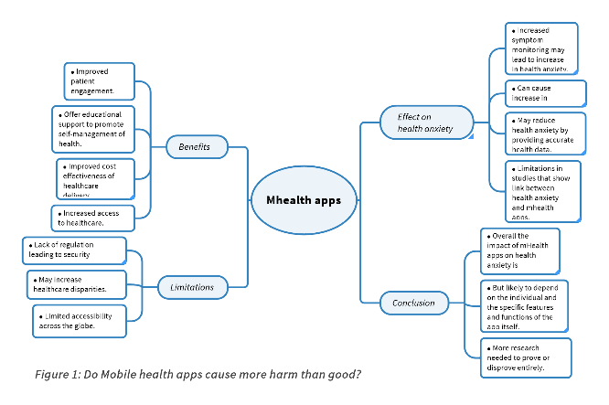
Recent Publications (minimum 5):
- Almokhtar, A. AdwasJ. et al. (2019) Anxiety: Insights into Signs, Symptoms, Etiology, Pathophysiology, and Treatment | J. M. Jbireal - Academia.edu. East African Scholars Journal of Medical Sciences. 2 (10), 580–588.
- Chang, H. et al. (2020) The impact of an mHealth app on knowledge, skills and anxiety about dressing changes: A randomized controlled trial. Journal of advanced nursing. [Online] 76 (4), 1046–1056.
- Garbóczy, S. et al. (2021) Health anxiety, perceived stress, and coping styles in the shadow of the COVID-19. BMC Psychology. [Online] 9 (1), 1–13.
- Hedman-Lagerlöf, E. et al. (2019) Health anxiety. BMJ. [Online] 364.
- Mahmood, A. et al. (2019) Use of mobile health applications for health-promoting behavior among individuals with chronic medical conditions. Digital health. [Online] 5.



Biography (150 word limit):
Malik Takreem Ahmad is a 3rd Year Medical Student at King’s College London, with an interest in Cardiology and Global Health. With 3 publications in cardiology, he is a budding researcher with a strong interest in how technology can impact the world of cardiology and improve detection and management of cardiac conditions.
Email: mtaresearch20@gmail.com

Notes/Comments:

Presenting author details
Full name: Malik Takreem Ahmad
Contact number: +44 7387436446
Twitter account: n/a
Linked In account: https://www.linkedin.com/in/malik-takreem-ahmad-a79436209/
Session name/ number:
Category: Poster presentation

