A Mixed Titanium/Zirconium Conversion Coating for Efficient Corrosion Protection of Susceptible Aluminum Alloy 2024
Markus Becker, Dr. rer. nat., Fraunhofer IFAM, Bremen, Germany

Abstract (300 word limit)
Chemical conversion coatings for aluminum alloys provide cost-efficient corrosion protection and adhesion promotion to subsequent paint systems. In the past decades, conversion coatings based on hexavalent chromium have been the golden standard in the aerospace industry, with exceptional corrosion protection and good adhesion promotion at relatively low cost. However, health concerns and environmental issues with Cr⁶⁺ raised the need for alternative systems, which still fail to provide comparable performance. In this work, Cr-free conversion coatings for aerospace applications are introduced along with the need of the industry to replace chromates. We developed a completely Cr-free conversion coating on the basis of Zr and Ti for corrosion susceptible aluminum alloy 2024 and investigated the effects on pitting protection and adhesion promotion along with analytical investigations. The best treatment solution contained hexafluorometallate salts of Zr and Ti along with metavanadate inorganic and tannic acid organic additives. Neutral salt spray test showed few corrosion products at the edges after 168 h, which is superior to most alternative Cr-free conversion coatings. Additionally, cross-cut tests displayed a high performance in adhesion promotion of painted panels when treated at 45 °C for 15 min. Although panels treated without tannic acid showed a denser morphology and already good bare corrosion protection, it was significantly better with tannic acid. This confirms the strong contribution of the organic additive to bare corrosion protection by physical adsorption in cracks or delamination. EDX mappings demonstrated a homogeneous distribution of Zr, Ti, O and F when treated with both additives, while strong fluorine delamination was observed without additives. Potentiodynamic polarization and impedance measurements confirmed the higher electrochemical resistance with both additives, XPS indicated the superficial existence of oxide and fluoride species of Zr and Ti along with C from the organic additive. This work shows that aerospace requirements concerning corrosion protection and adhesion promotion can be met by a completely Cr-free conversion coating.

Image
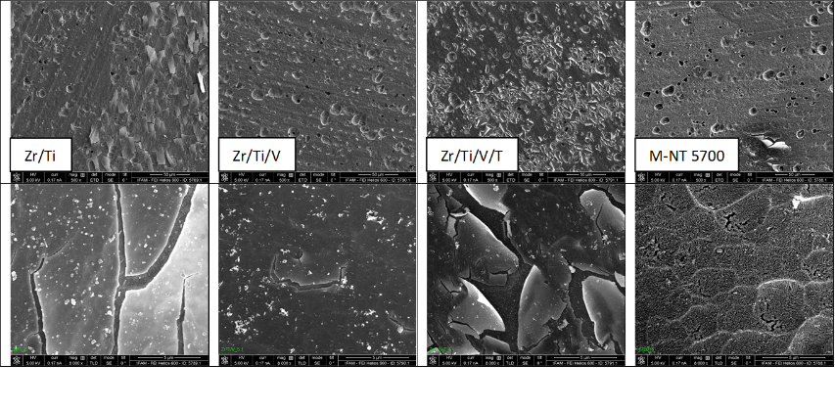
Figure 1: Top-view SEM surface morphologies of the four CCC-systems; magnification: 500 x (top row), 8000 x (bottom row).
Recent Publications (minimum 5)
1) Kendig, M. W.; Buchheit, R. G. Corrosion Inhibition of Aluminum and Aluminum Alloys by Soluble Chromates, Chromate Coatings, and Chromate-Free Coatings. CORROSION 2003, 59, 379–400.

2) Frankel, G. S.; McCreery, R. L. Inhibition of Al Alloy Corrosion by Chromates. Electrochem. Soc. Interface 2001, 10, 34–38.

3) Becker, M. Chromate-free chemical conversion coatings for aluminum alloys. Corrosion Reviews 2019, 37, 321–342.

4) Milošev, I.; Frankel, G. S. Review—Conversion Coatings Based on Zirconium and/or Titanium. J. Electrochem. Soc. 2018, 165, C127-C144.

5) Santa Coloma, P.; Izagirre, U.; Belaustegi, Y.; Jorcin, J. B.; Cano, F. J.; Lapeña, N. Chromium-free conversion coatings based on inorganic salts (Zr/Ti/Mn/Mo) for aluminum alloys used in aircraft applications. Appl. Surf. Sci. 2015, 345, 24–35.

Biography (150 word limit)

Dr. Markus Becker is a project leader in the Department of Adhesion and Interface Research at the Fraunhofer Institute for Manufacturing Technology and Advanced Materials IFAM in Bremen, Germany. He has obtained the Dr. rer. nat. in Chemistry from the Carl von Ossietzky University of Oldenburg, Germany. Dr. Becker has a strong research background in Surface Science and Wet-Chemical Surface Treatment and is currently working on Aerospace-Related Surface Pre-Treatments.
Email: markus.becker@ifam.fraunhofer.de

Notes/Comments:

Presenting author details
Full name: Markus Becker
Contact number: +49 421 2246 7365
Session name/ number: Surface Engineering / 13
Category: Oral presentation

