A Systematic Review on the Application of Automated Pupillometry to Improve Outcomes in Patients with Traumatic Brain Injury (TBI)
Carmen Chung, Warwick Medical School, UK
Damon Hoad, PhD MRCP AKC, Associate Clinical Professor at Warwick Medical School, UK

Abstract (300 word limit)

Background: The pupillary light reflex (PLR) is sensitive to changes in intracranial pressure and an essential part of neurological examination in Traumatic Brain Injury (TBI) patients. Automated pupillometry provides an objective, reliable, non-invasive, and quantifiable method of measuring PLR. This systematic review evaluates evidence for the application and utility of automated pupillometry to improve outcomes in patients with TBI.

Methods: MEDLINE, Embase, Web of Science, and Scopus databases were systematically searched for clinical studies evaluating the use of automated pupillometry in Traumatic Brain Injury patients up to October 9, 2022.

Results: 12 observational studies met the inclusion and exclusion criteria. All studies reported on the usefulness of automated pupillometry in identifying abnormal pupillary reflexes in the acute hospital stage. 5 studies reported inverse relationship between the Neurological Pupil Index (NPi) and clinical outcomes in TBI patients. 4 studies reported correlation between NPi measured with automated pupillometry and intracranial pressure (ICP). 3 studies reported that NPi score is predictive of surgical interventions in TBI patients.

Discussion: This systematic review demonstrates that automated pupillometry is effective in measuring abnormalities of the PLR in TBI patients. A number of studies report specific PLR parameters and the NPi score having diagnostic and prognostic utility in patients with TBI. However, no evidence was identified for application of automated pupillometry in monitoring recovery of cognition in sub-acute or chronic stages.

Conclusion: Automated pupillometry provides an objective, non-invasive and rapid means to assess pupillary function. Clinical evaluations of the technology demonstrated diagnostic, prognostic, and therapeutic potential in the management of TBI patients in acute hospital settings. Further evidence will support wider clinical uptake and there is potential for future research to evaluate application of automated pupillometry in post-acute cognitive rehabilitation settings.
Image
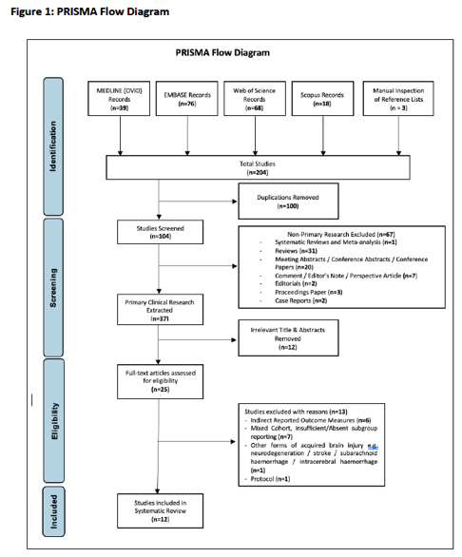

Recent Publications (minimum 5)
- Boulter, J.H., Shields, M.M., Meister, M.R., Murtha, G., Curry, B.P. and Dengler, B.A. (2021). The expanding role of quantitative pupillometry in the evaluation and management of traumatic brain injury. Frontiers in neurology, 12, pp.1-5.
- Chen, J.W., Vakil-Gilani, K., Williamson, K.L. and Cecil, S. (2014). Infrared pupillometry, the Neurological Pupil index and unilateral pupillary dilation after traumatic brain injury: implications for treatment paradigms. Springerplus, 3(1), pp.1-10.
- El Ahmadieh, T.Y., Bedros, N., Stutzman, S.E., Nyancho, D., Venkatachalam, A.M., MacAllister, M., Ban, V.S., Dahdaleh, N.S., Aiyagari, V., Figueroa, S. and White, J.A. (2021). Automated pupillometry as a triage and assessment tool in patients with traumatic brain injury. World neurosurgery, 145, pp.e163-e169.
- Jahns, F.P., Miroz, J.P., Messerer, M., Daniel, R.T., Taccone, F.S., Eckert, P. and Oddo, M. (2019). Quantitative pupillometry for the monitoring of intracranial hypertension in patients with severe traumatic brain injury. Critical care, 23(1), pp.1-9.
- Teixeira, T.L., Peluso, L., Banco, P., Njimi, H., Abi-Khalil, L., Chanchay Pillajo, M., Schuind, S., Creteur, J., Bouzat, P. and Taccone, F.S. (2021). Early pupillometry assessment in traumatic brain injury patients: a retrospective study. Brain sciences, 11(12), p.1657-1668.

Biography (150 word limit)


Carmen Chung is currently a graduate entry medical student at Warwick Medical School. Prior to studying Medicine, she was a Healthcare and Life Sciences Consultant. Carmen is passionate about developing digital solutions to address unmet clinical needs and to improve patient experience. She seeks to bridge the gap between Medicine and digital health.
Email: carmenchung17@gmail.com
Notes/Comments:
Presenting author details
Full name: Carmen Chung
Contact number: 07754147259
Twitter account: carmenchung217
LinkedIn account: carmenchung17
Session name/ number:
Category: Oral presentation

