Integration of community mental health care model into the existing health care system in Bangladesh
Farjana Sharmin, Programme Manager, Clinical Psychology, BRAC Bangladesh
Morseda Chowdhury PhD, Director, Health Nutrition and Population Programme, BRAC Bangladesh

Statement of problem: In Bangladesh each year over 10,000 people die due to suicide; the scenario has become even worse since the Covid-19 pandemic. Mental health issue is still not a priority globally and Bangladesh is not an exception. A national survey conducted in 2019 revealed that 92.3% of people who had mental health issues did not seek appropriate care due to a lack of awareness, social stigma and unavailability of services. At present there is no large-scale mental health intervention at community level aimed at improving awareness, sensitization overall care-seeking behavior. Methodology: To address the issue of low care seeking in Bangladesh, BRAC has developed a community-based mental health model in collaboration with government of Bangladesh and implementing the model into two geographic areas covering ~400,000 people. In the model, we have included Community Health Workers (CHW) and paracounsellors (PC) at the community level to sensitize regarding mental health well-being through courtyard meetings, school campaigns, and mass campaigns. They also identify people with mental health conditions provide psychosocial first aid (PC) and refer severe cases into tertiary government facilities. The model has been built on the existing healthcare model to make it sustainable and efficient. Findings: Over the project duration (June 2022-Jan, 2023) 149,720 people were sensitized regarding mental health and well-being. Around 1,101 people were identified with mental health conditions and provided psychosocial services from the PCs (male 15.5%, female 84.4%). Conclusion: Through this community mental health model we have been successfully able to integrate mental health services into existing health care system and gradually minimizing the treatment gap in these two areas. Recommendation: With the collaboration with Bangladesh government and BRAC, this model can scale up in others areas and ensure the mental health service.
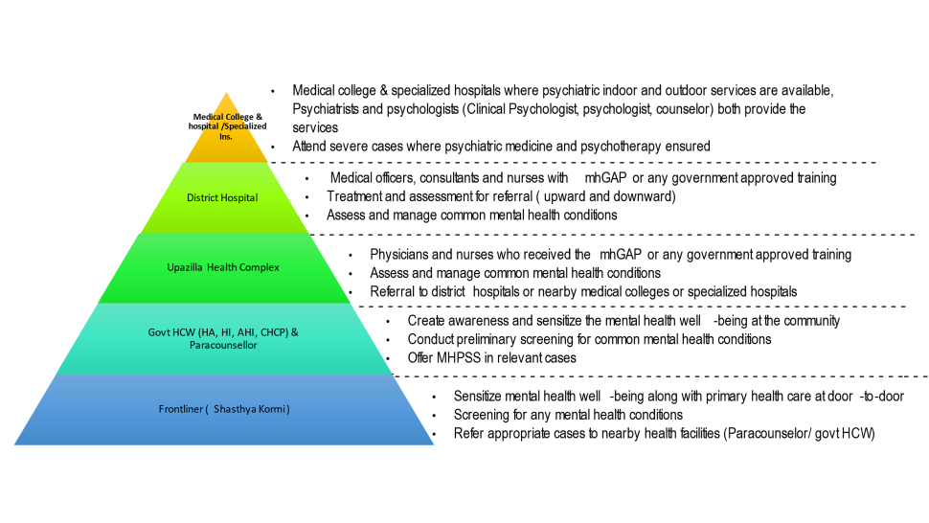
Figure: Community Mental Health Model


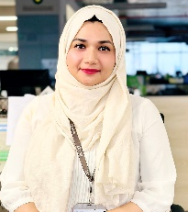
Farjana Sharmin has expertise in diagnosing and evaluating mental and emotional disorders of individuals through observation, clinical interviews, psychometric tools, formulating and administrating scientific intervention. Right now she is working in BRAC Health Nutrition and Population Programme as a programme manager and leading in the development of a community mental health model in national level with the partnership government of Bangladesh. She has done the research and contributed national-level mental health situations (intervene Rana plaza incidents, Nepal plan crushed, burn, and acid survivors).
Email:farjana.sharmin1@brac.net

Presenting author details
Full name: Farjana Sharmin
Contact number: +8801722121296
Linked In account: www.linkedin.com/in/farjana-sharmin-958176199
Category: Oral presentation

