Sustainability of Expanded Polystyrene as a Preferred Thermal Insulation Material
Cíntia Martins, Joana Araújo, João Coutinho, Daniela Rodrigues, Adriana Moreira and Paulo Teixeira, CeNTI – Centre for Nanotechnology and Smart Materials, PT.
Nuno Oliveira Ferreira, Houselab Technologies, PT.
Nelson Bento Pereira, CICon – Center for Innovation in Construction, PT.

Abstract (300 word limit)
Construction is one of the largest sectors of the world economy, however, it appears to be conservative and slow to adopt changes and innovations. If the construction paradigm does not change, it will be difficult to meet the global demand for infrastructure and housing. Moreover, with the construction industry accounting for a high percentage of global energy-related carbon-dioxide emissions, it is imperative to work toward making the industry more sustainable. The project STEPS aims at the development of a new advanced building system that reduces the environmental impact of the production chain, improving substantially and productivity of the construction sector. Insulation materials are an important component in construction as they contribute to energy efficiency and, therefore, to the achievement of climate goals. Expandable polystyrene (EPS) is one of the most used materials for thermal insulation in buildings. Despite the technical properties of EPS, which make it a material with remarkable performance, it presents a high ecological footprint, since its production requires significant energy consumption and is difficult to dispose of. The present work discusses the development of a numerical model for the maximization of thermal performance in terms of predicting the best combination of materials and geometry, as well as development in thermal-insulation systems, including EPS, with an improved ecological footprint, will be presented.
This work was developed in the scope of project STEPS, which was co-financed by Portugal 2020, under the Norte 2020, through the European Regional Development Fund (ERDF) (NORTE-01-0247-FEDER-047054).

Image – Graphical abstract

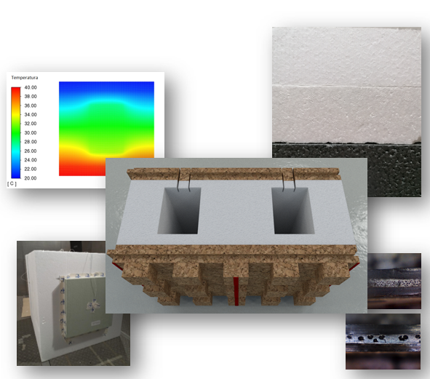

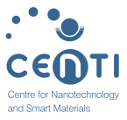
 Biography (150 word limit)

Cíntia Martins holds a master’s degree in Polymer Engineering from the University of Minho. She currently works as a researcher at CeNTI – Centre of Nanotechnology and Smart Materials, in Functional Fibers area. As part of her career, she acquired relevant experience in research and development of polymers, specifically in their processing and characterization.
Cíntia has been working on the development of polymeric structures with different functional properties, including magnetic, piezoresistive, and light-responsive, among others, and with the incorporation of functional and sustainable materials. She also has knowledge of characterization, performance evaluation, and pilot-scale processing techniques.
Email: cmartins@centi.pt

Notes/Comments:

Presenting author details
Full name: Cíntia Isabel Rodrigues Silva Martins
Contact number: +252104152
Twitter account:
Linked In account:
Session name/ number: Materials for Green Technology/ Track 4
Category: Oral presentation

