Strategies to reduce the environmental impact of meat packaging

Harrison Tetteh^{1*}, MSc, Mercè Balcells², PhD, Alba Bala³, PhD, Pere Fullana-i-Palmer³, PhD, María Margallo⁴, PhD, Ruben Aldaco⁴, PhD and Rita Puig¹, PhD

¹Department of Computer Science and Industrial Engineering, University of Lleida, Spain

²Department of Chemistry, University of Lleida, Spain

³UNESCO Chair in Life Cycle and Climate Change ESCI-UPF, Spain

⁴Department of Chemical and Biomolecular Engineering, University of Cantabria, Spain

Abstract
Statement of the Problem: Packaging plays an important role, especially in meat products, via safety and shelf-life extension. Nevertheless, it must be designed to be as environmentally friendly as possible. Therefore, the aim of this study is to environmentally assess and compare 3 chicken meat packaging types, and to obtain from this comparison, the most important strategies to improve the environmental performance of meat packaging. The 3 types of packaging evaluated were: polyethylene (PE) bag, polyethylene terephthalate (PET) tray and film and multi-layer polystyrene (PS)/polyvinyl chloride (PVC) tray with PVC film (Figure 1).
Methodology & Theoretical Orientation: The assessment was performed using LCA methodology and EP 3.0 impact assessment method.
Findings: The PE bag performed best in the climate change impact category while the PET tray was the worst. This is partly due to the fact that the PE bag has the lowest weight per kg of meat content compared with the others. Considering the recyclability of the 3 packaging types, the multi-layer PS/PVC tray is not recyclable while the PET tray is the most recyclable, but this does not change the order of the environmental performance of the packaging types. When 20% recycled content (rPET) was included in the PET packaging, as the only material among the three, whose recycling and secondary use as food contact material is safety assessed in Europe, this decreased its climate change impact by ~9%, but it was still the worst performing packaging among the three.
Conclusion and Significance: Although packaging plays an important role in meat products, large differences can be found when comparing the environmental impact of different types of packaging. Increasing the recyclability and recycled content of packaging need to be promoted to meet circular economy objectives. However, the weight of the packaging should not be ignored as it affects the environmental impact.

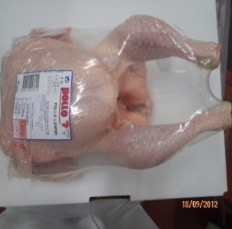
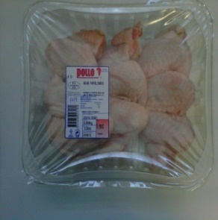
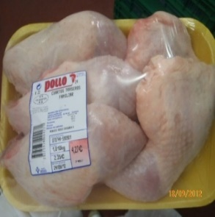
PE bag

PET tray
PS/PVC
tray

Figure 1: The 3 chicken meat packaging alternatives assessed. From left to right: Polyethylene (PE) bag; Polyethylene terephthalate (PET) tray and film; Multi-layer polystyrene (PS)/polyvinyl chloride (PVC) tray with PVC film.

Acknowledgements

The authors wish to acknowledge the financial support from the Spanish Ministry of Science and Innovation to the project KAIROS-BIOCIR (PID2019-104925RB-C32). The first author also appreciates the support (2021FI_B 00100) from the Secretariat for Universities and Research of the Ministry of Business and Knowledge of the Government of Catalonia and the European Social Fund.

Recent Publications

- Ingrao C, lo Giudice A, Bacenetti J, Mousavi Khaneghah A, Sant’Ana A de S, Rana R, Siracusa V (2015) Foamy polystyrene trays for fresh-meat packaging: Life-cycle inventory data collection and environmental impact assessment. Food Research International 76:418–426.
- Lopez-Aguilar J F, Sevigné-Itoiz E, Maspoch M L, Peña J (2022) A realistic material flow analysis for end-of-life plastic packaging management in Spain: Data gaps and suggestions for improvements towards effective recyclability. Sustainable Production and Consumption 31:209–219.
- Maga D, Hiebel M, Aryan V (2019) A comparative life cycle assessment of meat trays made of various packaging materials. Sustainability 11(19).
- Pauer E, Wohner B, Heinrich V, Tacker M (2019) Assessing the Environmental Sustainability of Food Packaging: An Extended Life Cycle Assessment including Packaging-Related Food Losses and Waste and Circularity Assessment. Sustainability 11(3):925.
- Tetteh H, Bala A, Fullana-i-Palmer P, Balcells M, Margallo M, Aldaco R, Puig R (2022) Carbon Footprint: The Case of Four Chicken Meat Products Sold on the Spanish Market. Foods 11(22):3712.
- Wikström F, Williams H, Venkatesh, G (2016) The influence of packaging attributes on recycling and food waste behaviour – An environmental comparison of two packaging alternatives. Journal of Cleaner Production 137:895–902.

Biography
Harrison Tetteh holds a master’s degree in environmental engineering and sustainable energy from Rovira and Virgili University, Spain, and currently pursuing his doctorate at the University of Lleida, Spain, with a research focus on environmental performance evaluation and circularity improvement of agri-food products and their packaging. Harrison is in his second year of the PhD program and has one journal publication and two international conference presentations (an oral and a poster) to his credit. Moreover, Harrison is a recipient of the Joan Oró grant (FI 2021), to support his PhD studies, generously provided by the Secretariat for Universities and Research of the Ministry of Business and Knowledge of the Government of Catalonia, Spain, and the European Social Fund.

