Efficacy of perioperative duloxetine for analgesia in primary total joint arthroplasty: A systematic review and meta-analysis of randomized controlled trials
Tang Xiumei¹*, RN PhD. and He Yue², RN PhD
¹Institute of Hospital Management, West China Hospital, Sichuan University, Chengdu, China
²West China School of Nursing, Sichuan University / Department of Orthopaedics, West China Hospital, Sichuan University, Chengdu, China

Abstract
Aims and objectives: To quantify the analgesic efficacy of duloxetine in patients with primary total joint arthroplasty.
Background: Duloxetine is a serotonin and norepinephrine reuptake inhibitor that is usually used to treat chronic neuropathic pain. The effects of duloxetine in TJA remains unclear.
Design: Meta-analysis of randomized controlled trials with a systematic review, GRADE assessment, and trial sequential analysis.
Methods: PubMed, CINAHL, OVID, Embase, MEDLINE, CENTRAL, Google Scholar, and Cochrane were searched without language restrictions from inception to 1 February 2022. The primary outcomes were postoperative knee pain at ambulation (measured on a scale from 0 to 10) and cumulative opioid consumption. The secondary outcomes were knee pain at rest, knee pain at night, and adverse events.
Results: Eight randomized controlled trials involving 740 patients were included in the analysis. Moderate-certainty evidence showed that duloxetine use was associated with a reduction in ambulation knee pain scores within 3 months and reduced opioid consumption at 24 and 48 hours. In addition, low- to moderate-certainty evidence showed that duloxetine reduced the knee pain scores measured at rest and at night. Compared with placebo, duloxetine was associated with a higher rate of drowsiness but a lower rate of postoperative nausea and vomiting. Moreover, the subgroup analysis suggested a reduction in ambulation pain scores in both patients with central sensitization and non-central sensitization, and this reduction was similar to that in the at-rest knee pain scores.
Conclusions: After total joint arthroplasty, moderate-certainty evidence showed that duloxetine reduced postoperative pain scores and opioid consumption within 3 months in both patients with central sensitization and non-central sensitization. However, the statistically significant effects were below the expected minimal clinically relevant differences. Additionally, the trial sequential analysis suggested that more trials are needed to detect differences and increase the credibility of the results.

Image
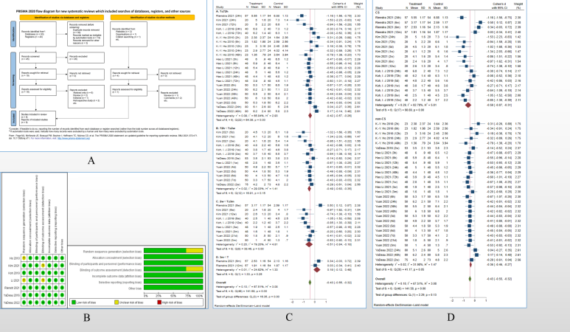
Recent Publications

- Bedard, N. A., Pugely, A. J., Westermann, R. W., Duchman, K. R., Glass, N. A., & Callaghan, J. J. (2017). Opioid Use After Total Knee Arthroplasty: Trends and Risk Factors for Prolonged Use. J Arthroplasty, 32(8), 2390-2394. doi:10.1016/j.arth.2017.03.014
- Branton, M. W., Hopkins, T. J., & Nemec, E. C. (2021). Duloxetine for the reduction of opioid use in elective orthopedic surgery: a systematic review and meta-analysis. Int J Clin Pharm, 43(2), 394-403. doi:10.1007/s11096-020-01216-9
- Carter, N. J., & McCormack, P. L. (2009). Duloxetine: a review of its use in the treatment of generalized anxiety disorder. CNS Drugs, 23(6), 523-541. doi:10.2165/00023210-200923060-00006
- Chappell, A. S., Desaiah, D., Liu-Seifert, H., Zhang, S., Skljarevski, V., Belenkov, Y., & Brown, J. P. (2011). A double-blind, randomized, placebo-controlled study of the efficacy and safety of duloxetine for the treatment of chronic pain due to osteoarthritis of the knee. Pain Pract, 11(1), 33-41. doi:10.1111/j.1533-2500.2010.00401.x
- Chappell, A. S., Ossanna, M. J., Liu-Seifert, H., Iyengar, S., Skljarevski, V., Li, L. C., . . . Collins, H. (2009). Duloxetine, a centrally acting analgesic, in the treatment of patients with osteoarthritis knee pain: a 13-week, randomized, placebo-controlled trial. Pain, 146(3), 253-260. doi:10.1016/j.pain.2009.06.024

Biography
Tang xiumei has her expertise in evidence-based medicine, anesthesia in surgery, hospital management, and policy research. She is now a PhD student in Hospital Management and Health Policy. She had her 3 years’ internship in the Department of Orthopedic, West China Hospital, Sichuan University, China, during the period, she participated in 4 randomized conrolled trials, and her master’s dissertation was the “Efficacy and safety of different analgesic regimens after total knee arthroplasty”.

