An Audit of Visual outcomes following cataract surgery in Southern Karamoja

Atto GLADYS, Moroto Regional Referral Hospital, Uganda

Problem statement: Biometry is crucial for good outcomes. Only 20% of patients undergoing cataract surgery in Karamoja subregion were having biometry done.
Methods: We collected secondary data on Snellen visual acuity pre and post operatively, and after one week follow up and entered it into Microsoft excel spreadsheet for analysis and presentation using tables.
Results: A total of 418 surgeries were carried out in the months of March, April, September, and October 2022 in Southern Karamoja. Of these, 252 (60.3%) were done with biometry and 166 (39.7%) using standard Intraocular lenses (IOLs). 167 (39.2%) of the patients were males and 251 (60.0%) were females. The age group ranged from 35-95.
Of the 166 eyes operated using standard Intraocular lenses, 83 (50%), 71 (42.8%), and 12 (7.2%) had good, borderline, and poor outcomes respectively on the first postoperative day without correction. After one week, 140 (84.3%) were available for review while 21 (13%) were lost to follow-up. Of those reviewed, 90 (64.3%), 41 (29.3%), and 10 (7.1%) had good, borderline, and poor outcomes respectively.
Of the 252 eyes that had biometry done before surgery, 122 (48.4%), 103 (40.9%) and 27 (10.7%) had good, borderline, and poor outcomes respectively on the first postoperative day without correction. After correction with pinhole, 177 (70.2%), 49 (19.4%) and 26 (10.3%) had good, borderline, and poor outcomes respectively. 184 (73%) eyes were reviewed after one week while 68 (27.1%) were lost to follow-up. Of the 184 reviewed, 140 (76.1.%), 39 (21.2%), and 4 (2.2%) had good, borderline, and poor outcomes respectively without correction.
Conclusion: There was an overall improvement in visual outcomes in eyes that had biometry done. The findings also drew attention to the difference in visual outcomes in the immediate postoperative period and after one week follow-up with the latter probably due to improvement in postoperative pain and adjustment to the intraocular lens.

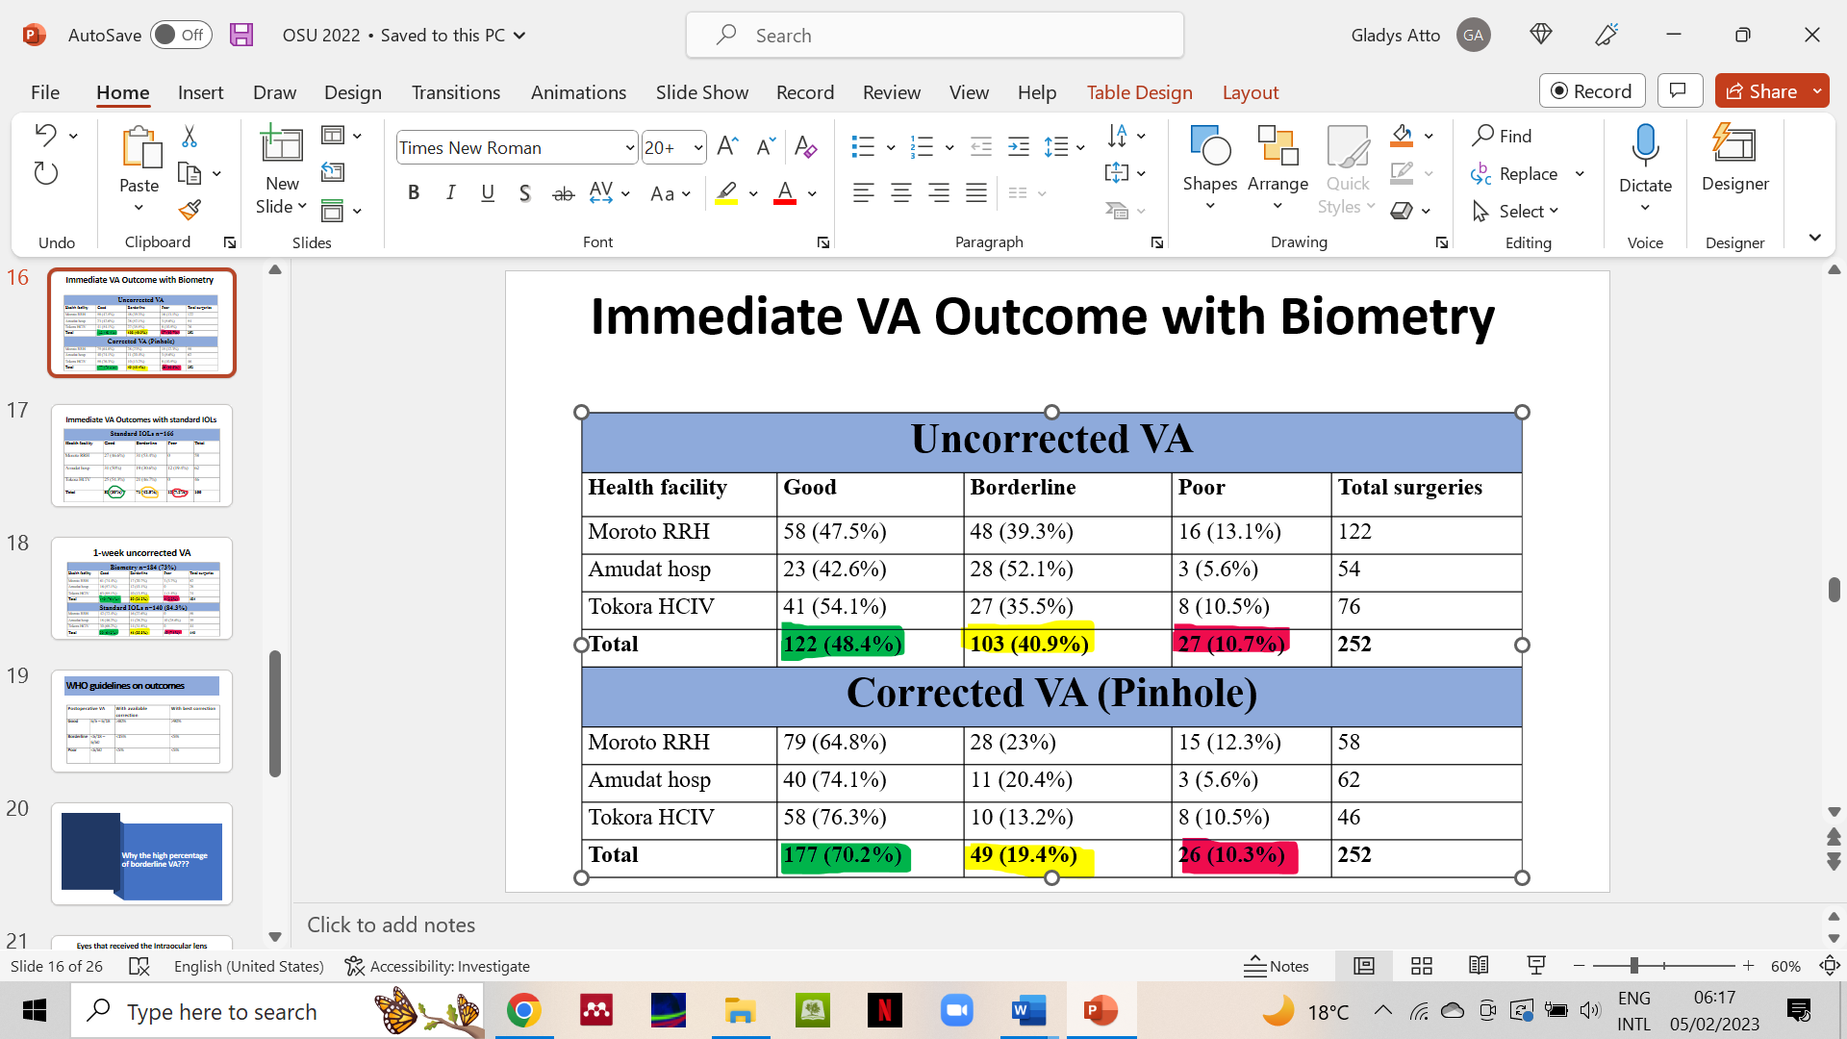
Recent Publications
- Arunga S, Atto G, Ayebazibwe B, Onyango J, Macleod D, Hu VH, Burton MJ. (2020). Factors associated with poor presenting vision among patients with microbial keratitis In Uganda. JOECSA 24(1)
- Atto G, Twinamasiko A, Arunga S. (2021). Sensitivity, and specificity of McMonnies questionnaire in diagnosing dry eye syndrome among patients aged 40 years and above in Uganda. JOECSA 25(1)

- Atto Gladys (2022). Global perspectives: What it is like to be the only ophthalmologist in my region. CRST

Dr Gladys Atto is a Ugandan ophthalmologist with a subspecialty training in public eye health from London School of Hygiene and Tropical medicine. She has a legacy of being the first ophthalmologist in Karamoja subregion - one of the hardest to reach areas in Uganda. She not only functionalized the eye unit at the Regional Referral Hospital in Moroto district, but also turned it into a Centre of excellence for the provision of eye care services in the sub-region. She received the 'the women in medicine' award from the Uganda Medical Association in recognition of her efforts in strengthening the health system in 2021 and was nominated for "Doctor of the year'' and "Global Health Champion, North" categories of Heroes in Health awards by Ministry of health, Uganda in 2022.


Presenting author details
Full name: Gladys Atto
Contact number: +256773943552
Mail id: attoglad@gmail.com
Category: (Oral presentation)

