Nutritional Composition of Isolates from Solojo Cowpea (Vigna Unguiculata L. Walp) and Its Potential as a Safer Food Substitute to Animal Protein Source for Better Health.
Chibudike O. Henry, PhD, FIIRO, Lagos-Nigeria

Abstract
Public health is the science of protecting and improving the health of people and their communities. This is achieved by promoting healthy lifestyles, researching disease and injury prevention, and detecting, preventing and responding to infectious diseases. Food and nutrition have significant implications for the health and well-being of society. Both food and nutrition are matters of Public Health because food and nutrition are closely related to health. There is strong evidence that links a healthy diet with optimal growth and development such as improved infant, child and maternal health, stronger immune systems, safer pregnancy and childbirth, lower risk of non-communicable diseases (such as diabetes, cardiovascular disease, obesity, osteoporosis, cognitive decline, and certain types of cancer), high educational attainment and longevity. Nutrition is about eating a healthy and balanced diet. Food and drink provide the energy and nutrients you need to be healthy. Understanding these nutrition terms may make it easier for you to make better food choices. Most people in the United States don't eat a healthy diet and consume too much sodium, saturated fat, and sugar, increasing their risk of chronic diseases. These are the three biggest nutrition related challenges to public health. Large amounts of saturated fat and cholesterol amongst others are problems associated with animal protein sources. The water and energy resources needed for the creation of animal protein is very high compared to plant-based protein production. Nowadays, concerns about high-cholesterol and growing awareness about nutritional dependent ailments, has made consumers more conscious in their food selection thus making plant protein to be preferred. The excessive price of protein from animal origin has induced the increasing excitement in utilization of plant protein industrially both in edible and non-food market with special interest in legumes. Economic growth and global food security now depend on a dwindling number of plant species. In human history, more than 4,000,000 plant species have been identified as having potential to be used as food, shelter, fibers, industrial, cultural and medicinal plants. Unfortunately, barely a handful of these plants are widely utilized. The remaining plant diversity is underutilized and gradually going into extinction. This research paper will seek to explore how food and nutrition can promote health, quality of life, and economic prosperity. It will also explores nutrition-related health issues and challenges, across the globe, from infancy through adulthood. Malnutrition, food insecurity, and hunger all too often occur within the same communities and households. The relationship among malnutrition, food security, hunger, and health, incorporating the four pillars of food availability, access, utilization, and stability, will be used in assessing and developing strategies that accelerate progress toward optimal health.
Keywords: Public Health, Nutrition, Animal-based food, Malnutrition, Plant-based protein

Image

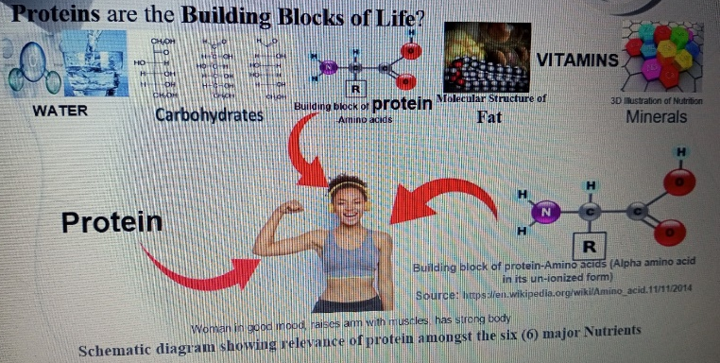

Recent Publications
- Chibudike H.O. and Udohitinah J.S. (2009). “Local Sourcing of Non-wood Pulp Plant for Paper-making”. J. Chem. Soc. Nigeria, Vol.34, No. 1, pp169-172 (2009).
- Chibudike H.O. and Udohitinah J.S. (2009). “Evaluation of Pulp and Paper-making Potentials of Cereal Straws (agro-wastes)”. Journal of Engineering Research, Vol. 14, No. 4, December, 2009
- Chibudike H.O. and Udohitinah J.S. (2009). “Determination of Pulp, Paper and Board-making Potentials of Rhizophora Racemose (Red Mangrove)”. Journal of Chemical Society Nigeria, Vol. 34, No. 1, pp179-183 (2009)
- Chibudike H.O., Udohitinah J.S., Adeyoju O.A., Hassan M.T., Kayode O.F., Mgbachiuzo E. and Ojo B.I. (2011). “Studies of Fibre Characteristics and Paper-making Potentials of Adansonia Digitata Linn.”. NJERD, Vol. 10, No. 1, 2011
- Chibudike H.O., Mgbachiuzo E., Adeyoju O.A., Kayode O.F., Arowolo, A.B., Ojo B.I., Tojola O.B., Asieba G.O., Orekoya E.O., (2011). “STUDIES OF FIBRE CHARACTERISTICS AND PAPER-MAKING POTENTIALS OF AGRICULTURAL WASTES”. NJEM, Vol. 12, No. 1
- Chibudike H.O., Igwe C.C., Mgbachiuzo E., Chibidike E.C., and Adeyoju O.A. (2018). “Influence of Furnish Characteristics on Strength Properties of Date Fiber Ceiling boards”. International Journal of Scientific & Engineering Research Volume 9, Issue 10, October-2018 1704 ISSN 2229-5518
- Chibudike H.O., Igwe C.C., Mgbachiuzo E., Chibudike E.C., and Adeyoju O.A. (2018). “Influence of Chemical Properties, Fiber Morphology and Biometry of Ten (10) Nigeria Cultivated Agro-based Fibers on Properties of Paper-pulp”. Proceedings of Researchfora International Conference, Cape Town, South Africa, 24th-25th. September 2018.
- Chibudike H.O., Mgbachiuzo E., Ndukwe N.A., Obi N.I., Adeyoju O.A., and Chibudike E.C. (2020). “A Study on MEA-Pulping of Ten (10) Nigerian Cultivated Agro-based Fiber for the Production of Pulp Stock Paper”. IEEE-SEM, Volume 8, Issue 11, November-2020. ISSN 2320-9151.
- Chibudike, H. O., Ndukwe, N. A., Chibudike, E. C., Adeyoju, O. A. and Obi, N. I. (2021). “Optimization of Pulp Yield for Catalyzed-MEA Conversion of Agro-wastes to Paper-pulp”. International Journal of Science Academic Research Vol. 02, Issue 07, pp.1818-1823, July, 2021 Available online at http://www.scienceijsar.com

- Chibudike, H. O., Ndukwe, N. A., Chibudike, E. C., Obi, N. I. and Adeyoju, O. A. (2021). “Comparative Assessment of the Pulping Potentials of Soda and MEA Processes for the Development of Paper-pulp from Sugarcane Bagasse”. World Journal of Advanced Research and Reviews, 2021, 12(01), 230–242
- Chibudike O. H., Ezeanyanaso S. C., Odega N.E., Ndukwe A. N., Chibudike E. C., and Adeyoju O. A. (2022). “Proton Generating NAEM-catalyzed Organo-solv Pulping of Seven (7) Nigeria Savanah Timbers: A Potential Replacement for the kraft Process”. International Journal of Chemical Science.Volume 6, Issue 1, 2022, Page No. 22-29.
- Chibudike, H.O., Odega N.E., Chibudike, E. C., Adeyoju, O. A. Obi, N. I. (2021). “Catalyzed-Mea Conversion of Agro-biomass to Paper-pulp: Influence of Pulping Additives and Synergy Effect on Pulp Screened Yield”. World Journal of Advanced Research and Reviews, 2021, 12(02), 392–400

- Chibudike, H. O., Mgbachiuzo, E., Ndukwe, N. A., Obi, N. I, Adeyoju, O. A. and Chibudike, E. C., (2021). “Soda-AQ Pulping of Woody Petioles of Oil Palm Fronds (ElaeisGuineensis): Determination of Paper-making Potentials and Optimum Pulping Conditions”. International Journal of Advances in Engineering and Management (IJAEM) Volume 3, Issue 5 May 2021, pp: 01-12 www.ijaem.net ISSN: 2395-5252
- Chibudike, H. O., Ndukwe, N. A., Chibudike, E. C., Adeyoju, O. A. and Obi, N. I. (2021). “MEA-conversion of agro-wastes to paper-pulp: Optimization of pulping conditions”. World Journal of Advanced Research and Reviews, 2021, 11(02), 337–349.
- Chibudike, H. O., Ndukwe, N. A., Chibudike, E. C., Adeyoju, O. A. and Obi, N. I. (2021). “Production of Writing and Printing Papers from Woody Petioles of Oil Palm Fronds (Elaeis guineensis): Determination of Optimum Pulping Conditions using Soda-AQ Process”. International Journal of Applied Research and Technology. 10(9): 24 – 34.
- Chibudike, H.O., Igwe C.C., Mgbachiuzo, E., Chibudike, E.C. and Adeyoju, O.A. “Production of Fire-Resistant Ceiling Board from Agro-Based Fiber”. International Journal of Recent Innovations in Academic Research. Volume-3, Issue-1, January-2019: 86-98 ISSN: 2635-3040
- Chibudike H.O., Ndukwe N.A., Obi N.I., Adeyoju O.A., and Chibudike E.C. (2020). “MEA-pulping of Sugarcane Bagasse: Effect of Fiber Morphology and Beating Treatment on Properties of Furnished Paper”. American Journal of Innovative Research and Applied Sciences. ISSN 2429-5396 I www.american-jiras.com
- Chibudike O. H., Ezeanyanaso S. C., Ndukwe A. N., Chibudike E. C., and Adeyoju O. A. (2022). “Comparative Assessment of the Chemical Properties of Seven (7) Nigerian Cultivated Agro-based Fibers and their Potentials for Production of Paper-pulp”. International Journal of Applied Research and Technology. 11(04): 11– 27.
- Chibudike H.O., Ndukwe N.A., Lawal A.K., Chibudike E.C., Adeyoju O.A. (2021). “Optimization of process condition for laboratory scale enzymatic conversion of cassava starch to glucose syrup”. International Journal of Food Science and Nutrition. Volume 6, Issue 4, 2021, Page No. 51-58. ISSN: 2455-4898
- Chibudike H.O., Ndukwe N.A., Obi N.I., Adeyoju O.A., and Chibudike E.C. (2020). “Soda Pulping Experiments and Yield Optimization on Bamboo Fiber for Pulp and Paper Production”. Global Scientific Journal GSJ: Volume 8, Issue 11, November 2020 ISSN 2320-9186
- Chibudike H.O., Mgbachiuzo E., Ndukwe N.A., Obi N.I., Adeyoju O.A., and Chibudike E.C. (2021). “Monoethanolamine Pulping Of EFB (Agro-Biomass): Effect of Operational Variables on Pulp Screen Yield”. International Journal of Research and Innovation in Applied Science (IJRIAS) | Volume VI, Issue I, January 2021|ISSN 2454-6194
- Chibudike H.O., Mgbachiuzo E., Ndukwe N.A., Obi N.I., Adeyoju O.A., and Chibudike E.C. (2021). “Fiber Studies and Pulping Experiments on Empty Fruit Bunch (EFB) of Oil Palm (Elaeis Guineensis) Using Soda-AQ Process”. International Journal of Scientific & Engineering Research Volume 12, Issue 1, January-2021 220 ISSN 2229-5518
- Chibudike E.C., Chibudike H.O., Ndukwe N.A., Obi N.I., Adeyoju O.A. (2021). “Optimizing Web-Based Information Dissemination: Innovations of Research Institutions’ For Entrepreneurs in Nigeria”. International Journal of Advances in Engineering and Management (IJAEM). Volume 3, Issue 3 Mar. 2021, pp: 25-31 www.ijaem.net ISSN: 2395-5252
- Adeyoju O.A., Chibudike H.O., Adebowale K.O., Olu-Owolabi B.I., Chibudike E.C. (2021). “Nutritional Composition and Functional Properties of Flour and Protein Isolates from Two Varieties (DAS & BS) of Nigerian Cultivated Solojo Cowpea (Vigna Unguiculata L. Walp)”. HSOA Journal of Food Science and Nutrition. J Food Sci Nutr 2021, 7: 123 DOI: 10.24966/FSN-1076/100123
- Chibudike H.O., Ndukwe N.A., Chibudike E.C. Adeyoju O.A., and Obi N.I. “Optimization of Pulp Yield for Catalyzed-MEA Conversion of Agro-wastes to Paper-pulp”. International Journal of Science Academic Research Vol. 02, Issue 07, pp.1818-1823, July, 2021. Available online at http://www.scienceijsar.com
- Chibudike E.C., Haruna A., Chibudike H.O., Ngige O.C., Adeyoju O.A., and., Obi N.I. “Machine Learning - A New Trend in Web User Behavior Analysis”. International Journal of Computer Applications (0975 – 8887). Volume 183– No.5, May 2021
- Adeyoju O.A., Adebowale K.O., Olu-Owolabi B.I., Chibudike H.O. and Chibudike E.C. (2021) “Amino acid composition (AA) and SDS-PAGE electrophoresis of flour & protein isolates from two varieties (DAS & BS) of Nigeria cultivated solojo cowpea [Vigna unguiculata (L.) WALP]” European Journal of Biotechnology and Bioscience. Volume 9, Issue 3, 2021, Page No. 75-81 ISSN: 2321-9122
- Adeyoju O.A., Adebowale K.O., Olu-Owolabi B.I., Chibudike H.O. and Chibudike E.C. (2021). “Effect of germination on the bulk density of flours and protein isolates from Solojo cowpea (Vigna Unguiculata L. Walp)”. International Journal of Food Science and Nutrition. Volume 6, Issue 3, 2021, Page No. 78-83 ISSN: 2455-4898
- Adeyoju O.A., Adebowale K.O., Olu-Owolabi B.I., Chibudike H.O. and Chibudike E.C. (2021) “Influence of Germination and Morphological properties on Microscopic Characteristics of protein isolates from Two (2) Solojo Cowpea (Vigna Unguiculata L. Walp) Varieties in Nigeria” IOSR Journal of Environmental Science, Toxicology and Food Technology (IOSR-JESTFT) e-ISSN: 2319-2402,p- ISSN: 2319-2399.Volume 15, Issue 9 Ser. I (September 2021), PP 60-67 www.iosrjournals.
- Adeyoju O.A., Adebowale K.O., Olu-Owolabi B.I., Chibudike H.O. and Chibudike E.C. (2021) “Effect of Ionic Strength on Emulsion Activity (EA) of Isolates from Two Varieties (DAS & BS) of Nigerian Cultivated Solojo Cowpea (Vigna Unguiculata L. Walp)”. European Journal of Food Science and Technology. Vol.9, No.2, pp.22-36, 2021. 365: 519-530.
- Adeyoju O.A., Adebowale K.O., Olu-Owolabi B.I., Chibudike H.O. and Chibudike E.C. (2021) “Physico-Functional Characterization of Flour and Protein Isolates from Nigeria Cultivated Solojo Cowpea [Vigna unguiculata (L.) WALP]” Asian Food Science Journal 20(9): 131-148, 2021; Article no.AFSJ.71834 ISSN: 2581-7752.
- Adeyoju O.A., Adebowale K.O., Olu-Owolabi B.I., Chibudike H.O. and Chibudike E.C. (2021). “Physicochemical and Functional Properties of Flour and Protein Isolates from Two (2) Solojo Cowpea (Vigna Unguiculata L. Walp) Varieties in Nigeria”. World Journal of Food Science and Technology 2021; 5(2): 25-32 http://www.sciencepublishinggroup.com/j/wjfst doi: 10.11648/j.wjfst.20210502.12 ISSN: 2637-6016 (Print); ISSN: 2637-6024 (Online)
- Anyakora A.N., Mudiare E., Chibudike H.O., Adeyoju O.A. (2011). “Investigation of properties of oil palm empty fruit bunch fiber in the strength and fracture performance of boards”. Journal of Engineering and Applied Sciences 7 (2011) 16-21
- Adeyoju O.A., Adebowale K.O., Olu-Owolabi B.I., Ndukwe N.A., Chibudike H.O. and Chibudike E.C. (2022). “Concentration Effect on Foaming and Stability of Isolates from Two Varieties (DAS & BS) of Nigerian Cultivated Solojo Cowpea (Vigna Unguiculata L. Walp)”. HSOA Journal of Food Science and Nutrition. 8: 133 DOI: 10.24966/FSN-1076/100133
- Adeyoju O.A., Adebowale K.O., Olu-Owolabi B.I., Chibudike H.O. and Chibudike E.C. (2021) “Nutritional and functional properties of flour and protein isolates from germinated Solojo Cowpea Vigna unguiculata (l.) Walp.” J Food Sci Nutr Res 2021; 4 (2): 161-174. DOI: 10.26502/jfsnr.2642-11000069
- Nicholas-Okpara V.A.N., Ubaka A.J., Adegboyega M.O., Utazi I.A., Chibudike C.E. and Chibudike H.O. “Advancements in Food Technology Using Artificial Intelligence- Deep Learning”. (2021). Current Journal of Applied Science and Technology. 40(18): 1-9; Article no.CJAST.70223 ISSN: 2457-1024 (Past name: British Journal of Applied Science & Technology, Past ISSN: 2231-0843, NLM ID: 101664541)
- Chibudike, C. E., Peter C. M. and Chibudike H.O. “Some Contributions of ICT to the Research Findings of Tertiary Institutions in Nigeria towards SMEs”. Proceedings AIT 2017 2nd International Conference on Applied Information Technology. Pages 135-139
- Chibudike, C. E., Chibudike H.O., Obi N.I. and Adeyoju O.A. (2020). “Some Contributions of ICT to the Research Findings of Tertiary Institutions in Nigeria towards SMEs”. The International Journal of Engineering and Science (IJES). Volume 9, Issue 12. Series II. Pages PP 21-27 ISSN (e): 2319-1813 ISSN (p): 20-24-1805
- Chibudike E.C., Haruna A., Chibudike H.O., Nicholas-okpara V.N., Obi N.I. and Adeyoju O.A. (2021) “The Impact of Corporate Website on Dissemination of Research Information Among Stakeholders in Nigeria”. International Journal of Computer and Information Technology. Volume 10 – Issue 3.
- Chibudike, C.E., Ezeanyanaso C.S., Odega N.E., Chibudike H.O., Okpara V., Adeyoju O.A. and Abdu H. (2022). “Review on the Application of Machine Learning to Cancer Research”. HSOA Advances in Industrial biotechnology”.4:013 DOI: 10.24966/AIB-5665/100013
- Ezeanyanaso C.S., Chibudike C.E., Chibudike H.O., Etchie T. O., Olayanju A. “Automation of Statistical Reports of Mycotoxins of Agricultural Products in Sub-Saharan Africa”. .J.C. Bose University of Science and Technology, YMCA, Faridabad 8th International Symposium on Fusion of Science and Technology (ISFT-2020). January 6-10, 2020.

- Chibudike H.O., A.N. Anyakora A.N., Suleiman MAT, Adeyoju O.A., Arowolo A.B., Akubueze E.U., Etoamaihe M.A., Asieba G.O. and Samuel E.A. (2011). “Utilization of Bamboo in the Production of Ceiling Board”. Journal of Engineering Research, Vol. 16, No. I, March, 2011
.

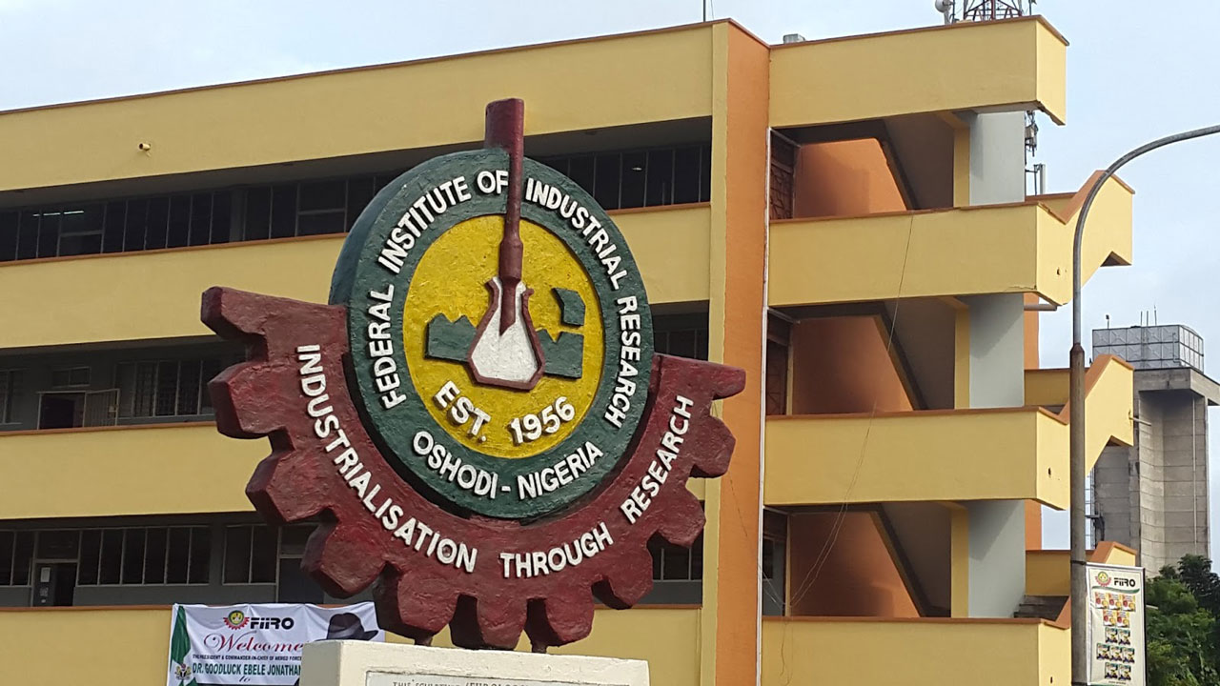

Biography
Chibudike’s research exploits include: 1. Determination of the Pulping Potentials of Seven (7) Nigerian Savanah Timbers and Assessment of the Pulping Potentials of Twenty one (21) Nigeria Cultivated Agro-based Fibers and their suitability for the production of various grades of pulp, paper, ceiling and fire retardant boards. 2. Production of Glucose Syrup from Cassava via Enzymatic approach. 3. Conversion of Glucose Syrup to Sorbitol via Hydrogenation process. In this role, he has shown initiative and made tangible impact. He through utter determination and unabashed environmental concern proposed and faced the challenges of changing the principles of Pulping operation in the Pulp and Paper Laboratory, FIIRO. He strengthened the fabric of these aspects of research by his innovative contributions and pioneering work to develop Eco-friendly principles and technology for converting woody and non-woody ligno-cellulosic biomass to pulp and paper in attempt to address issues of environmental concern associated with pulp and paper production. He has researched on Formability & Extensibility of Furnished Paper from admixture of Agro-wastes fiber for the production of 3D-Paper for making different kinds of biodegradable packaging products and cutleries. His passion for Food Chemistry and concerns for solution to problems of malnutrition and food in-security triggered his research interest in the discovery and development of some under-utilized agricultural food crops, which include two varieties of cowpea, Dark-Ash Solojo (DAS) and Brown Solojo (BS). One of the numerous research project he has executed on Solojo Cowpea include “Characterization and Functional Properties of Flour and Protein Isolated from Germinated Solojo Cowpea, Vigna unguiculata (L.) WALP.
Email: henrychibudike@gmail.com

- Official Email: Chibudike.henry@fiiro.gov.ng
- Full Name: CHIBUDIKE HENRY OKWUDILI
- University/Organization: Federal Institute of Industrial Research, Oshodi (FIIRO), Lagos-Nigeria
- Country: NIGERIA
- Personal Email: henrychibudike@gmail.com
- Mobile Number:+2348023225788
- Session/Track Name:
- Category (Oral/ Poster/ E-poster / Workshop): Oral
- Contact Address: 1 Rev. Father Burke Crescent, pff Ago Palace Way, Okota, Lagos

