HIV infection and adult vaccination: Assessing uptake, knowledge, and acceptance of vaccination among PLWH.
Mitchell Muchichwa, PH, Vaccinology, Masters Candidate, SA
Mitchell Muchichwa, PH, Vaccinology, Masters Candidate, SA

Abstract (300-word limit)
Statement of the Problem: People living with HIV (PLWH) have a greater risk of acquiring vaccine preventable diseases (VPDs) and of developing severe disease due to impaired immune responses associated with systemic T-cell destruction and impaired cell mediated immunity. The risk of acquiring VPDs among PLWH is greater in adults aged 15-49 years as a result of common infections found in occupational, social and travel settings. Even during the Highly Active Antiretroviral Therapy (HAART) era, HIV-positive persons are at a higher risk of complications from VPDs than their HIV-negative counterparts. At the same time studies have demonstrated low vaccination coverage among this population. For this reason, international and local guidelines for the vaccination of HIV-infected adults have been drawn up to address challenges in immunization in the HIV setting. However, there is little evidence on the compliance to these guidelines and on the knowledge and attitudes of PLWH to vaccination for VPDs. The purpose of this study is to investigate the vaccination uptake and knowledge and acceptance of vaccination among PLWH in South Africa which remains the epicenter of the HIV pandemic. Methodology: In-depth interviews and retrospective file reviews were utilized accordingly to obtain and verify social and medical information. Findings: several studies have indicated low vaccine coverage rates among PLWH, their knowledge and acceptance of vaccines varied by setting. Findings for this study are still under investigation and will be presented soon. Conclusion & Significance: Compliance to immunization guidelines among adults can be difficult to evaluate. However, studies have shown that PLWH are more susceptible to VPDs. If prioritized, vaccination can improve morbidity, reduce healthcare expenses and provide economic benefits for PLWH.

Image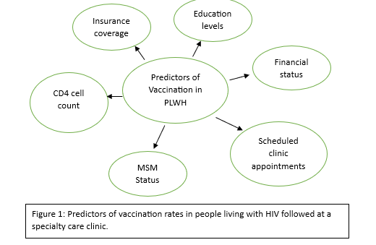

Recent Publications (minimum 5)

 Biography (150 word limit)


Mitchell Muchichwa is an MSc candidate in the field of Vaccinology and has an extensive background in public health and health promotion. She is a graduate student researcher at the Charlotte Maxeke Academic hospital in South Africa. Mitchell shares a passion in vaccinomics and builds her expertise in infectious disease control, where she contributes her efforts towards vaccine studies and vaccine awareness under the supervision of African Leadership in Vaccinology Expertise (ALIVE). Through constant experience in data management, Mitchell hopes for a framework that develops evidence based strategies informed by data.
Email: mitchellmuchichwa@gmail.com

Notes/Comments:

Presenting author details
Full name: Mitchell Muchichwa
Contact number: 0790522133
Twitter account: -
Linked In account: Mitchell Muchichwa
Session name/ number:
Category: (Oral presentation/ Poster presentation):

