Prevalence and Socio-Demographic Correlates of Mental Health Problems among Iranian Health Sciences Students

Abstract

Statement of the Problem: University students are a high-risk population for certain mental health problems as well as experiencing a critical transitory period in which developmental challenge of transition to adulthood occurs. Our two purposes in this study were (a) to describe the prevalence of selected mental health problems among a representative sample of Iranian health sciences students, and (b) to examine the socio-demographic correlates of these psychological problems in Iranian health sciences students. Methodology & Theoretical Orientation: A total of 560 medical and other health sciences students (250 males and 310 females) were recruited from Iran University of Medical Sciences. Data were obtained by self-administered questionnaire, including questions on socio-demographic characteristics. The Beck Depression Inventory, Beck Anxiety Inventory, General Health Questionnaire, and WHO well-being index were used. Findings: Ten percent of students had BDI scores consistent with clinically significant depression (6.6% mild, 1.8% moderate, 1.6% severe), and 28.7% had BAI scores consistent with clinically significant anxiety (20.7% mild, 7.1% moderate, 0.9% severe). Kurdish students had an odds ratio (OR) of 2.71 for mild to severe depression symptoms when compared to Persian students. The prevalence of distressed health sciences students and poor psychological well-being was 13.4% and 14.1%, respectively. Maternal education gave an OR of 0.57 for anxiety symptoms, after adjustment for all other factors. The possibility of general psychiatric morbidity was significantly lower in students who studied medicine (OR, 0.40). Being born in the capital city was associated with better psychological well-being (OR, 0.48). Conclusion & Significance: Ethnicity, birthplace, discipline, and maternal educational level were major determinants of mental health status among health sciences students. Further research should be undertaken to determine the prevalence of psychological disorders using more reliable diagnostic interview.

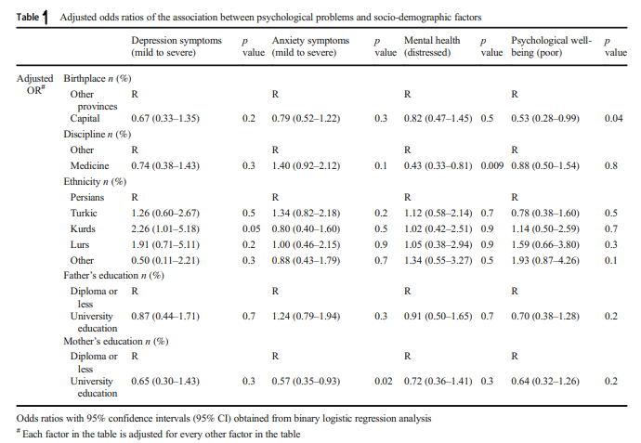

Recent Publications:

- Hoveidamanesh S, Tayefi B, Rampisheh Z, Khalili N, Ramezani M. The Factors Affecting the Physical Activity of the Health Care Workers of Iran University of Medical Sciences: A Qualitative Study. Arch Public Health 80, 214 (2022).

Rampisheh Z, Ramezani M, Khalili N, Massahikhaleghi P, Hoveidamanesh S, Darroudi S, SoleimanvandiAzar N and Tayefi B. Physical Activity and Well-being Status among Employees of University of Medical Sciences. Med J Islam Repub Iran. 2022 (27 Aug); 36:973.

Ramezani M, Tayefi B, Zandian E, SoleimanvandiAzar N, Khalili N, Hoveidamanesh S, Massahikhaleghi P, Rampisheh Z. Workplace interventions for increasing physical activity in employees: A systematic review. J Occup Health. 2022 Jan; 64(1):e12358

Hoveidamanesh, S., Tayefi, B., Rampisheh, Z. et al. Factors affecting the physical activity of healthcare workers of Iran University of Medical Sciences: a qualitative study. Arch Public Health 80, 214 (2022).

Tayefi B, Eftekhar M, Tayefi M, Darroudi S, Khalili N, Mottaghi A, Shanjani ZH, Nojomi M. Prevalence and socio-demographic correlates of mental health problems among Iranian health sciences students. Academic Psychiatry. 2020 Feb;44(1):73-7.

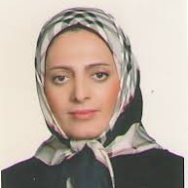 Biography

Graduation an MD and working as a general practitioner for almost 10 years did not stop me from pursuing my interest in public health and community medicine in 2010 when I started my residency and specialty course at the School of Medicine, Shahid Beheshti University of Medical Sciences, where my research was focused on Social health. Since the completion of my specialty course, I started working in academia with a focus on research areas of social determinant of health. Since 2018, I have worked as an Assistant Professor in the Department of Community and Family Medicine at Iran University of medical Sciences. Moreover, I am as a senior researcher in Preventive Medicine and Public Health Research Centre. In my recent research, I focused on mental health and well-being in university students and also physical activity level in employees as the social determinants of health.

Email: ba.tayefi@gmail.com

Presenting author details
Full name: Batool Tayefi Nasrabadi
Contact number:+989122805659
Linked In account: https://www.linkedin.com/in/batool-tayefi-81a863a6/
Session name/ number: Mental illness/7
Category: Oral presentation

