Identification of a Potential Vaccine against Treponema Pallidum Using Subtractive Proteomics and Reverse-Vaccinology Approaches

Siyab Khan, Northeast Normal University, China

Abstract
Syphilis, a sexually transmitted infection, is a deadly disease caused by Treponema pallidum. It is a Gram-negative spirochete that can infect nearly every organ of the human body. It can be transmitted both sexually and perinatally. Since syphilis is the second most fatal sexually transmitted disease after AIDS, an efficient vaccine candidate is needed to establish long-term protection against infections by T. pallidum. This study used reverse-vaccinology-based immunoinformatic pathway subtractive proteomics to find the best antigenic proteins for multi-epitope vaccine production. Six essential virulent and antigenic proteins were identified, including the membrane lipoprotein TpN32 (UniProt ID: O07950), DNA translocase FtsK (UniProt ID: O83964), Protein Soj homolog (UniProt ID: O83296), site-determining protein (UniProt ID: F7IVD2), ABC transporter, ATP-binding protein (UniProt ID: O83930), and Sugar ABC superfamily ATP-binding cassette transporter, ABC protein (UniProt ID: O83782). We found that the multiepitope subunit vaccine consisting of 4 CTL, 4 HTL, and 11 B-cell epitopes mixed with the adjuvant TLR-2 agonist ESAT6 has potent antigenic characteristics and does not induce an allergic response. Before being docked at Toll-like receptors 2 and 4, the developed vaccine was modeled, improved, and validated. Docking studies revealed significant binding interactions, whereas molecular dynamics simulations demonstrated its stability. Furthermore, the immune system simulation indicated significant and long-lasting immunological responses. The vaccine was then reverse-transcribed into a DNA sequence and cloned into the pET28a (+) vector to validate translational activity as well as the microbial production process. The vaccine developed in this study requires further scientific consensus before it can be used against T. pallidum to confirm its safety and efficacy.

Image
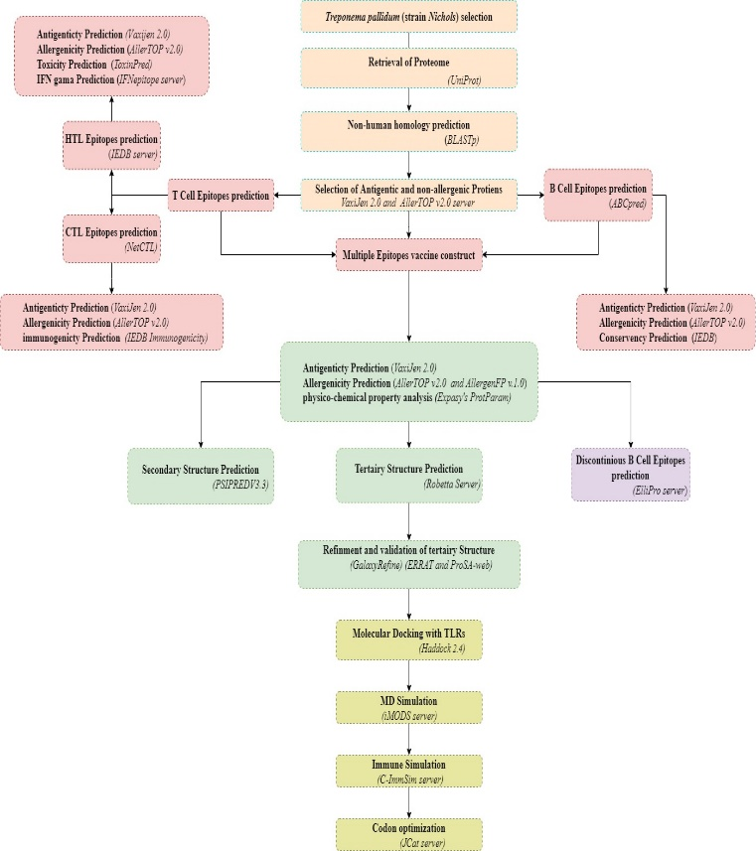
Figure: The flowchart represents the overall methodology for developing a multi-epitope subunit vaccine construct.

Recent Publications (minimum 5)
- Vilela Rodrigues, T. C., Jaiswal, A. K., de Sarom, A., de Castro Oliveira, L., Freire Oliveira, C. J., Ghosh, P., ... & de Castro Soares, S. (2019). Reverse vaccinology and subtractive genomics reveal new therapeutic targets against Mycoplasma pneumoniae: a causative agent of pneumonia. Royal Society open science, 6(7), 190907.
- Khan, M. T., Mahmud, A., Iqbal, A., Hoque, S. F., & Hasan, M. (2020). Subtractive genomics approach towards the identification of novel therapeutic targets against human Bartonella bacilliformis. Informatics in Medicine Unlocked, 20, 100385.
- Sudha, R., Katiyar, A., Katiyar, P., Singh, H., & Prasad, P. (2019). Identification of potential drug targets and vaccine candidates in Clostridium botulinum using subtractive genomics approach. Bioinformation, 15(1), 18.
- Ahmad, S., Navid, A., Akhtar, A. S., Azam, S. S., Wadood, A., & Pérez-Sánchez, H. (2019). Subtractive genomics, molecular docking and molecular dynamics simulation revealed LpxC as a potential drug target against multi-drug resistant Klebsiella pneumoniae. Interdisciplinary Sciences: Computational Life Sciences, 11(3), 508-526.5.
- Yip, C. C. Y., Ho, C. C., Chan, J. F. W., To, K. K. W., Chan, H. S. Y., Wong, S. C. Y., ... & Yuen, K. Y. (2020). Development of a novel, genome subtraction-derived, SARS-CoV-2-specific COVID-19-nsp2 real-time RT-PCR assay and its evaluation using clinical specimens. International journal of molecular sciences, 21(7), 2574.


Paste your Logo here
Biography:
Mr. Siyab Khan has completed his BS in Biotechnology at the age of 20 years from University of Swat, Pakistan. Currently, He is students in department of molecular Biology and Biochemistry, School of Life sciences, Northeast Normal University, China; Under CSC Scholarship.

Email: siyabkhan4443@gmail.com

Notes/Comments:

Presenting author details
Full name: Siyab Khan
Contact number: +8613104491697
Linked In account:
Session name/ number:
Category: (Oral presentation)

