Data-driven decarbonisation pathways for reducing life cycle GHG emissions from food waste in the hospitality & food service sectors
I Kit Cheng¹ and Kin K. Leong²
¹Department of Physics and Astronomy, University College London, London, UK
²Institute of Environmental Management and Assessment (IEMA), Lincoln, UK
Abstract
The Hospitality and Food Service (HaFS) sectors are notoriously known for their contribution to the food waste problem. Hence, there is an urgent need to devise strategies to reduce food waste in the HaFS sectors and to decarbonise their operation to help fight hunger, achieve food security, improve nutrition and mitigate climate change. This study proposes three streams to decarbonise the staff cafeteria operation in an integrated resort in Macau. These include upstream optimisation to reduce unserved food waste, midstream education to raise awareness amongst staff about the impact of food choices on the climate and health, and finally downstream recognition to reduce edible plate waste using a state-of-the-art computer vision system. Technology can be an effective medium to facilitate desired behavioural change through nudging, much like how speed cameras can cause people to slow down and help save lives. The holistic and data-driven approach taken revealed great potential for organisations or institutions that offer catering services to reduce their food waste and associated carbon footprint whilst educating individuals about the intricate link between food, climate and wellbeing.
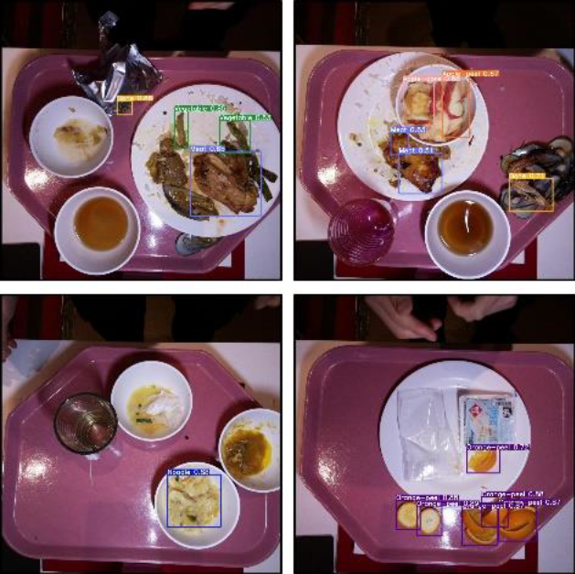

Recent Publications
- Cheng, I.K., Leong, K.K. (2022). “Data-driven decarbonisation pathways for reducing life cycle GHG emissions from food waste in the hospitality & food service sectors.” Full text available at Nature Scientific Reports.
Biography
IKC did a master’s in Physics at Imperial College London, specialising in Space Physics. He joined UCL CDT in Data Intensive Science in 2019 and worked in a 6-month placement on reducing food waste in the hospitality and food service industry with a data-driven approach. He has published 4 research articles, and presented at several conferences such as COSPAR and AGU.

