Transient and stationary transport of adsorbing pollutants in model porous media
Daniela Bauer, PhD, IFP Energies Nouvelles, France
Guillaume Batôt, PhD, IFP Energies Nouvelles, France
Zaineb Zaafouri, PhD, IFP Energies Nouvelles, France
Benoit Coasne, PhD, Liphy, CNRS, France
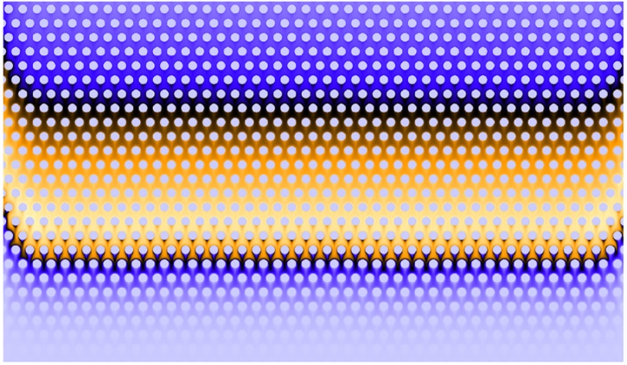

Abstract
Understanding the transport of pollutants inside different porous structures remains a complex task as pollutants can adsorb to the solid surface following specific underlying adsorption kinetics. Transport is dominated by the pollutant specific adsorption behavior coupled to the porous structure. We investigated the coupling between transport and adsorption in a two-dimensional regular porous medium by means of an extended Lattice Boltzmann approach [1-4]. We focused on the behavior of molecules following: (1) the Henry model in which the adsorbed quantity is proportional to the adsorbate concentration and (2) the Langmuir model that describes monolayer adsorption and accounts for surface saturation.
The effect of the adsorption/desorption parameters on the transport behavior in model porous media was investigated. For all adsorption conditions, we observed the three well-known transport regimes: diffusion-dominated regime (small times), transient regime (intermediate time range) and Gaussian or nearly Gaussian dispersion regime (large time range). However, there were important differences induced by the adsorption models. Particularly transient regimes, characterized by an asymmetric concentration profile, strongly depend on system parameters [5]. Concentration profiles become Gaussian (or nearly Gaussian) in the asymptotic longtime regime when the dynamical adsorption equilibrium is reached. We observed that the characteristic time to reach this equilibrium depends on the system's parameters and can be very long. In practice, such results may explain experimental observations where transport is found to be non-Gaussian even at a very large time scale. Consequently, for a better evaluation of pollutant transport in the subsoil or in water remediation processes it is crucial to consider the long-lasting transient regimes.



Asymmetric concentration profile due to adsorption in regular porous media (taken from [5])

Recent Publications
- Zaafouri Z Batôt G Nieto-Draghi C Coasne B Bauer D (2022) Impact of adsorption kinetics on pollutant dispersion in water flowing in nanopores: A Lattice Boltzmann approach to stationary and transient conditions, Advances in Water Research.
- Zaafouri Z Batôt G Nieto-Draghi C B. Rotenberg, Bauer D Coasne B (2021) Lattice Boltzmann method for adsorption under stationary and transient conditions: Interplay between transport and adsorption kinetics in porous media, Physical Review E.
- Vanson J.-M Coudert F.-X. Rotenberg B Levesque M Tardivat C Klotz M Boutin A (2015) Unexpected coupling between flow and adsorption in porous media, Soft Matter.
- Vanson J.-M Boutin A Klotz M Coudert F.-X. (2017a) Transport and adsorption under liquid flow: the role of pore geometry, Soft Matter.
- Bauer D Zaafouri Z Batôt G Coasne B (2022) From Transient to Stationary Transport in Porous Networks under Various Adsorption Conditions and Kinetics. Journal of Physical Chemistry B.



Daniela Bauer has her expertise in modelling flow and transport problems in porous media. She is particularly interested in the transport behavior of adsorbing molecules. She focuses on the different adsorption thermodynamics and kinetics and their influence on the different transport regimes. Her flow and transport simulations are performed by means of an extended Lattice-Boltzmann code accounting for adsorption.
Email: Daniela.Bauer@ifpen.fr
Full name: Daniela Bauer
Contact number: +33 1 47 52 69 73
Session name/ number:
Category: e-Poster presentation

