SPATIAL AND TEMPORAL EVALUATION OF AIR QUALITY INDEX (AQI) FROM PRE TO POST COVID-19 LOCKDOWN IN THE MEGACITY OF PAKISTAN.
Falak Naeem, M.Phil, Department of Earth and Environmental Sciences, Federal Urdu University of Arts, Science and Technology, Karachi, Pakistan.
Lubna Ghazal, PhD, Department of Geography, University of Karachi, Pakistan.

Abstract

Air pollution is the world’s leading cause of deaths around the world. According to the World Health Organization (WHO), 7 million lives are lost due to exposure to hazardous atmospheric compounds. Pakistan, a third-world country of south Asia, is found to be occupied in severe economic and environmental crisis. Population in the country is exponentially growing, resulting in unplanned urbanization, fast industrialization, increased vehicular emissions, poor infrastructures and transport system. The performed study aims to highlight the variation in hazardous atmospheric compounds due to anthropogenic activities. Whereas, it also serves the purpose of providing air pollution status of the megacity of Pakistan. The selected study area was Karachi city and the parameter under observation was Air Quality Index (AQI). Live data retrieved from Plume Labs was sorted according to time and days and then was imported into ArcGIS software for formulation of choropleth maps. Results were classified into hazard as defined by United States Environment Protection Agency (USEPA) under various seasons in 4 divisions of Karachi. During autumn 2019, unhealthy AQI (181) was recorded in October. AQI in winter 2019-2020 increased further to 214 in December. In spring 2020, AQI became hazardous to 224 in February but prominently decreased after implementation of lockdown in April to 94. During summer 2020, noticeable drop was observed to 22 in June. While in July 2020, when lockdown was partially lifted, AQI reached to 88 and then slowly stabilized. After end of lockdown in October 2020, unhealthy AQI, 175, was observed. The fluctuations in AQI values is a strong evidence that anthropogenic activities majorly contribute in the degradation of air quality. In order to reduce the hazard, it is recommended to increase green infrastructure of the city to dilute hazardous compounds. Decrease in lawlessness with increase in heavy fines would effectively stimulate sustainability.
Image
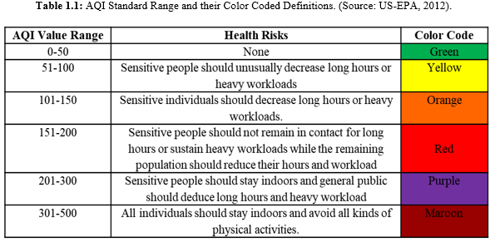
Recent Publications
- Naeem, F., & Ghazal, L. (2021) Ground Water Quality Analysis Using GIS: A Case Study Of Bari Doab, Punjab-Pakistan. Int. J. Biol. Biotech., 18 (4): 701-713.
- Naeem, F. and Ghazal, L. (2021), Assessment of Physiochemical Characteristics of Groundwater Quality in Districts of Punjab: A Geo-informatics Perspective. Pakistan Geographical Review, Vol. 76, No. 1, June 2021, PP 191-202.
- Naeem, F. and Ghazal, L. (2020), GIS based Analysis of Ground Water Quality: A Case Study of Districts of Punjab- Pakistan, Inclusive and Sustainable Development Papers, Torque Communities, 1(1): pp.16-27.
- Ghazal, L., & Kazmi, S. J. H. (2014). Monitoring and measuring surface water in semi-arid environment using satellite data: A case study of Karachi. Journal of Basic & Applied Sciences, 10, 484.
- Ghazal, L., Zubair, S., Kazmi, J. H., & Ghani, H. Assessment of transformation of urban green spaces and agriculture land in karachi: a case study of gutter bagheecha in and its surrounding areas.

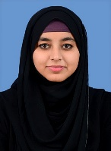 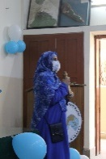Biography
Falak Naeem has her expertise in environmental monitoring and Geographic Information Science (GIS) system. Her research based on air quality evaluation through cell phone and biomonitoring technique will provide cheap and convenient means of conquering the issue of air pollution for a developing country like Pakistan. She has also presented her various research work in International Conferences and is currently providing her services as a lecturer. The research presented above will assist decision-makers, environmentalists, government officials, law-enforcing bodies and researchers in determining point source of environmental pollution to reduce loss of human lives and maintain healthy environment as per the Sustainable Development Goals (SDGs). Dr. Lubna Ghazal has been linked with research and education sector since 12 years. She has raised various environmental issues and natural hazards on different forums. She is currently an Assistant Professor and is also working on a project of sustainable organic farming.
Corresponding Author Email: falak.naeem94@gmail.com

Notes/Comments: Kindly keep us updated for the venue of the conference, so that we can apply for visa in time.

Presenting author details
Full name: Falak Naeem
Contact number: +92-335-3304964
Twitter account: N/A
Linked In account: Falak Naeem (https://www.linkedin.com/in/falak-naeem-570b77ab/)
Session name/ number: Earth Science 2023
Category: Oral presentation.

