Climate Change Impact on Water Resources Availability in the Kiltie Watershed, Lake Tana Sub-Basin, Ethiopia
Melsew A.Wubneh^{1,}
¹ Department of Hydraulic and Water Resources Engineering, University of Gondar, Gondar, Ethiopia

Abstract
The impact of climate change on water resource availability in watersheds must be assessed to ensure multipurpose water security. For RCP4.5 and RCP8.5 of the 2040s and 2070s time periods, the influence of climate change on water availability of the Kiltie watershed was assessed using an ensemble of two global climate models (MIROC and MPI) and one regional climate model (RCA4). The HBV hydrological model, which requires less data and is mostly used in data-scarce areas was used to simulate flow. RVE (relative volume error) of -1.27% and 6.93% (in the range of -10% to 10%) and NSE of 0.63 and 0.64 (higher than 0.6) are found in the model calibration and validation results, respectively. Future Seasonal Water Availability under the RCP4.5 scenario for the 2040s increase between 1.1mm and 33.2mm with the greatest increase in August and decrease in a range from 0.23mm to 6.89mm with a maximum decrease in September. While for the 2070s water availability increases between 7.2mm and 56.9 mm with maximum increments in October and decreases in July by 9mm. For RCP8.5 of 2040s future water availability increases between 4.1mm and 38.8 mm with maximum increment in August and decreases between 9.8mm and 31.2 mm with maximum decrements in the spring seasons. For the 2070s of RCP8.5 water, availability increases in a range from 2.7mm to 42.4 mm with maximum increments in August and shows decrements in a range from 1.8 mm to 80.3 mm with showing maximum decrements in June. This research found that future climate change will increase water availability during the rainy season, indicating the need for water storage structures to use excess water for dry agriculture. As future water availability reduces during the dry seasons, a water resource and land use land cover management plan for the watershed should be developed soon.

Image
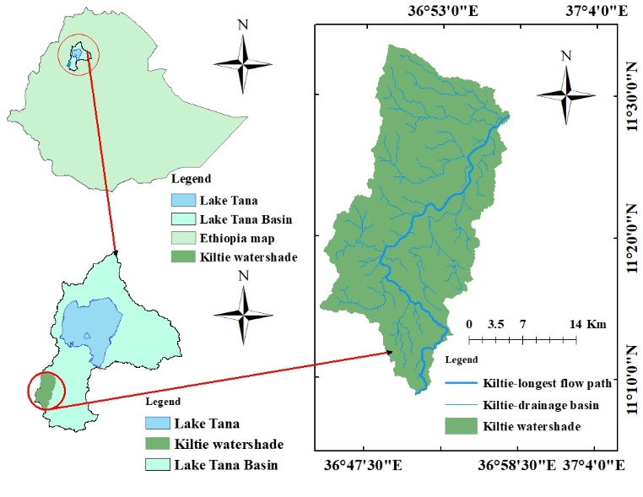
Figure1: Description of the study area

Recent Publications (minimum 5)
- Melsew A.Wubneh (2022), Climate Change Impact On Lake Tana Water Storage, Upper Blue Nile Basin, Ethiopia, Geo carto international journal, DOI: 10.21203/rs.3.rs-927576/v1
2. Melsew A.Wubneh Hydrological impacts of climate change in gauged sub-watersheds of Lake Tana sub-basin (Gilgel Abay, Gumara, Megech, and Ribb) watersheds, Upper Blue Nile Basin, Ethiopia, Journal of sustainable resources management, DOI: 10.1007/s40899-022-00665-6
3. Melsew A.Wubneh (2022) Assessment of surface irrigation potential and crop water requirement: the case of Megech watershed, Upper Blue Nile Basin, Ethiopia, Journal of sustainable water resources management, DOI: 10.1007/s40899-022-00690-5
4. Melsew A.Wubneh (2022) Identification of erosion hot spot area using GIS and gully contribution for reservoir sedimentation in the case of Abrajit reservoir, Upper Blue Nile Basin, Ethiopia, Journal of sustainable water resources management, DOI: 10.1007/s40899-022-00680-7

5. Melsew A.Wubneh (2022) Hydrological impact of climate change in selected ungauged watersheds of Lake Tana sub-basin, Ethiopia; A regionalization approach
6. Melsew A. Wubneh (2022) Evaluation of Rainfall-Runoff and Suspended Sediment Concentration in the Semi-Arid Ethiopian Highlands, Weshikayina and Megachoch Watershed, Ethiopia

.

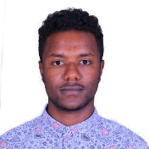

Biography
I am melsew Amsalu wubneh, I was born on August 18, 1992 at Gondar, Ethiopia. I attended my primary and secondary school in Gondar. And after finishing secondary school I joined Wollo University and graduated in 2015 with Water resource and Irrigation Engineering Department. I graduated with my MSc degree in Hydraulic and water resource engineering at Bahir Dar University in 2020. Currently, I am working as a lecturer and researcher at the University of Gondar department of Hydraulic and water resource engineering. My task at the university focus on teaching, doing research, and community service. Now I have published around six papers in well peer-reviewed journals. My interest is to be international researcher in the area of earth and climate change.
Email: melsew393@gmail.com

Notes/Comments:

Presenting author details
Full name: Melsew Amsalu Wubneh
Contact number: +251918291465
Twitter account:
Linked In account: Melsew Amsalu Wubneh
Session name/ number:
Category: (Oral presentation/ Poster presentation): oral prsenation

