DEMONSTRATING THE SAFETY PROFILE OF KETAMINE AS CONSCIOUS SEDATION IN CHILDREN; A PROSPECTIVE LONGITUDINAL REVIEW OF 985
Zahra Ahmed, University College London
Shiban Ahmed, FRCS, Children’s Surgical Consortium

Aim of the study: Conscious sedation has both a sedative and an analgesic effect. Ketamine is an increasingly popular choice for procedural conscious sedation in a paediatric day surgery. Ketamine is also cheaper than general anaesthetic. The objective of our study is to investigate the number of adverse events when using ketamine for conscious sedation and demonstrate its safety profile for use in paediatric day surgery.
Methods: A single-centre, single surgeon, single procedure 5-year longitudinal prospective review of 985 children (mainly infants) undergoing elective day care surgery using ketamine for conscious sedation between 2016-2020. We age-stratified our cohort and assessed patients’ pre-anaesthetic co-morbidities based on the American Society of Anesthesiologists (ASA) classification system.

Main Results: 91.2% patients were between 4 weeks-1 year and 98.4% were ASA Class 1. Most children received ketamine intramuscularly and only 3 children required additional ketamine to maintain conscious sedation. There were no serious adverse events and there were 38 mild adverse events in 36 patients (3.65% patients, Table 1). The most common adverse event occurring in 14 children was hypersalivation.

Conclusions: Ketamine is a safe drug to use for conscious sedation and should be considered more for children undergoing elective day-care surgery however it is imperative that staff conducting procedures must have advanced training and experience in paediatric and neonatal airway management and resuscitation.

Image
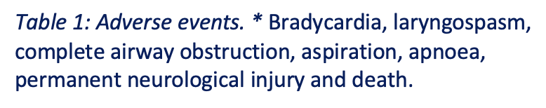

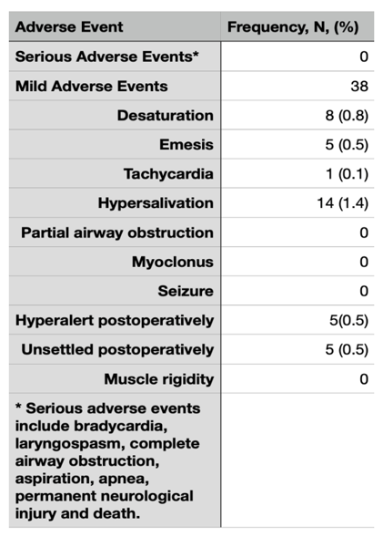

Biography
Zahra Ahmed is a University College London medical student with an interest in pediatric surgery. Having worked at the Children’s Surgical Consortium she actively reached out to the surgeon Mr. Shiban Ahmed, consultant paediatric surgeon and urologist to do research into the safety of ketamine as conscious sedation in paediatric elective daycare surgery. Zahra has won awards at medical school including the Wolfson Intercalated award, awarded by the Royal College of Physicians, England to highly achieving medical students who are likely to pursue a career in research or academic medicine.
Email: zahra.ahmed.20@ucl.ac.uk

Presenting author details
Full name: Zahra Ahmed
Contact number: 07463677561
Linked In account: Zahra Ahmed
Category: Oral presentation

