RISK AND RESILIENCE: WELLNESS AMONG FIRST NATIONS IN CANADA

Paul J^{1*}, McQuaid R,² and Bombay A³
¹Department of Psychology, Faculty of Science, Dalhousie University, Canada
²Department of Neuroscience, Faculty of Science, Carleton University, Canada
³Department of Psychiatry, Faculty of Medicine, Dalhousie University, Canada

*jc425178@dal.ca (*Corresponding author’s email)

ABSTRACT
Current health inequities amongst Indigenous peoples are frequently attributed to various historical and ongoing effects of colonization. While some evidence suggests that certain aspects of Indigenous cultural identity buffer against poor health outcomes that are worsened through experiencing social stress, inconsistent evidence and minimal research have explored these links among First Nations peoples living on-reserve or in northern communities in Canada. Secondary analyses of the First Nations Regional Health Survey (FNRHS) 2015/16 among First Nations youth and adults were performed. Secondary analyses of the youth RHS sample (aged 12-17 years old) revealed that experiences of bullying and incidents of cyber-bullying were linked to increased psychological distress (i.e., stronger feelings of anxiety and depression). Conversely, community belonging was associated with reduced psychological distress. Strong sense of community belonging buffered against increased psychological distress among those reporting experiences of bullying and cyber-bullying. Secondary analyses of the adult RHS sample (aged 18+ years old) revealed that experiencing physical aggression, verbal aggression, and cyberbullying were linked to increased psychological distress. Strong feelings of community belonging were linked with reduced psychological distress and buffered against higher psychological distress levels among bullied people. Participation in community events was not directly associated with psychological distress but with reduced psychological distress among those who reported experiencing physical and verbal aggression. Results highlighted the influence of social stressors in the lives of First Nations peoples and the potential protective effects of particular aspects of cultural identity within First Nations communities. Hopefully, this project will inform the need for more culturally based health and social policies and programming for psychosocial interventions for First Nations communities.

Keywords: social support; determinants of health, community health
Themes: social determinants of health, health equity, community health

Biography
Jocelyn Paul

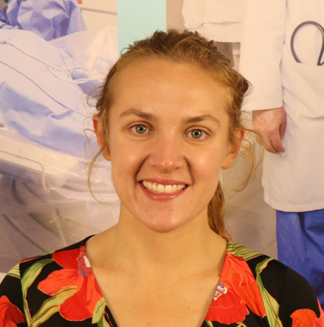
Ph.D. in Clinical Psychology Resident
Department of Psychology
Dalhousie University
Canada

Bio: (Only 50 words)
Jocelyn Marie Paul is in the second year of her Ph.D. in Clinical Psychology at Dalhousie University in Nova Scotia, Canada. Jocelyn is a Mi'kmaq (Membertou First Nation) woman whose research focuses on First Nations mental health and reducing inequities about culturally safe mental health interventions and service delivery.
Contact Information:
Jocelyn Paul
Tel: +19024021375
Email: jc425178@dal.ca

