Emerging Connection of the Mental Health and Well-being Axis with Digital Technology: A Quantitative and Qualitative Study.

Arianna Alejandra Andino, BS, University of Illinois at Urbana-Champaign, Champaign, IL, USA
Jeanne Joehler, PhD, State Farm Insurance and Financial Services, Champaign, IL, USA
Moin Rahman, State Farm Insurance and Financial Services, Champaign, IL, USA

Abstract

Background

The COVID-19 pandemic exacerbated mental health concerns and highlighted the potential for digital platforms and services to provide support beyond the clinical setting. Given patients may have financial hardships, limited workforce capacity, and/or lack of access to care, there is a tremendous gap in mental health care in the United States. Expanding access through telehealth and leveraging technology have the potential in addressing this gap.

Objective

The aim of this study is to investigate the role and landscape of digital technologies in mental health management and treatment using a mixed-methods approach involving both qualitative and quantitative research.

Methods

Through a four-stage research process, the authors analyzed several factors, including the experience of young adults (1100 participants) with digital mental health tools, preferences and perceived value in tools and services, reasons for abandonment, and increased interest in using telehealth services.

Results

The findings suggest young adults who engage in digital mental health tools view these tools as an effective way to decrease obstacles of traditional mental health services and strengthened engagement in the long-term use of the mental health strategies.

Conclusions

Consequently, this study highlights the growing presence of digital mental-health technologies that include tools, features, and resources as well as the perceived as benefits, value, and usefulness. The findings have implications for building awareness within the behavioural younger generation’s use and beliefs around these tools. Finally, this paper encourages deeper development of multipurpose, evidence-based research, and determines the value and efficacy of mental health digital platforms.

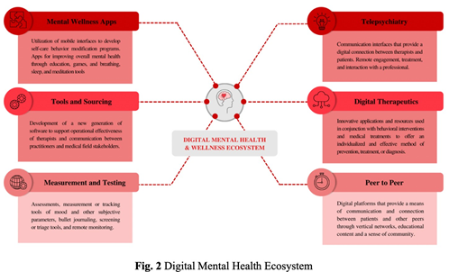

Recent Publications

1. Sturm, Emily & Mellinger, John & Koehler, Jeanne & Wall, Jarrod. (2019). An Appreciative Inquiry Approach to the Core Competencies: Taking it From Theory to Practice. Journal of Surgical Education. 77. 10.1016/j.jsurg.2019.11.002.
2. Koehler, Jeanne & Sturm, Emily. (2018). The Surgical Workplace Learning Environment: Integrating Coaching and Mentoring. 10.1007/978-3-319-64728-9_14.
3. Istas, Kathryn & Paolo, Anthony & Berardo, Benito & Bonaminio, Giulia & Fontes, Joseph & Walling, Anne & Davis, Nancy & Cianciolo, Anna & Englander, Robert & Koehler, Jeanne & Lomis, Kimberly. (2016). On the Origins of Perceptions: Student Perceptions of Active Learning and Their Implications for Educational Reform. Teaching and Learning in Medicine. 28. 362- 366. 10.1080/10401334.2016.1217224.
4. Sturm, Emily & Mellinger, John & Koehler, Jeanne & Wall, Jarrod. (2017). An Appreciative Inquiry Approach to the Core Competencies: Taking It from Theory to Practice. Journal of the American College of Surgeons. 225. S170-S171. 10.1016/j.jamcollsurg.2017.07.386.
5. Irwin, Edwin & Guest, Robert & Rahman, Moin. (2016). Risk for First Responders Due to Cognitive Workload and Communication Loss. 10.1007/978-3-319-41929-9_28.

Biography

As an Enterprise Research analyst, Arianna Andino has expertise in the research process and data analysis of several different areas, particularly in the tele-mental health axis. With a mixed-method approach, she has a passion for the examination of the function and landscape of digital technology in mental health management and treatment. Based on an extensive literature review, she has built a digital mental health and well- being ecosystem that serves as a framework to understand the emerging connection between mental health and digital platforms and services.

Presenting author details
Full name: Arianna Andino
Contact number: +593 98 771 9317
Email: aandinop@hotmail.com
Linked In account: https://www.linkedin.com/in/arianna-alejandra-andino
Session name/ number: Mental Health - Emerging Connection of the Mental Health and Well-being Axis with Digital Technology Category: Oral presentation

