Dietary patterns and risk of breast cancer: case control study in the west of Iran
Behjat Marzbani, senior expert in education and health promotion, provincial health center, Kermanshah, Iran.

Abstract
The aim of this Breast cancer is the leading cause of cancer related deaths among women all over the world. Unhealthy dietary patterns are the most important changeable risk factors in its incidence. The aim of this study is to assess the relationship between diet patterns and the risk of breast cancer among women in the west of Iran. All under 50 women with positive pathology of breast cancer between 2013-2015 who were referred to the radiation therapy, oncology and chemotherapy clinics of referral center of cancer diagnosis in the west of Iran (Imam Reza hospital) were selected as the cases 212 persons and 408 under 50 women referred to other outpatient clinics of the same hospital who were without breast or other cancers at the time of study and two years later were selected as the control group. The data were collected using periodical care form of Iran Health.The most powerful risk factor for breast cancer was fried foods, so that the odds ratio of breast cancer in women consuming fried foods more than once a month was higher than women who have consumed it once or lower in a month. There was a non-linear relationship between breast cancer and food consumption. Consumption and non-consumption of fast foods, junk foods and carbonate beverages increase the odds of breast cancer. Dose-response model indicated that increasing vegetables and fruits consumption to 60 times a month decrease the odds of breast cancer, but more than 60 times a month can increase breast cancer. Inadequate consumption of vegetables and soft drinks, industrial juices, fried foods and sweetmeat are as the risk factors for breast cancer, so sensitization, informing and education about healthy diets seem necessary.
Image
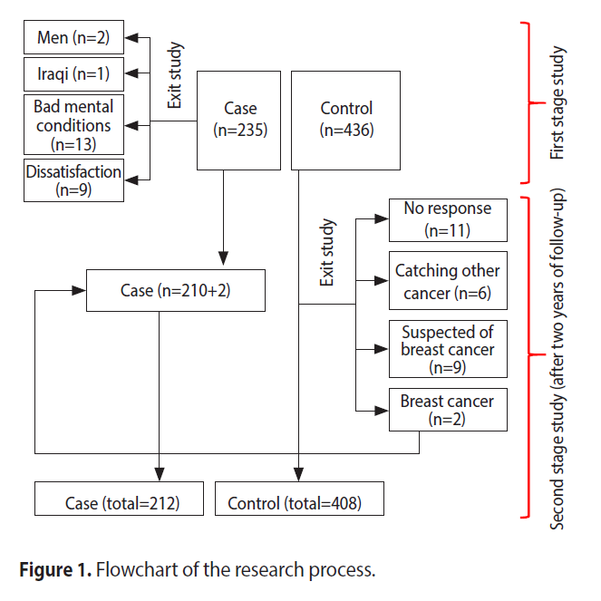
Recent Publications (minimum 5)
- Dong JY, Zhang L, He K, Qin LQ. Dairy consumption and risk of breast cancer: a meta-analysis of prospective cohort studies. Breast Cancer Res Treat 2011;127:23-31.
- Plagens-Rotman K, Piskorz-Szymendera M, Chmaj-Wierzychowska K, Pieta B. Breast cancer - analysis of the selected risk factors. Eur J Gynaecol Oncol 2017;38:425-430.
- Alim NE, Kiziltan G. Assessment of risk factors of obesity and diet on breast cancer in Ankara, Turkey. Pak J Med Sci 2016;32:1537-1542.
- Kojima R, Okada E, Ukawa S, Mori M, Wakai K, Date C, et al. Dietary patterns and breast cancer risk in a prospective Japanese study. Breast Cancer 2017;24152-160.
- Goodwin PJ, Stambolic V. Impact of the obesity epidemic on cancer. Annu Rev Med 2015;66:281-296.

 Biography


I am a member of the Research Council of Kermanshah Behavioral Diseases Research Center. - I have 4 ISI articles, 8 completed research projects and 21 accepted articles in conferences. I have taught at Kermanshah Azad University and collaborated in the training and education of Kermanshah public health students. - During my service, the responsibilities I held include: health care provider, family health unit manager, marriage counseling unit consultant, thalassemia expert, elderly program expert, health education and health promotion department expert of Kermanshah province health center. My main research interests are: - Conducting research on the role of companion health applications in the field of preventive care - Conducting research in the field of health promotion approaches to empower people and communities.
Email: marzbanibehjat@gmail.com

Presenting author details
Full name: Behjat Marzbani
Contact number: 09183575503
Twitter account: -
Linked In account: -
Session name/ number: -
Category: Poster presentation

