The Cultures Tangle with Cosmetic Dentistry from Historical Perspectives: for Eating, for Beauty or for Something Else
Show-Yu, Lin, Professor, Department of Religious Cultures and Information Management, Aletheia University, Taiwan (ROC)

Abstract
Today, humans’ teeth are not only related to biological functions, such as eating or chewing but are also tangled with the issues of societal functions such as beauty culture. In this study, we will show how teeth have been represented in popular culture from historical perspectives. Literature reviews and document analysis will be applied in this study. We found that in modern societies, people’s obsession with bright white teeth and neat teeth may be to shape a beautiful face or to express self-confidence. However, throughout human history, black teeth were marked as beautiful rather than ugly, not commoners but royalty were allowed, and dyeing teeth black was a rite of passage for growing up, getting married, and even as a method of preventing tooth decay or maintaining oral hygiene, and so forth. Besides, in traditional culture, extracting part or all of teeth is a mature ritual for men and customs of some tribes in order to communicate with others or save their lives, to show their healthy bodies, their wealth, and so on. This cultural evolution has changed the views that human teeth seem to have shift from biological functions, to a combination of biological and societal functions, and then to a culture that is entangled in more societal than biological functions. We therefore argue that from tradition to the present, people have shifted from a focus on biological functions to a culture that emphasize societal functions through some sort of bodily modification. This shift may be due to changing cultural perceptions, combined with medical interventions in cosmetic dental techniques, such as wearing braces, resulting in a culture of straight white teeth that has spread across the globe. Additionally, this shift enhanced popular cultures by incorporating derived meanings, such as beautiful smiles, good interpersonal relationships, and wonderful lives.
Key words: cosmetic dentistry, biological functions, societal functions, historical perspectives, beauty cultures
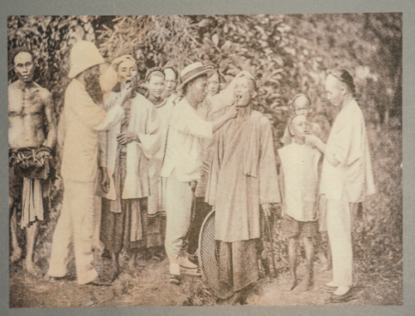 | 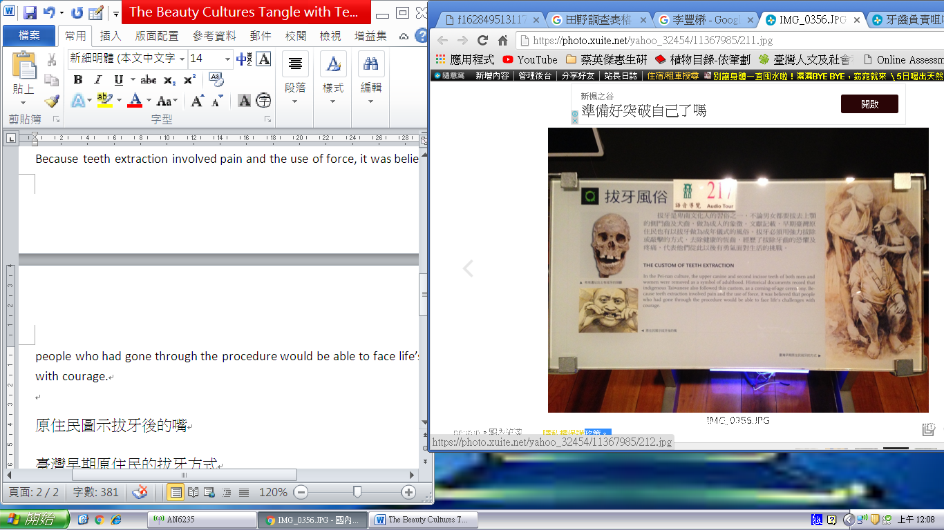
Fig. 1 The Traditional Methods of Teeth Extraction

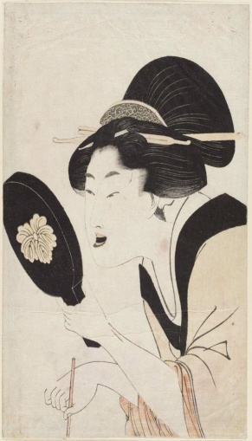  婦人相学拾躰 かねつけ 喜多川歌麿。 | 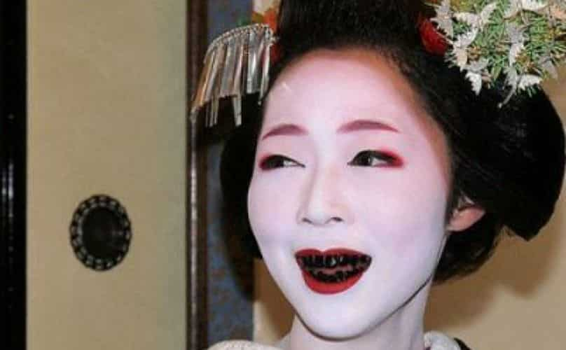 | 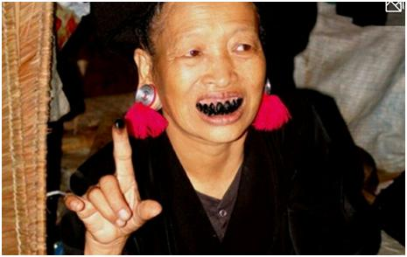
Fig 2 A Custom of Dyeing Teeth Black Color of Beauty Cultures
https://www.taisounds.com/Global/Top-News/China/uid4357955996
https://kknews.cc/health/an5m86.html

Recent Publications (minimum 5)
- Hsien, M.J., Lin, C.Y., Li, S. Y., and Lin, S.Y. (2020). Students’ conceptions of health: A cross educational stage survey. Heliyon, 6(11) (2020), e05383.
- Lin, S.Y., Lin, C.Y., and Hisen, M.J. (2019). Visual thinking on hierarchical illustrations of the structure of chromosome. Journal of Biological Education. 53(1), 79-91.
- Show-Yu Lin (2018). College Students’ Understanding of Chemical Compounds, Sources of Information and Risk Perceptions Regarding Environmental Sustainability Issues. International Journal of Learning and Teaching, 4(4), 326-329.
- Lin, S.Y., Lin, C.Y., and Hsien, M.J. (2018). Comparison of social and culture based risk perception of personal hygiene behaviours. Heliyon, 4 (2018), e00839.
- Lin, S.Y., Wu, M.T., Cho, Y.I., and Chen, H.H. (2015). The Effectiveness of a Popular Science Promotion Program on Nanotechnology for Elementary School Students in I-Lan City. Research in Science and Technological Education, 33(1), 22-37.

 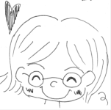 Biography (150 word limit)
Paste your Logo here
SY, Lin is a professor of departments of religious cultures and informative management at Aletheia University, Taiwan (ROC). Her work focuses specifically on health conceptions across educational stages, social and culture based risk perception of personal hygiene behaviors, visual thinking on illustrations, risk perceptions regarding environmental issues as well as popular science promotion program on nanotechnology. Her recent interests are becoming to focus on social science issues relevant to cosmetics dentistry. Email: au4329@mail.au.edu.tw

Notes/Comments:
Presenting author details
Full name: SHOWYU, LIN
Contact number:+886-915994932
Twitter account: NO
Linked In account: NO
Session name/ number: Cosmetic Dentistry
Category: (Oral presentation/ Poster presentation) Oral presentation

