Is there relationship between Toxoplasma gondii IgG seropositivity and idiopathic Parkinsonism and does it have correlation with cortisol blood level ?

Ahmed Abd El Rahman Daoud

1-Medical Parasitology Department, Faculty of medicine, Tanta University
2-Neuropsychatry Department, Faculty of medicine, Tanta University.

Key Words: Toxoplasma gondii, Toxoplasmosis, Parkinson's disease, Cortisol.

Abstract:
Background: some researches linked between latent Toxoplasmosis and neurological diseases, now the main interest is the propable relation between toxoplasmosis and neurological diseasesas epilepsy and Parkinsonism.
Aim: To detect the incidence of Toxoplasma gondii infection in patients idiopathic Parkinsonism and correlate it to their blood level of cortisol.
Materials and Methods: This study was conducted on 30 idiopathic Parkinson's Patients, 30 psychiatric Patients, 30 apparently healthy individuals. All subjects were submitted to a questionnaire, detection of ant-Toxoplasma IgM, anti-Toxoplasma IgG and cortisol level by ELISA.
Results: of the 90 cases; 41.11% and 1.11% were positive for ant-Toxoplasma IgM and IgG, respectively. The percentage of positive anti-Toxoplasma IgG cases was in healthy group (46.67%.) followed by Parkinsonism group (43.3%). Mean cortisol level higher in Pakinson's group than other groups but still within normal levels. Contact to cats, drinking unfiltered water and consuming unwashed raw vegetables were significantly higher in Toxoplsma IgG seropositive Parkinson's patients. Highest anti-Toxoplasma IgG positive casaes in Parkinson's group were detected in stage 3 of the disease .
Conclusion: A high Toxoplasma seropositivity in association with Parkinsonim. Toxoplasma gondii oocyst may be was the most propable main mode of transmission of Toxoplasma gondii in idiopathic Parkinson's patients. Toxoplasma gondii may worsen idiopathic Parkinsonism. Cortisol level was higher in Parkinson's patients, still it showed no significant relationship with Toxoplasma gondii seropositivity.

Biography:
prof . Ahmed Abdelrahman Daoud has completed his Ph.D. in Medical parasitology at the faculty of medicine Tanta University 1980.
And another Ph.D. in Microbiology And Immunology in 1992 at Cairo Military Medical Academy .

Presenting author details

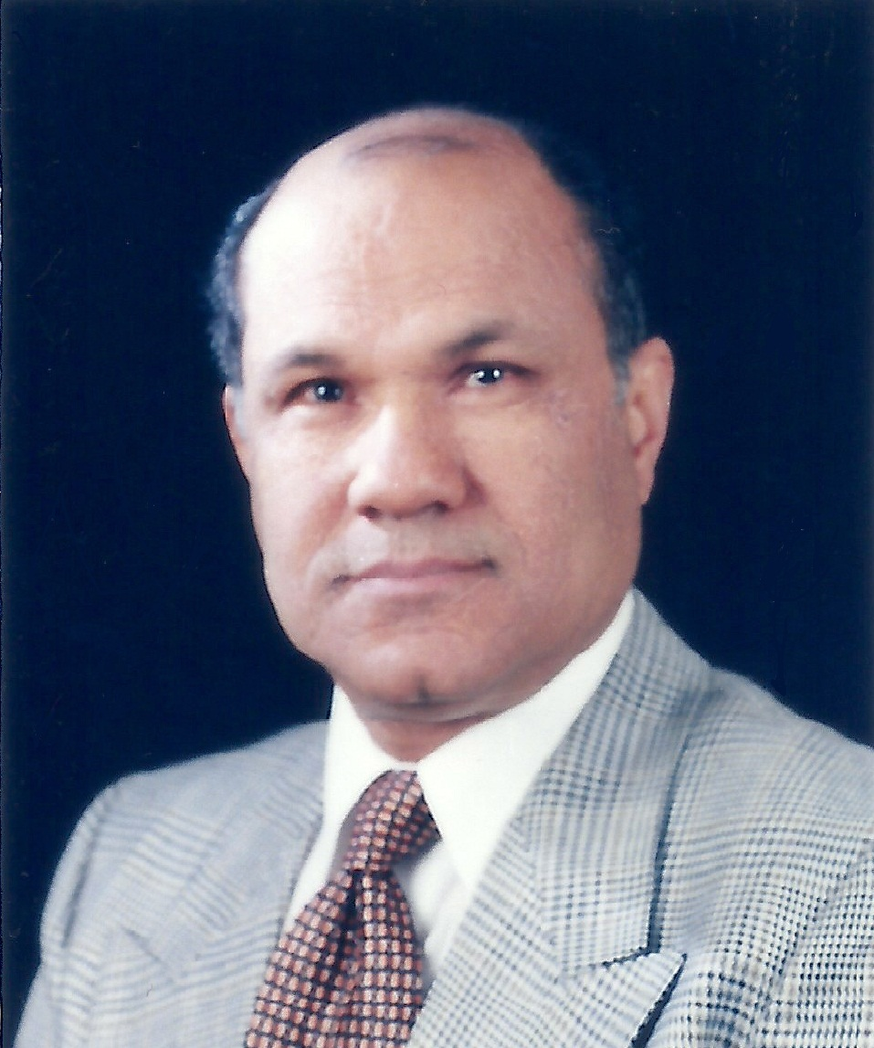
Full Name: Ahmed Abdelrahman Daoud .
Contact number:+201114141493
Category: Poster presentation
Passport Number:05232M1308301

