Enhancing the neuroprotection potential of edaravone in transient global ischemia treatment with glutathione (GSH) conjugated Poly (methacrylic acid) nanogel as a promising carrier for brain drug delivery
Soroush Bijani, Pharm.D, Zanjan Applied Pharmacology Research Center, Zanjan, Iran
Mir-Jamal Hosseini, PhD, Department of Pharmacology and Toxicology, Zanjan University of Medical Sciences, Zanjan, Iran

Abstract (300 word limit)
Statement of the Problem: Ischemic stroke is the most common among various stroke types and the second leading cause of death worldwide. It suggested that oxidative stress is the main mechanisms associated with ischemic stroke pathophysiology. Edaravone (EDV) is one of the cardinal antioxidants that is capable of scavenging oxygen species free radicals specially hydroxyl molecule. Low water solubility, stability and bioavailability in aqueous medium are major EDV drawbacks. Decorating nanogel surface with glutathione to target brain tissue was performed to optimize drug delivery.
Methodology & Theoretical Orientation: Nano vehicle characterization was assessed with FT-IR and HNMR. Images from the surface of nano vehicle was captured by AFM and TEM instruments. After development of mPEG-b-PLGA EDV nano particles their effect on biochemical factors including malondialdehyde, protein carbonyl level was measured on Wistar rats under global ischemia. In addition, the amount of reduced Glutathione and total cellular antioxidant were also measured.
Findings: The Size (199 nm, hydrodynamic diameter) and zeta potential (-25 mV) of optimum formulation was assessed and the calibration curve in deionized water was created at 244 nm. Encapsulation Efficiency and drug loading were determined to be 37.45 % and 99.88% respectively. In vitro drug release profile depicted a sustained release process. EDV and glutathione presence in one vehicle simultaneously, made the possibility of antioxidant and anti-apoptotic application to the brain in specific doses which resulted in elevated spatial memory and learning along with cognitive function in Wistar rats. In addition, significantly lower MDA and PCO as the byproducts of ROS, and higher level of neural GSH and total antioxidant level were observed.
Conclusion & Significance: The developed mPEG-b-PLGA EDV nanogel can be a suited vehicle for brain drug delivery of EDV to the brain, while managing to minimize the biochemical and pathophysiological alterations in ischemic-like disorder.

Image
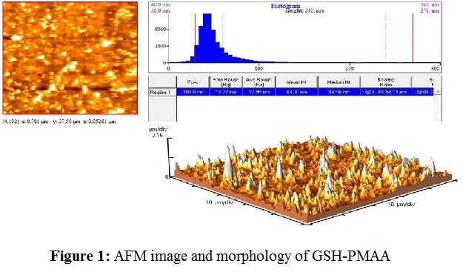
Recent Publications (minimum 5)
- Ahmari, M., Sharafi, A., Mahmoudi, J., Jafari-Anarkoli, I., Gharbavi, M., Hosseini, M.-J., 2020. Selegiline (l-Deprenyl) Mitigated Oxidative Stress, Cognitive Abnormalities, and Histopathological Change in Rats: Alternative Therapy in Transient Global Ischemia. Journal of Molecular Neuroscience 70, 1639-1648.
- Andalib, S., Mashhadi-Mousapour, M., Bijani, S., Hosseini, M.-J., 2019. Coenzyme Q10 alleviated behavioral dysfunction and bioenergetic function in an animal model of depression. Neurochemical research 44, 1182-1191.
- Avşar, A., Gökbulut, Y., Ay, B., Serin, S., 2017. A novel catalyst system for the synthesis of N, N′-Methylenebisacrylamide from acrylamide. Designed monomers and polymers 20, 434-440.
- Baba, A., Kawakami, Y., Saito, K., Murashima, Y.L., Itoh, Y., 2016. Effects of edaravone on hippocampal antioxidants in EL mice. Journal of Nippon Medical School 83, 100-106.
- Bartolo, M., Zucchella, C., Capone, A., Sandrini, G., Pierelli, F., 2015. An explorative study regarding the effect of l-deprenyl on cognitive and functional recovery in patients after stroke. Journal of the neurological sciences 349, 117-123.
- Bijani, S., Dizaji, R., Sharafi, A., Hosseini, M.-J., 2022. Neuroprotective effect of apigenin on depressive-like behavior: mechanistic approach. Neurochemical Research 47, 644-655.
- Feng, S., Yang, Q., Liu, M., Li, W., Yuan, W., Zhang, S., Wu, B., Li, J., 2011. Edaravone for acute ischaemic stroke. Cochrane Database of Systematic Reviews.
- Hosseini, M.-J., Mahmoodi, N., Eskandari, J., Bijani, S., Yazdinezhad, A.R., Anoush, M., 2022. Protective effects of Vinca herbaceous extract against scopolamine-induced behavioral disturbances and brain oxidative stress in rats. Heliyon 8, e09295.
- Jafari, B., Gharbavi, M., Baghdadchi, Y., Manjili, H.K., Mahmoudi, J., Jafari-Anarkoli, I., Amiri, S., Hosseini, M.-J., 2022. Mitigated Oxidative Stress and Cognitive Impairments in Transient Global Ischemia using Niosomal Selegiline-NBP delivery. Behavioural Neurology 2022.
- Kikuchi, K., Kawahara, K.-i., Tancharoen, S., Matsuda, F., Morimoto, Y., Ito, T., Biswas, K.K., Takenouchi, K., Miura, N., Oyama, Y., 2009. The free radical scavenger edaravone rescues rats from cerebral infarction by attenuating the release of high-mobility group box-1 in neuronal cells. Journal of Pharmacology and Experimental Therapeutics 329, 865-874.
- Lee, X.-R., Xiang, G.-L., 2018. Effects of edaravone, the free radical scavenger, on outcomes in acute cerebral infarction patients treated with ultra-early thrombolysis of recombinant tissue plasminogen activator. Clinical Neurology and Neurosurgery 167, 157-161.
- Mozafari, H., Amiri, S., Mehr, S.E., Momeny, M., Amini-Khoei, H., Bijani, S., Hosseini, M.-J., 2020. Minocycline attenuates depressive-like behaviors in mice treated with the low dose of intracerebroventricular streptozotocin; the role of mitochondrial function and neuroinflammation. Molecular Biology Reports 47, 6143-6153.
- Ohta, M., Higashi, Y., Yawata, T., Kitahara, M., Nobumoto, A., Ishida, E., Tsuda, M., Fujimoto, Y., Shimizu, K., 2013. Attenuation of axonal injury and oxidative stress by edaravone protects against cognitive impairments after traumatic brain injury. Brain research 1490, 184-192.
- 14. Sharifyrad, M., Gohari, S., Fathi, M., Danafar, H., Hosseini, M.-J., Mostafavi, H., Manjili, H.K., 2022. The efficacy and neuroprotective effects of edaravone-loaded mPEG-b-PLGA polymeric nanoparticles on human neuroblastoma SH-SY5Y cell line as in vitro model of ischemia. Journal of Drug Delivery Science and Technology, 103378.
- 15. Watanabe, K., Tanaka, M., Yuki, S., Hirai, M., Yamamoto, Y., 2018. How is edaravone effective against acute ischemic stroke and amyotrophic lateral sclerosis? Journal of clinical biochemistry and nutrition, 17-62.
- Zhang, M., Teng, C.H., Wu, F.F., Ge, L.Y., Xiao, J., Zhang, H.Y., Chen, D.Q., 2019. Edaravone attenuates traumatic brain injury through anti‑inflammatory and anti‑oxidative modulation. Experimental and Therapeutic Medicine 18, 467-474.Harper C (2009) The neuropathology of alcohol-related braindamage. Alcohol Alcohol 44:136-140.

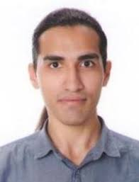Biography (150 word limit)
Paste your Logo here
Soroush Bijani has completed his Pharm.D at the age of 24 years from Zanjan University of Medical Sciences. Aside of serving as a community pharmacist, he is a teacher assistant and a member of Zanjan Applied Pharmacology Research Center. He has published more than 12 papers in reputed journals and has been serving as a reviewer of journals in the field of neurosciences.
Email: soroush.bijani@gmail.com

Notes/Comments:

Presenting author details
Full name: Soroush Bijani
Contact number: +989100488867
Twitter account:
Linked In account: https://www.linkedin.com/in/soroush-bijani-175486202/?originalSubdomain=ir
Session name/ number:
Category: (Oral presentation/ Poster presentation) Poster presentation

