Immunlogical and Epidemiological Insights into Covid-19 Vaccination
Darko Richter, MD, PhD, Zagreb, Croatia

Abstract (300 word limit)
Statement of the Problem: The initial COVID-19 vaccination campaign did not meet expectations due to errors in the roll-out strategy that did not take into account the incubation, index of reproduction, and duration of humoral immunity. Purpose: to point out the factors that were neglected in creating the COVID-19 vaccination strategy. Methodology: critical observation of what has been done in comparison to what should have been taken into consideration from the outset. Observations: It has been known for at least 50 years that humoral immunity following a 2-dose primary immunization last 4-6 months. Thereafter, short-incubation diseases (<8-9 days) need periodic boosting to maintain a steady protective antibody titer. In long-incubation infections, there is enough time to mount an anamnestic response to avert clinical disease, and boosters are not indispensable. Unless the herd immunity of 45% population had been attained during the B1 strain (reproduction index 1.8) predominance in Europe, no interruption of pandemic spread could have been hoped for. Instead, the pandemic spread on, “breakthrough” infections were infections that appeared after the waned specific antibody titers, and new variants allowed to boom with immune evasion and increasing reproduction index and transmissibility. Moreover, it was not appreciated that more generous spacing between the doses increased immunogenicity and that a single vaccine dose at the appropriate (3-6 months) post-recovery interval induced powerful hybrid immunity. Indeed, as of mid-2022, mRNA vaccines have been offered as a series of 3 doses at intervals of up to 8 weeks for the primary series, and at least 5 and 4 months for doses 3 and 4, respectively. Conclusion and significance: COVID-19 pandemic could have been controlled in the initial phases of the vaccination campaign if a faster roll-out or a 3-dose schedule had been adopted from the outset.

Image
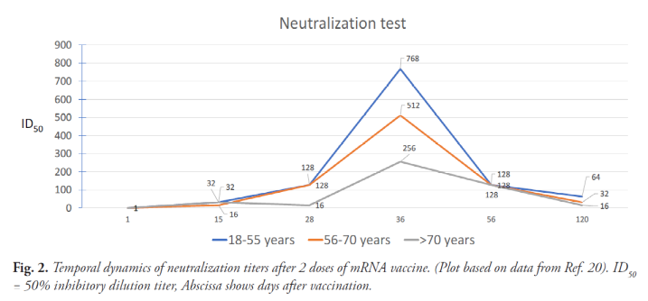

Recent Publications (minimum 5)
- Richter D (2021) Ethical Aspects of Immunization. In: Duncan LT ed Advances in Health and Disease. New York: Nova Science Publishers, 2021. Pp 53-104.
- Richter D (2022) Pitfalls in Understanding and Handling of COVID-19 Vaccination (“Any Fool Can Know. The Point Is to Understand”). Central Eur J Paed 2022;18(2):128-141.
- Widge AT, Rouphael NG, Jackson LA, Anderson EJ, Roberts PC, Makhene M, et al. (2021) Durability of Responses after SARS-CoV-2 mRNA-1273 Vaccination. N Engl J Med 2021;384:80-2.
- Regev-Yochay G, Gonen T, Gilboa M, Mandelboim M, Indenbaum V, Amit S, et al. (2022) Efficacy of a Fourth Dose of Covid-19 mRNA Vaccine against Omicron. N Engl J Med 386(14):1377-80.
5. Crotty S. Hybrid immunity. COVID-19 vaccine responses provide insights into how the immune system perceives threats. Science 2021;372(6549):1392-3.

Biography (150 word limit)
Paste your Logo here

Darko Richter is paediatrician, subspecialist in allergy and clinical immunology. He studied and worked in Zagreb, Croatia. Retired from the University Hospital Center Zagreb in 2020. Active in DermaPlus Polyclinic since. D – Medical School Zagreb 1979. The main field of interest: paediatric allergy, immunodeficiency and vaccines. Authored and co-authored more than 120 articles in medical journals, and 26 chapters in 13 medical textbooks in Croatian and English. Invited lecturer on more than 150 occasions of professional, academic, and sponsored lectures. Scopus H-index 15. President, Croatian Pediatric Society – Zagreb (2009 - 2013). Founder and President, Section on Pediatric Allergy and Clinical Immunology, Croatian Paediatric Society (2010 - 2020).
Email: darkorichter@gmail.com

Notes/Comments:

Presenting author details
Full name: Darko Richter
Contact number: 00385 91 507 6396
Mail id: darkorichter@gmail.com
Category: invited lecture

