The Effects of Pore Size and Percentage Composition of Air Voids on Impact Energy Absorption of Al Foam using Numerical Approach
Seyfu Tiruneh Debebe, Africa, Ethiopia, Debre Markos

Abstract
Recently, there is a high interest to use lightweight aluminum foams for automotive, railway and aerospace applications. Because of its high ductility and deformability, Aluminum foam is usually used for energy absorption purpose for crashworthiness application. To keep the safety and to avoid occupant injuries it is necessary to absorb the kinetic energy generated during impact. Therefore, to absorb high kinetic energy, the crash box material needs a special material microstructure which is light in weight and can absorb more energy than the existing one like CaCo₃, CBC, SiC. B₄C etc. In particular, the analysis of energy absorption of aluminum foam in automotive for energy absorption applications is limited. The main objective of this research is to analyze, and optimize the porosity size and voids percentage on impact energy absorption of aluminum foam using a numerical approach. For this purpose, first, fifteen CAD Al foam specimens were developed by using Digimat multi-scale material modeling software. Second, cubic elements with circular bubble shape at 5%, 10% and 15% void percentage and at 1.5mm, 2mm, 2.5mm, 3mm and 3.5mm bubble sizes were modeled. Finally, the numerical analysis of impact energy by using ANSYS workbench 19.2 Explicit dynamics by applying initial low velocity was performed. The parameters were compared to each other to optimize the proper percentage composition and cell size for the best of energy absorption applications. The effects of bubble shape, foaming agent and percentage composition on energy absorption were discussed. In this study the analysis was accomplished by determining and comparing the energy absorptions of all the models and finally, comparing with existing foaming agents.

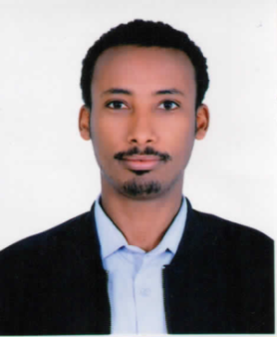

Seyfu Tiruneh Debebe, lecturer and Researcher at Debre Markos University, Debre Markos institute of Technology, School of Mechanical and Industrial Engineering, Debre Markos, Ethiopia.
.
Email: seyfu.tiruneh@aait.edu.et

Presenting author details
Full name: Seyfu Tiruneh Debebe
Contact number: +251910071208
Twitter account:
Linked In account: https://www.linkedin.com/in/seyfu-tiruneh-2a110b234/
Session name/ number:
Category: (Oral presentation/ Poster presentation)

