Multiple nanoemulsions with 5-fluorouracil and short chain triglycerides improve drug cytotoxicity against colorectal cancer cells

Claudio Fukumori, MSc, Department of Pharmacology, Institute of Biomedical Sciences, University of Sao Paulo, Brazil.
Paola Cristina Branco, PhD, Department of Pharmacology, Institute of Biomedical Sciences, University of Sao Paulo, Brazil.
Luciana Biagini Lopes, Assoc. Prof., Department of Pharmacology, Institute of Biomedical Sciences, University of Sao Paulo, Brazil.

Abstract

Colorectal cancer (CRC) is the third most common cancer in the world and fourth in cause of death world-wide. The drug of first choice is 5-fluorouracil (5FU), but due its low oral bioavailability and short plasma half-life, it is administered intravenously at high dosage and frequency which, combined with poor selectivity for tumor cells, leads to serious systemic adverse effects. We propose the co-encapsulation of 5-fluorouracil with short-chain triglycerides (SCT) in a multiple nanoemulsion of oral administration to enhance cytotoxicity and reduce the dose necessary for treatment of CRC. Microemulsions w/o containing either tributyrin or tripropionin as SCT in the oil phase and 5FU in the water phase were obtained. It was studied their dispersion in an external water phase to form the multiple nanoemulsions. They were evaluated according to their stability in gastrointestinal conditions, in vitro release model, cytotoxicity in CRC cell lines and spheroid. They displayed droplets of 400 nm and PDI of 0.2. Transmission electron microscopy analysis showed spherical aggregates of droplets containing smaller droplets in their interior. They followed Korsmeyer-Peppas in vitro release model; and tributyrin system was stable when incubated in buffers mimicking gastrointestinal fluids. The 5FU cytotoxicity in monolayer cell lines presenting various mutations were influenced by its incorporation in the nanocarrier, presence of SCT and cell mutation status. They were less cytotoxic against a normal colon cell line suggesting selectivity. They reduced the viability of spheroids suggesting nanocarrier could improve cytotoxicity in more complex models. These results show we can co-encapsulate substances with different physical-chemical characteristics in a multiple nanoemulsion to enhance the cytotoxicity of the formulation with selectivity and possibility reducing the dose.

Image
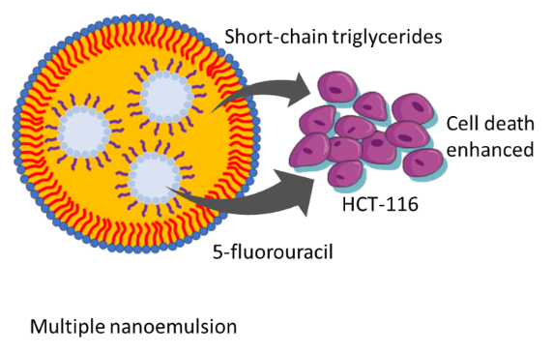
Multiple nanoemulsion for co-delivering short-chain triglycerides and 5-fluorouracil to treat colorectal cancer cells have different outcome depending on cell mutations.
Recent Publications (minimum 5)
- Geng, H. W. et al. (2021). Butyrate Suppresses Glucose Metabolism of Colorectal Cancer Cells via GPR109a-AKT Signaling Pathway and Enhances Chemotherapy. Frontiers in Molecular Biosciences, 8(March), 1–9.
- Yuan, L. et al. (2018). The influence of gut microbiota dysbiosis to the efficacy of 5-Fluorouracil treatment on colorectal cancer. Biomedicine & Pharmacotherapy, 108(August), 184–193.
- Castro, F. et al. (2021). Advances on colorectal cancer 3D models: The needed translational technology for nanomedicine screening. Advanced Drug Delivery Reviews, 175.
- Pangeni, R. et al. (2018). Preparation, characterization, and in vivo evaluation of an oral multiple nanoemulsive system for co-delivery of pemetrexed and quercetin. Pharmaceutics, 10(3).
- Vasta, J. D. et al. (2022). KRAS is vulnerable to reversible switch-II pocket engagement in cells. Nature Chemical Biology.
- McClements, D. J. (2021). Advances in edible nanoemulsions: Digestion, bioavailability, and potential toxicity. Progress in Lipid Research, 81(October 2020), 101081.

Biography
Claudio Fukumori is graduated in Pharmacy and began his career in academy studying short-chain fatty acids (SCFA) in in vitro fermented meals. Then, he proceeded to improve his skills in HPLC, validating a bioanalytical method for quantify fluconazole in human plasma. He studied the influence of dam’s intestinal microbiota in the offspring of mice model, applying his knowledge of SCFA and chromatographical method. Lately, he decided to study a nanotechnology approach to deliver SCFA in and potentially improve the treatment of colorectal cancer, using alternative methods to optimize the use of animal experimentation like cell line culture and spheroids.

Email: claudio@fukumori.com.br

Notes/Comments:
This study was funded by FAPESP, grant #2018/13877-1 and 2019/03241-5, and CAPES – Brazilian Federal Agency for Support and Evaluation of Graduate Education within the Ministry of Education of Brazil to CF (finance code 001).

Presenting author details
Full name: Claudio Fukumori
Contact number: +55 11 98657 2814
Twitter account:
Linked In account: www.linkedin.com/in/claudio-fukumori-68369254
Session name/ number: Pharmaceutical nanotechnology/12
Category: Poster presentation

