Leukoaraiosis, a common ischemic finding of MRI, reduces the driving safety performances of healthy older drivers
Kaechnag Park, MD& Ph.D.,
Kochi University of Technology, Kochi, Japan

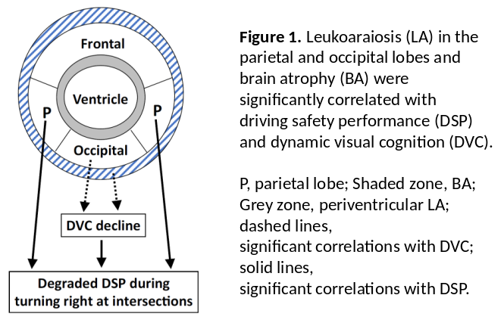
Abstract (300 word limit)
Leukoaraiosis, a common ischemic lesion diagnosed using magnetic resonance imaging (MRI), can influence driving safety performance (DSP). Most older drivers with leukoaraiosis are unaware of its existence in the brain because of being asymptomatic. Japan is a super-aged country, where preventing accidents caused by older drivers is an urgent national issue. We investigated the subcortical and periventricular leukoaraiosis regions that were most involved in DSP decline. The driving skills of 101 drivers (49 men, 52 women; mean age, 77.88 ± 3.77 years) without dementia were assessed by official driving instructors, using actual vehicles on a closed-circuit course. Parietal and occipital (but not frontal or temporal) leukoaraiosis volumes were significantly correlated with decreased DSP scores regardless of age, especially when turning right at intersections, which needs more attention than turning left because left-side driving is legally enforced in Japan. Occipital leukoaraiosis was also involved via a decline in dynamic visual cognitive function. MRI-based assessment of leukoaraiosis volume and localization may enable the identification of older drivers prone to DSP deterioration. Risk factors for leukoaraiosis include smoking and lifestyle-related diseases such as hypertension. Thus, brain healthcare in the elderly with MRI-diagnosed leukoaraiosis may be particularly useful for the risk management of traffic crashes caused by them in Japan.

Image

Recent Publications (minimum 5)
- Park, K., Nakagawa, Y., Kumagai, Y. & Nagahara, M. Leukoaraiosis, a common brain magnetic resonance imaging finding, as a predictor of traffic crashes. PLoS ONE 8, e57255 (2013).
2. Nakano, K. Park, K, et al. Leukoaraiosis significantly worsens driving performance of ordinary older drivers. PLoS ONE 9, e108333 (2014).
3. Park, K. et al. Aging brains degrade driving safety performances
of the healthy elderly. Front. Aging Neurosci. 13, 783717 (2021).
4. Park, K. et al. Cerebral white matter hyperintensity as a healthcare quotient. J. Clin. Med. 8, 1823 (2019).
5. Oba, H., Park, K, et al”. Parietal and occipital leukoaraiosis due to cerebral ischaemic lesions decrease the driving safety performance of healthy older drivers. Scientific Reports. (2023).

Biography (150 word limit)
Kaechang Park is a medical doctor specializing in brain healthcare and has been interested in the relationship between brain and driving performance, especially for older drivers because Japan is a super-aged country, where preventing accidents caused by older drivers is an urgent national issue. Brain Dock is a brain checkup using MRI, a preventive medicine that is prevalent uniquely in Japan. Aging brain without dementia is radio-graphically characterized by brain atrophy and leukoaraiosis, a common ischemic lesion diagnosed by MRI. To elucidate the relationship, he uses large-scale MRI data obtained from Brain Dock.
Email:park.kaechang@kochitech.ac.jp

Presenting author details
Kaechang Park:
Transportable Medicine and Social Brain Laboratory, Kochi University of Technology, Kochi, 782-0003 Japan
TEL +81-887-57-2743 FAX +81-887-57-9064
Healthcare and Technology/ number:
Category: Oral presentation

