Philip Kwakye

THE USE OF RENEWABLE ENERGIES IN GREEN HOUSES
Renewable energy is energy derived from natural sources that are replenished at a higher rate than they are consumed. Sunlight and wind, for example, are such sources that are constantly being replenished. Renewable energy sources are plentiful and all around us.

Fossil fuels - coal, oil and gas - on the other hand, are non-renewable resources that take hundreds of millions of years to form. Fossil fuels, when burned to produce energy, cause harmful greenhouse gas emissions, such as carbon dioxide.

Generating renewable energy creates far lower emissions than burning fossil fuels. Transitioning from fossil fuels, which currently account for the lion’s share of emissions, to renewable energy is key to addressing the climate crisis.

Renewables are now cheaper in most countries, and generate three times more jobs than fossil fuels. When it comes to energy resources, there is always the question of sustainability. It is important that resources provide enough energy to meet our needs—to heat our houses, power our cities, and run our cars. However, it is also important to consider how these resources can be used long term. Some resources will practically never run out. These are known as renewable resources. Renewable resources also produce clean energy, meaning less pollution and greenhouse gas emissions, which contribute to climate change.
The use of various renewable energy resources in agricultural greenhouses for heat and power generation has been studied extensively and several applications already exist. Among renewable energy resources solar energy, geothermal energy and biomass have been more or less used mainly for heat production in them. Currently economic and environmental considerations favour the replacement of fossil fuels with renewable energies for energy generation in greenhouses. The necessity of mitigation of greenhouse gases emissions and the decrease in the cost of energy generation from renewables make their use more attractive in various commercial applications including in agricultural greenhouses. In the case of Crete-Greece, cost analysis of the use of solid biomass and geothermal energy for direct heating and cooling greenhouses shows that these investments are very profitable and attractive. However, the use of geothermal heat pumps for heating and cooling them is not cost effective. Use of solar photovoltaic cells for power generation is not cost effective, particularly when electricity generation in greenhouses is subsidized by the government. The decrease of CO 2 emissions due to the use of renewables in the greenhouses is considered as an additional benefit.

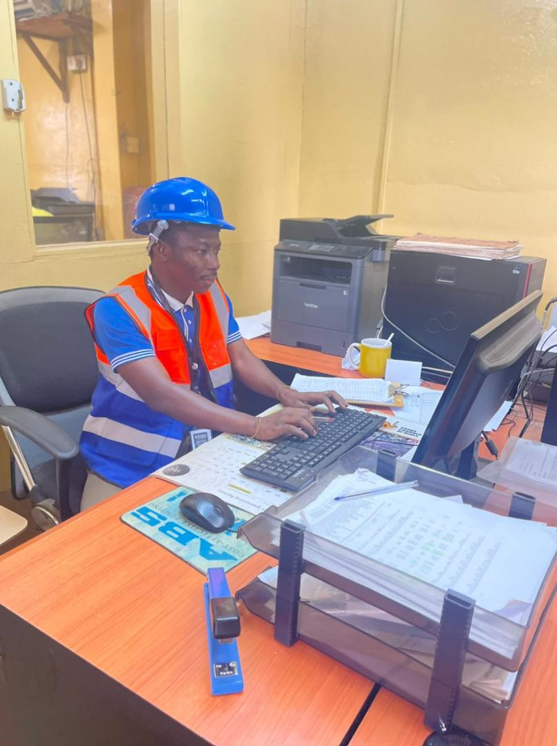
PHILIP KWAKYE
INVENTORY CONTROL OFFICER(GMC)
DIRECTOR (EXCELMUSAB ENTERPRISE)
SALES AND MARKETING STRATEGIST
PROFESSIONAL ARABIC INSTRUCTOR
MOTIVATOR/ENTREPRENEUR

CONTACT INFORMATION
EMAIL: kwakyephilip14@gmail.com
PHONE Number:+233509423487

ABOUT ME

Philip Kwakye is a professional sales and marketing strategist with experience in leveraging consultative selling strategies that build relationships across all market.He has in-depth knowledge of marketing campaign development and implementation of training programs for new hires.
He is process driven with extensive experience in managing profit and loss, devising pricing strategies , launching marketing initiatives and creating partner programs.Driven products management of new product from concept to launch to commercialization to end-of-life (market research, products definition, development, products launch,sales negotiations, inventory management etc).
He loves to dig into customer problems and solve them with modern technology.He creates,scales and optimize business portfolios that matter.Through out his career,he has been driven by his intellectual curiosity to find answers to the most pressing questions whether it's finding a perfect song for a firm or finding a rare products for a rocket.He has been able to quickly uncover customers pain point and identity strategic solutions.With his refined skill set,he brings customer centric mindfulness that enables firms to innovate and thrive.This is what he has done for his clients at Universal Group Company and African Resource company.His intellectual curiosity also drives him to be a lifelong learner.He recently earned his DBS from the University Of Education,winneba with a graduate certificate in Management Studies.
Philip Kwakye is a result-driven inventory control specialist with excellent problem solving, analytical and organisational abilities and strong focus for collaborating with employees to resolve business, customer and vendor issues quickly.He works alone or as part of team to manage high volumes of works in fast -paced environment. He is an inventory control professional with ten years (10) Plus of experience supporting GHANA MANGANESE COMPANY production progress.He is gifted at coordinating data,preparing reports and leading stock count team to successfully achieve zero variance in cycle counting and inventory audit.
He is team - oriented with the ability to collaborate with all employees from business leaders to contribute their quota effectively.He is effective at annual stock taken,audit support,log updating and project management. He is self motivated, reliable and dedicated to efficiency.He is fluent in English and Arabic,well coordinated in maintaining optimal inventories and supporting documentation to boost efficiency of supply and warehouse operations.He is talented communicator ,planner and problem solver offering numerous years of inventory experience across mining sectors.He has proven skills in reviewing paperwork and consulting with teams to keep current on needs and meet supply demands.He is detailed-oriented and systematic distribution professional with decades experience in storage procedures environment focused on smoothly managing the flow of goods into and out of stockroom and warehouse.

Philip Kwakye has enjoyed many leading positions throughout his career in inventory management, products management,product marketing, technical sales and strategy with Universal Group Company, African Resource company,Gari Sika Company ltd,Westurban Company,SamjoyMart,,Ransbert Supermarket ,Alfurqaan institute and many others.
Mr. Philip Kwakye holds various certifications, including DBS in Management studies-(University Of Education,winneba), Diploma in warehouse management (Alison institute-CDP) , Principles of occupational Health and safety Management systems(CDP-Alison institute) Supply Chain Management (CDP-Alison institute), Diploma In workplace Safety and Health (CDP -Alison), Entrepreneurship (CDP-Alison institute).
He is originally from Ghana but lives in Tarkwa -Western Region and works with Ghana Manganese Company Ltd and also the Director of Excelmusabenterprise. He is a
man of many skills and can successfully excel at the execution of big ideas given constraints.He educates,refine and drive himself to be a better person.He tell narratives that motivates and can align ,lead and grow world-class product team from ten -to-hundreds.

