Effect of different machining processes on the bearing strength of pin-loaded textile composite panels for automotive: Experimental and FEM analysis

Sandeep Olhan* and B.K. Behera
Department of Textile & Fibre Engineering, Indian Institute of Technology Delhi, Hauz Khas, New Delhi 110016, India

Abstract

This research examines the influence of various machinability processes, including drilling, abrasive water jet machining, and laser beam machining along with various fibre architectures on the behavior of machined holes, bearing strength, and failure mechanisms of various textile structural composites produced from different textile structures such as chopped fibre, unidirectional (UD), bidirectional (2D), and three-dimensional (3D) orthogonal woven structures using glass, basalt, and sisal fibres suitable for automotive applications. Optical microscopic examination was used to evaluate morphological damage and fractography of the produced composite materials. In comparison to glass fibre reinforced textile structural composites and sisal fibre reinforced textile structural composites, experimental findings showed that basalt fibre reinforced textile structural composite specimens had the highest bearing strength for all processes. The bearing strength of composites was in the order of 3D > chopped > 2D > UD, respectively. In addition, a novel systematic mechanics-based approach was developed using SOLIDWORKS to create a mesoscale finite element model to analyse the bearing strength of pin-loaded textile structural composites. The woven-based composite material damage modes were predicted using the well-known 3D Hashin's failure and Puck's failure models, which were implemented via a user subroutine in conjunction with LS-DYNA. The bearing response predicted by the FEM simulation was found in a good agreement with the experimental findings. (Figure 1)

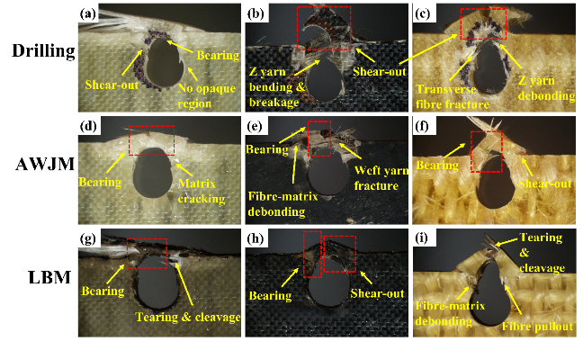
Figure 1. Microscopic fracture images of different 3D composites machined by drilling, AWJM, and LBM process: (a) DG-3D; (b) DB-3D; (c) DS-3D; (d) WG-3D; (e)WB-3D; (f) WS-3D; (g) LG-3D; (h) LB-3D; (i) LS-3D.
Recent Publications
- Khashaba, U. A., El-Sonbaty, I. A., Selmy, A. I., & Megahed, A. A. (2010). Machinability analysis in drilling woven GFR/epoxy composites: Part II–Effect of drill wear. Composites Part A: Applied science and manufacturing, 41(9), 1130-1137.
- Abrao, A. M., Rubio, J. C., Faria, P. E., & Davim, J. P. (2008). The effect of cutting tool geometry on thrust force and delamination when drilling glass fibre reinforced plastic composite. Materials & Design, 29(2), 508-513.
- Singh, H., Dewangan, B., & Jain, P. K. (2021). Experimental study on drilling characteristics of the hybrid sisal–jute fibre epoxy composites. Journal of Micromanufacturing, 4(2), 157-168.
- Murthy, B. R. N., Beedu, R., Bhat, R., Naik, N., & Prabakar, P. (2020). Delamination assessment in drilling basalt/carbon fiber reinforced epoxy composite material. Journal of Materials Research and Technology, 9(4), 7427-7433.
- Yang, B., Wang, H., Chen, Y., Fu, K., & Li, Y. (2021). Experimental evaluation and modelling of drilling responses in CFRP/honeycomb composite sandwich panels. Thin-Walled Structures, 169, 108279.

Biography

Mr. Sandeep Olhan is pursuing a Ph.D. at the Indian Institute of Technology (IIT), Delhi. He obtained M. Tech Degree in Mechanical Engineering (2011). He completed graduation in Mechanical Engineering (B. Tech) in 2009. His current research focuses on the development of textile fibre reinforced polymeric composites, metal matrix composites, hybrid composites, nanocomposites, natural fibre reinforced composites and 3-D composites for automotive applications. He has authored five peer-reviewed papers published in International Journal publications, one book chapter, and several others under communications. He has visited the Technical University of Liberec (TUL), Czech Republic, and Kyoto Institute of Technology, Japan, to attend the International Conference (TRS) in 2019 and 2022. Mr. Sandeep Olhan has a rich blend of teaching and technical experience in the field of mechanical engineering, material testing and composite processing and characterization. He was awarded a gold medal for his commendable performance during his M. Tech from university.

