New Approach to Chronic Back Pain Treatment: A Case Control
Study
Matteo Bonetti

Istituto Clinico Città di Brescia, 25128, Brescia Italy

Abstract
Background and objective: Our study compares the clinical outcome of chronic low back pain present for
over six months treated with alpha-lipoic acid (ALA) + palmitoylethanolamide (PEA) and myrrh and
periradicular infiltrations of oxygen-ozone under CT guide to periradicular steroidal infiltrations in a short
(one week), medium (three months) and long-term period (six months). Methods: We enrolled 246
patients (Group A) with low back pain treated with periradicular infil- trations of oxygen-ozone under CT
guide combined with 800 mg/day of ALA + 600 mg/day of PEA + 200 mg/day of myrrh orally. Group B
consisted of 176 patients with low back pain treated with periradicular infiltrations of steroids. Patients
were clinically monitored one week after the end of treatment, at three months, and at six months using a
modified version of McNab’s method. Results: In Group A, the one-week clinical follow-up registered a
complete remission of painful symptoms in 206 patients (83.7%), and this manifestation remained
optimal in 191 patients at the three-month follow-up (77.6%) and in 178 at six months (72.3%). While the
results were satisfactory in 28 patients (10.9%) at one week, 32 (13%) in the medium term, and 41
(16.6%) in the long term, non-significant results were found in 12 patients in the control at one week
(4.6%), in 23 at three months (9.3%) and in 27 at six months (10.9%). In Group B, at the short-term
follow-up we obtained an excellent clinical result in 103 patients (80.5%), while at three months 85
patients reported the persistence of clinical benefit (66.4%) and at six months, 72 (56.2%) reported the
same result. The result was rated satisfactory in 11 (8.5%) and poor in 4 (3%). At the three-month followup,
23 (18%) reported a satisfactory result, and 20 (15.6%) had a poor result. At six months, 24 (18.8%)
reported the persistence of a satisfactory result while for 32 the result was poor (25%). Conclusion: The
results highlight how the treatment associated with ozone therapy and oral administration of alpha-lipoic
acid + palmitoylethanolamide and myrrh can be considered a valid alternative to common therapeutic
approaches in the treatment of chronic low back pain.of chronic low back pain. 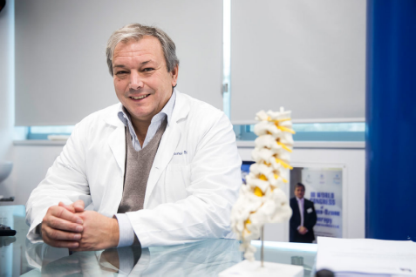
Biography
Dr. Matteo Bonetti was born in Cremona on 02/03/1962. He graduated in the Faculty of
Medicine and Surgery of the University of Brescia in 1986-87.
From 1986 he attended the II Radiology Service of the Spedali Civili of Brescia.
He specialized in Radiodiagnostic on 1991-92, with the score of 50/50 cum laude.
Professor of "Neuroanatomy and Neuroradiological Techniques" at the School for Medical
Radiology Health Technicians of Brescia (1991-92 to 1997-98)
From 1998 he was appointed "Chief of the Neuroradiology Services of the San Donato Group”.
Professor at the Faculty of Medicine and Surgery of the University of Insubria (2006-07 to 2013-
14).
Secretary of the W.F.O.T. (World Federation of Ozone Therapy) ISICO AWARD WINNER for the year 2005. Italian prize reserved for the best scientific
research papers dedicated to the spine published in an indexed international journal.
President of Nuova FIO (Italian Federation of Oxgen-Ozone): 2018-22, 2022 – …
Incoming president W.F.O.T.: 2024–26.
Professor at Univeristy of Verona: 2021-22 - …
Presenting Author Details:
Full Name: Matteo Bonetti
Contact Number: 00393476404800

