Role of nutraceutical in management of dyslipidemia- A meta-analysis of 250 RCTs

Kaneez Fatima Jawwad, M.Sc.

Public Nutrition, Pakistan Certified Clinical Dietitian- Islamabad, Pakistan
Certified Nutrition Fitness Specialist-ACE-USA

Abstract

Statement of the Problem: Dyslipidemia is one of the major risk factors for non-communicable diseases (NCD). Its worldwide prevalence depicts that 40% female and 37% male population have raised cholesterol mainly associated with NCDs like cardiovascular diseases, hypertension, diabetes, fatty liver, inflammatory bowel syndrome (IBS), obesity, hypothyroidism, cancers, osteoarthritis, stroke, cerebrovascular disease, causing mortality of 10 million people per year. Globally 30-40% patients are statin intolerant to pharmacological intervention owing to its side effects like kidney & liver failure, muscle weakness, diarrhea, memory loss, and cataracts. The causative factors include unhealthy foods & lifestyle, obesity, smoking, alcoholism, physical inactivity, and diabetes.
Objectives: 1). To explore the most effective nutraceutical improving individual quantities of lipid profile. 2). To identify the highly significant nutraceuticals for the management of dyslipidemia.
Methodology & Theoretical Orientation: Research design is review based meta-analysis involving 250 RCT studies, with 21,450 subjects, sampled through Prisma flow and PICO (Population, Intervention, Comparison, Outcome) being research instrument. Data collection & inclusion criteria were availability of complete article, human subjects, dosage, regime/day, treatment duration, and fasting lipid profile (TC, LDL, TG and HDL cholesterol) before and after treatment. Paired sample t-test and one-way ANOVA with 95% CI were used for inferential status.
Findings: The result demonstrated amongst 25 nutraceuticals, the most effective for improving individual quantities of lipid profile are Bergamot for TC reduction (p=0.003), Polyphenol reduced LDL (P=0.01), Spirulina reduced TG (p=0.004) & Niacin increased HDL (p=0.02). The highly significant nutraceuticals to treat overall dyslipidemia are (1). Niacin which reduced bad cholesterol (p=0.001) & increased HDL-C (p=0.02), (2) Dietary fiber reduced bad cholesterol (p=0.001) and increased HDL-C (p=0.005) and (3) Berberine reduced bad cholesterol (p=0.007) and increased HDL-C (p=0.05).
Conclusion & Significance: Nutraceuticals work best without side effects but with other good effects of on health, accompanied with healthy diet, DASH diet for hospitalized CKD, diabetic, CVD and other NCDs as well as in Statin intolerant. Bergamot, Polyphenol, Spirulina and Niacin significantly improved TC, TG, LDL and HDL-C, respectively. Niacin, Dietary fiber and Berberine are highly significant to manage dyslipidemia.

Image:

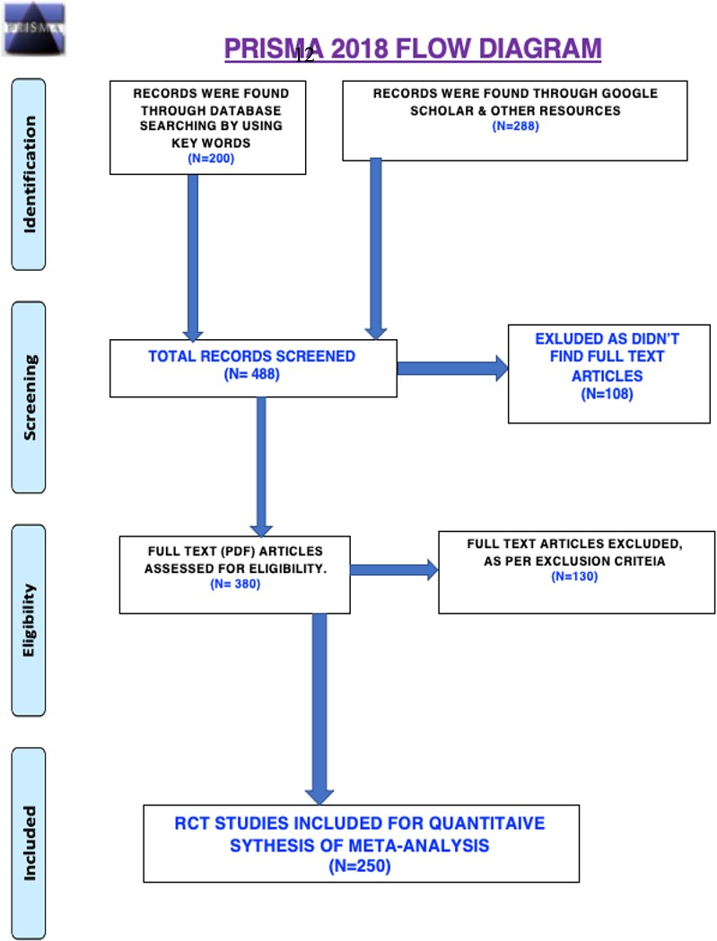
Recent Publications
I have done many researches but due to load of my studies and exams, I won’t be able to submit any of my research paper for publication.
But this present meta-analysis research of 250 randomized control trails has just submitted to Lancet.

Biography (150-word limit)
Kaneez Fatima Jawwad has her expertise in evaluation and passion in improving the health and wellbeing. Her open and contextual evaluation model based on responsive constructivists creates new pathways for improving healthcare. She has built this model after years of experience in research, evaluation, teaching, and administration both in hospital and education institutions. Methodology that utilizes the previous studies evaluations: measurement, description, and judgment. It allows for value-pluralism. This approach is responsive to all stakeholders and has a different way of focusing.

