Comparable b2a2/e13a2 and b3a2/e14a2 reporting in Xpert® BCR-ABL Ultra when calibrated by WHO IS and by IVT-RNA Copy Number

Huilin Wei, Tran Tran, Jessica Saini, Krupa Shridhar, Nick Wang, Gwo-Jen Day
Oncology R&D, Cepheid, Sunnyvale, USA

Abstract

Introduction: Xpert® BCR-ABL Ultra, automated cartridge-based assay for monitoring BCR-ABL transcript levels, is calibrated by WHO IS to standardize the %reporting for both b2a2/e13a2 BCR-ABL (e13a2) and b3a2/e14a2 BCR-ABL (e14a2) relative to control ABL gene in peripheral blood of patients as a standard management of Chronic Myeloid Leukemia (CML) ^{[1]}. Studies have shown differences in patients carrying e13a2 or e14a2 in molecular response to Tyrosine Kinase Inhibitor (TKI) treatment ^{[2-4]}. Therefore, it is necessary to understand if there is %reporting differences between two transcripts calibrated by WHO IS ^{[5]} and explore the calibration method using breakpoint specific RNA input copy number (CN) for accurate TKI treatment monitoring. Objectives: To establish a %CN e13a2/ABL and e14a2/ABL reporting method with known CN of IVT-RNAs and compare to WHO IS for e13a2/e14a2 breakpoint specific % reporting. Methods: Three IVT-RNAs (e13a2-ABL-BCR, e14a2-ABL-BCR and ABL-BCR) were used to generate standard curves for %CN reporting (Figure1). Four levels of IVT-RNA panels with same CN of e13a2 and e14a2 were tested for breakpoint specific % reporting comparison. K562(e14a2), BV173 (e13a2) cell lysates and CML clinical samples carrying e13a2 or e14a2 transcripts were tested to evaluate the %CN reporting compared to WHO IS. Result: Good linearity demonstrated in Ct vs CN input for e13a2, e14a2 and ABL IVT-RNA (Figure2) with comparable efficiency (E) between e13a2 (E=0.992) and e14a2 (E=0.986). %e13a2 reporting was ~1.50-fold (by WHO IS) and ~1.46-fold (by %CN) higher than %e14a2, by testing IVT-RNA panel (Table1). Minor differences in %reporting observed between % CN and WHO IS for e13a2 (84.5%~110.8%) vs e14a2 (82.5%~89.5%) from cell lysates (Table2) and e13a2 (92.6%~105.5%) vs e14a2 (88.1%~92.2%) from clinical samples (Table3). Conclusion: Both WHO IS and %CN showed very minor differences between e13a2 and e14a2 for % reporting. %CN method demonstrated comparable %reporting to WHO IS.

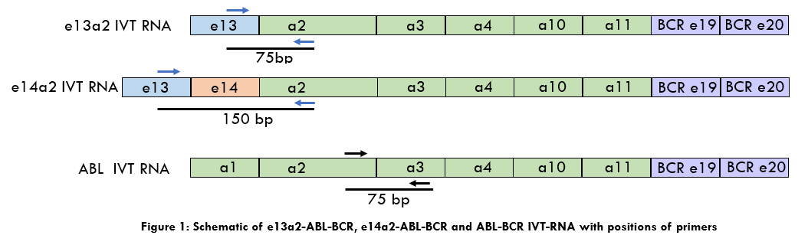

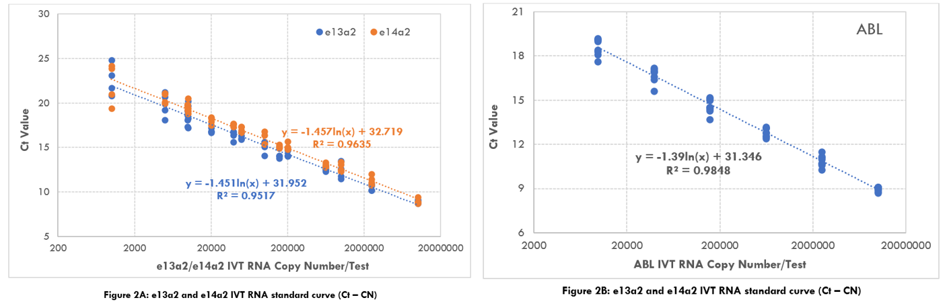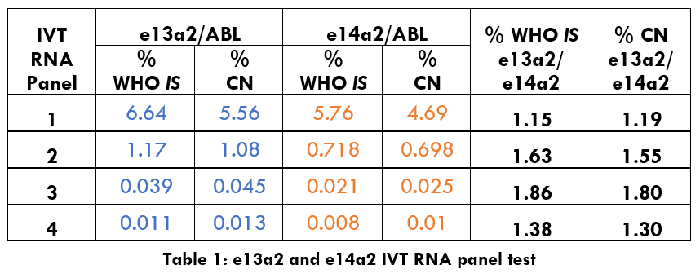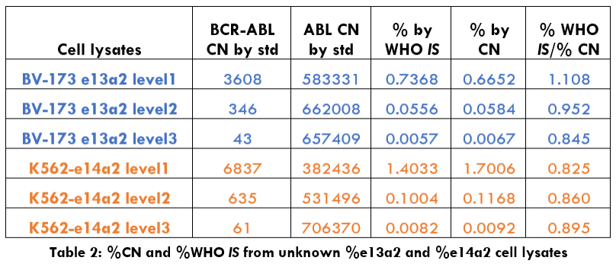

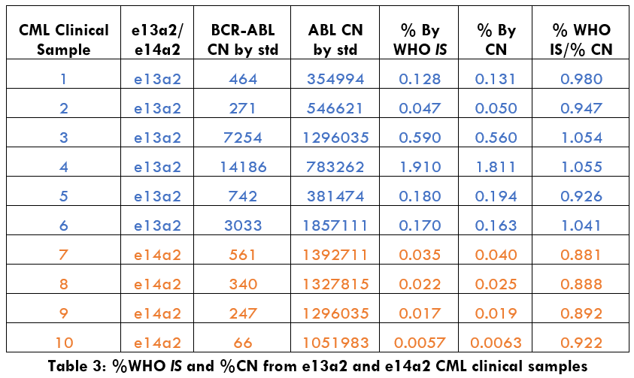

Recent Publications
- Dominy KM, Simon IM, Khorashad JS (2021) Evaluation of Xpert® BCR-ABL Ultra for the confirmation of BCR-ABL1 international scale conversion factors for the molecular monitoring of chronic myeloid leukaemia, Int J Lab Hematol, Feb;43(1):e31-e34.
- Hanfstein B, Lauseker M, Hehlmann R, Saussele S, Erben P, Dietz C (2014) Distinct characteristics of e13a2 versus e14a2 BCR-ABL1 driven chronic myeloid leukemia under first-line therapy with imatinib. Haematologica.99:1441–7.
- Jain P, Kantarjian H, Patel KP, Gonzalez GN, Luthra R, Shamanna RK (2016) Impact of BCR-ABL transcript type on outcome in patients with chronic-phase CML treated with tyrosine kinase inhibitors. Blood.127:1269–75.
- Castagnetti F, Gugliotta G, Breccia M, Iurlo A, Levato L, Albano F (2017) The BCR-ABL1 transcript type influences response and outcome in Philadelphia chromosome-positive chronic myeloid leukemia patients treated frontline with imatinib. Am J Hematol. 92:797–805.
- Matthew S, White HE, Hana Z, Nicholas C.P C (2022) Impact of BCR::ABL1 transcript type on RT-qPCR amplification performance and molecular response to therapy. Leukemia 36(7):1-8



Huilin Wei has more than 15 years of extensive experience in molecular and protein assay development. She has her expertise in molecular biology, immunology, and oncology. Current research focuses on assay control and detection platforms to provide accurate and high quality IVT products for cancer diagnostic and monitoring.
Email: huilin.wei@cepheid.com

Notes/Comments:

Presenting author details
Full name: Huilin Wei
Contact number:4082420314
Twitter account:
Linked In account: linkedin.com/in/huilin-wei-91779438
Session name/ number:
Category: (Oral presentation/ Poster presentation)

