The adaptation model of Immunity and outcomes of immune responses
Masoud H. Manjili, DVM, PhD, VCU Massey Cancer Center, USA
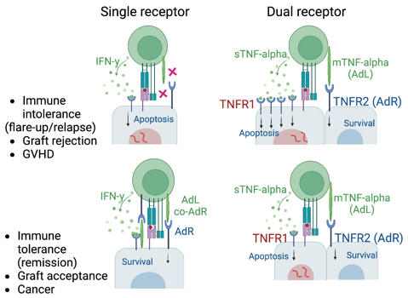

Abstract
The self-nonself (SNS) model of immunity suggests that foreign antigens induce alloreactive immune responses, resulting in graft rejection whereas tolerance towards self-antigens expressed by malignant cells facilitates cancer development. Also, breakage of immunological tolerance towards self-antigens results in autoimmune diseases. Accordingly, immune suppression is recommended for the management of autoimmune diseases, allergy, and organ transplantation while immune inducers are used for the treatment of cancers. Nevertheless, a cure for immune-related diseases remains elusive. This is in large part due to applying the SNS model in the areas that are beyond its realm. Here, I discuss the adaptation model of immunity to explain the decision-making process by activated T cells. According to this model, all somatic cells express adaptation receptors (AdRs) to tolerate ongoing immune responses by engaging with their nominal adaptation ligands (AdLs) expressed on activated T cells. The AdR/AdL axis establishes signal IV for orchestrating the primary function of the immune response, which is to support cellular integrity and homeostasis. Any loss or alterations in the expression of tissue-specific AdRs results in immune intolerance or autoimmune diseases as well as graft rejection (Figure 1). Upregulation or downregulation of the AdRs by tumor cells could also dictate the outcomes of tumor-reactive immune responses. Therefore, novel therapeutics should focus on the discovery and targeting of the AdRs for the treatment of immune-related diseases and cancer.

Image

Figure 1. The AdRs/AdLs could exist in a single receptor form (left panel) and dual receptor manner interacting with the same ligand where balance between AdRs (TNFR2) and its opposing counterpart (TNFR1) (right panel).

Recent Publications (minimum 5)
- Isbell M, Mirshahi F, Aqbi HF, Guo C, Saneshaw M, Koelsch N, Idowu MO, Austin D, Gelber C., Wang XY, Sanyal AJ, Manjili MH (2022) Restoration of CD4⁺ T cells during NAFLD without modulation of immunological pattern is not sufficient to prevent HCC. Cancers 14(22):5502
- Mirshahi, F, Aqbi HF, Isbell M, Manjili SH, Guo C, Saneshaw M, Bandyopadhyay D, Dozmorov M, Khosla A, Wack K, Carrasco-Zevallos OM, Idowu MO, Wang XY, Sanyal AJ, Manjili MH (2022) Distinct hepatic immunological patterns are associated with the progression or inhibition of hepatocellular carcinoma. Cell Reports 38(9):110454
- Manjili MH (2023) The adaptation model of immunity: signal IV matters most in determining the outcomes of an immune response. J Immunol (in press)
- Manjili MH (2023) The adaptation model of immunity: a new insight into etiology and treatment of multiple sclerosis. Scan J Immunol Jan 20:e13255
- Manjili MH (2023) The adaptation model of immunity: is the goal of central tolerance to eliminate defective T cells or self-reactive T cells? Scand J Immunol. 96(4):e13209. doi: 10.1111/sji.13209

Biography (150 word limit)
Email: masoud.manjili@vcuhealth.org
Masoud H Manjili is an immunologist who has conceptualized the adaptation model of immunity as well as immunological pattern discovery approach for understanding of collective immune function during cancer and immune-related diseases. The adaptation model is designed to explain decision-making for T cells in destroying or supporting its target cell/tissue. The pattern discovery approach relies on systems immunology to understand collective immune function emerging from internetwork mutual interactions of immune cell types.

