The great potential of lectin-protease conjugates in Cancer therapeutics
Ashraf Abdullah Saad, MBBS, MRCPCH.
Pediatric Hematologic Oncology and BMT, Sultan Qaboos University Hospital, Muscat, Oman

Abstract

Unlike cytotoxic chemotherapy, cancer immunotherapy offers targeted therapies that exploit the effector mechanisms of the immune system to combat cancer. However, most therapeutic strategies have so far focused predominantly on the orchestration of the adaptive immune responses to anti-cancer immunotherapies. Unfortunately, the emergence of resistance and associated severe toxicities rendered this modality of treatment imperfect. Because of their complex nature and the late ability to selectively separate distinct innate immune responses, the enormous potential of innate immunity as an immunotherapy was largely neglected. Recently, the growing demand to find alternatives to adaptive immunity-based immunotherapy concurred with growing appreciation of the innate immune effectors contributions to anti-tumor immunity. In particular, the innate immunity anti-infective responses overlap with those that target cancer indicating that these responses can readily be manipulated to design new therapeutic approaches. The paradigm of lectin pathway in recognition of distinct ‘non-self’ (antigenic) glycans on the surface of pathogenic microbes in concert with cancer’s indigenous aberrant (antigenic) glycans render lectin pathway a canonical component of innate immune system that can be extrapolated to cancer immunotherapy. By virtue of recent advances in lectin engineering, the encouraging results of using engineered lectins as anti-viral agents can be replicated in cancer immunotherapy.
Image
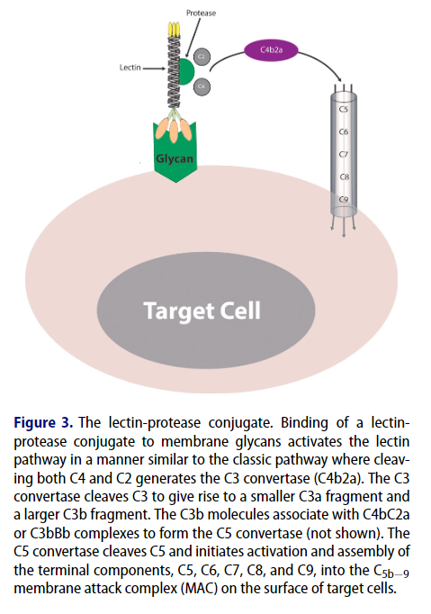

Recent Publications
- Ashraf Abdullah Saad (2022) Targeting cancer-associated glycans as a therapeutic strategy in leukemia, All Life, 15:1, 378-433, DOI: 10.1080/26895293.2022.2049901
- Saad, A. (2022). Unveiling the Great Therapeutic Potential of MASPs as Hemostatic Agents. Journal Of Hematology, 11(6), 240-245.
- Saad AA. Targeting P-selectin ligands: ushering in a new treatment paradigm for Sickle Cell Disease. Hematol Transfus Int J. 2021;9(6):134‒136. DOI: 10.15406/htij.2021.09.00270
- Saad AAD. Recombinant lectins as pioneering anti-viral agents against COVID-19. Hematol Transfus Int J. 2021;9(4):77‒79. DOI: 10.15406/htij.2021.09.00259
- Ashraf Abdullah Saad (November 30th 2020). Juvenile Myelomonocytic Leukemia (JMML): A Mimicker of KMT2A-Rearranged Acute Myeloid Leukemia (AML), Acute Leukemias, Pier Paolo Piccaluga, IntechOpen, DOI: 10.5772/intechopen.94537. Available from: https://www.intechopen.com/chapters/74016
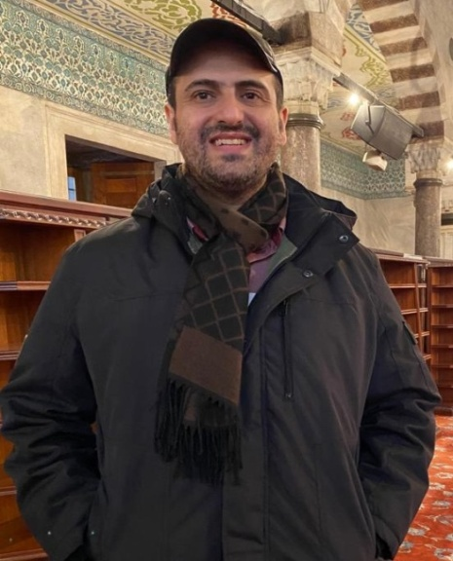

Biography
Dr. Ashraf Abdullah Saad is a pediatric hematologist with special interest in glycoimmunology. He aims to resurrect and rejuvenate research on the potential application of complement-dependent cytotoxicity elicited by the interactions of lectins with cancer-associated glycans as powerful and pioneering armamentarium that could lead to revolution in cancer therapeutics!. He introduced for the first time the concept of the lectin-protease conjugate that simulates the innate immune system mannose-binding lectin and its associated proteases (MASPs) and proposed it as pioneering cancer immunotherapy. This innovation is part of Dr. Ashraf’s inspirational mind trending thoughts that aim for ‘Research in fantasy until fantasy becomes a reality!’.

Presenting author details
Full name: Ashraf Abdullah Saad
Contact number: 00968 92538040
Email: dr.ashraf123321@gmail.com
Category: Oral presentation.

