Survey of Uruguayan women on knowledge related to the prevention of breast cancer

Name: Camejo Natalia.

Affiliation: Department of Clinical Oncology, Hospital de Clínicas “Dr. Manuel Quintela”, School of Medicine, University of Uruguay, Montevideo, Uruguay.

Co-authors: Amarillo Dahiana. Castillo Cecilia. Bernate Moira, Burguez Florencia, Darino Eliana, Deleón Adrián, MilwaTatiana, Barcia María, Krygier Gabriel

Abstract (300 word limit)

Introduction: In Uruguay, breast cancer has the highest incidence and mortality of all cancer in women. Objectives: To assess the knowledge of Uruguayan women about breast cancer screening for the early detection of BC. Material and Methods: This is a descriptive and observational study. A survey was applied to womwn, it was disseminated through social networks. Informed consent was requested at the beginning of the survey as an exclusive requirement to be able to carry it out. In the statistical analysis, the anonymity of the patients was maintained and the approval of the Ethics Committee of the Hospital de Clínicas was obtained. Results: 1859 women participated. 75.1% (1396) of those surveyed recognize BC as the one with the highest mortality in women. 52% (967) believe that 3 out of 10 women are at risk of developing BC, and 18.4% (342) do not know its prevalence. 60.2% (1119) recognize mammography as a test that has managed to reduce mortality from BC. 64.2% (1193) believe that it is done after 40 years of age. Regarding the frequency, 60.5% (1125) consider that it is carried out annually. The most considered risk factors for developing BC were smoking (60.9%, 1132), obesity (57%, 1.060) and sedentary lifestyle (56.8%, 1056). Conclusions: Our results show that the respondents are adequately informed about the importance of CM and the performance of screening mammography.

Recent Publications (minimum 5)
- Cecilia Castillo, Ana Laura Alfonso, Juan J. Dapueto, Natalia Camejo and Martín Silva. Inclusion of information technology-based assessments of health-related quality of life in routine oncology practice in Uruguay. Journal of Patient-Reported Outcomes (2022) 6:65
- Castillo C, Artagaveytia N, Brignoni L, Laitman Y, Camejo N, Hernández AL, Krygier G, Cayota A, Delgado L, Friedman E. Population-based screening of Uruguayan Ashkenazi Jews for recurrent BRCA1 and BRCA2 pathogenic sequence variants. Mol Genet Genomic Med. 2022 Mar 25:e1928.
- Camejo N, Castillo C, Amarillo D, Hernandez A L, Artagaveytia N, Krygier G. Reinserción laboral luego del diagnóstico y tratamiento del cancer de mama. Rev Med Inst Mex Seguro Soc. 2022;60(5):487-94.
- Camejo N, Amarillo D, Castillo C, Bernate M, Burguez F, Darino E, Deleón A, Milwa T, Barcia M, Krygier G. Conocimiento y uso de las distintas herramientas de tamizaje del cáncer de mama entre médicos del primer nivel de atención: un estudio transversal. Rev Méd Urug 2022; 38(3): e38305
- Camejo N, Amarillo D, Castillo C, Bernate M, Burguez F, Darino E, Deleón A, Milwa T, Barcia M, Krygier G. Encuesta a mujeres uruguayas sobre conocimientos relacionados con la prevención del cáncer de mama. An Facultad Med (Univ Repúb Urug). 2022; 9(1): e205.

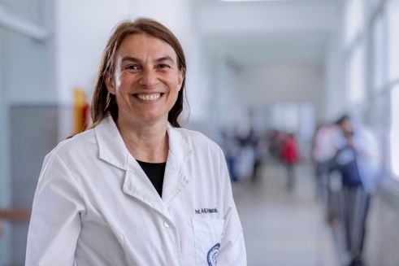

Biography (150 word limit)

MEDICAL SCHOOL: Faculty of Medicine, Universidad Mayor de la Republican, Montevideo, Uruguay; Doctor Medicine: August 2006. Faculty of Medicine, Universidad Mayor de la Republican, Montevideo, Uruguay; Medical Oncologist: March 2011
RESIDENCY Medical Oncology Resident at the Oncology Department of Hospital de Clinics. Faculty of Medicine , Universidad Mayor de la República. Montevideo, Uruguay. From April 2006 to April 2009
TEACHING EXPERIENCE: Assistant Professor at Oncology Department of Hospital de Clinicas. School of Medicine of the University of Uruguay. Teaching position at Oncology Department of Hospital de Clinicas. School of Medicine of the University of Uruguay. From October 2013 to October 2019. Research Assistant of the Department of Clinical Oncology. Clinical Oncology Service. Clinic Hospital "Dr. Manuel Quintela. " University of the Republic. Montevideo, Uruguay. From march 2012 to october 2014

Notes/Comments:

Presenting author details
Full name: NATALIA CAMEJO
Contact number: 0059899932545
Twitter account:
Linked In account:
Session name/ number: POSTER PRESENTATION
Category: (Oral presentation/ Poster presentation)

