Simultaneous bilateral congenital cataract surgery
(Highlighted trikes)
Video presentation

Ahmed Mostafa Eid MD.
Prof. ophthalmology and
anterior segment consultant
Minya University Hospital
Egypt

Male infant 3 months old with bilateral dens cataract
The plane is to do bilateral cataract surgery in same time
*the first eye (Rt Eye) I did tow paracentesis to perform the surgery started with anterior capsulorrhexis after staining it using microforces, then I did very gentle hydration to facilitate the irrigation aspiration I/A of the lens matter, after the I/A was completed I discovered rupture of the posterior capsule but this rupture was regular, central and circular so I considered it as the primary posterior capsulotomy then I did minimal anterior vitrectomy and leaved the eye aphakia, then the anterior chamber formed with air during closure of the paracentesis for good closure with minimal traction on the cornea due to air support.
* In the second eye I did the surgery as in the first eye except the hydration step, after the end of I/A the posterior capsule was intact, so I did primary posterior capsulorrhexis after staining of the capsule followed by anterior vitrectomy

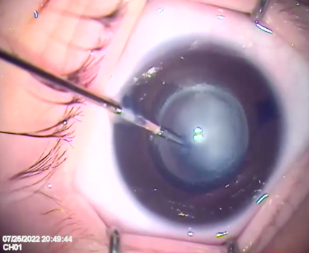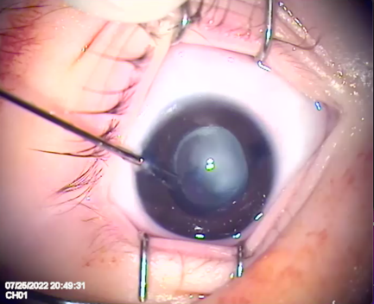

Recent publications

1-Novel technique of pneumatic posterior capsulorhexis for treatment and prevention of posterior capsular opacification Ahmed M. Eid, et. al. Journal of ophthalmology volume 2019
2-Evauation of post Lasik corneal flap and bet thickness using anterior segment OCT Ahmed M. Eid et. Al. Journal of Egyptian society of implants and refractive surgery October 2017
3-Q-value customized ablation(custom-Q) versus wavefront optimized ablation for primary myopic astigmatism Ahmed M. Eid et.al. international ophthalmology journal (2014) 34:259-262 DOI 10.1007/s10792-013-9828-1 ISSN 0165-5701 volume 34 Number 2
4-combind phacocanaloplasty for open-angle glaucoma and cataract: 12 months results Ahmed M. Eid et.al. clinical ophthalmology journal 2017:11 2169-2176
5-Macular sensitivity in areas of capillary non perfusion in non-proliferative diabetic retinopathy Ahmed M. Eid et.al. journal of Egyptian ophthalmological society volume 109- Issue 1- March 2016 ISSN:2090-0686

PROFFESIONAL MEMBERSHIP
- - MEMBER OF THE EGYPTIAN SOCIETY OF OPHTHALMOLOGY (ESO).
- - MEMBER OF THE EGYPTIAN SOCIETY OF GLAUCOMA (ESG).
- - MEMBER OF THE AMERICAN ACADEMY OPHTHALMOLOGY(AAO).
- - MEMBER OF THE INTERNATIONAL SOCITY OF REFRACTIVE SURGERY (ISRS).
- - MEMBER OF THE EUROPEAN SOCITY OF CATARACT AND REFRACTIVE SURGRY (ESCRS).

E mail: ahmedmostafa1966@yahoo.com

EXPERIENCE
-Anterior Segment Surgeon consultant .
-Cataract and Refractive Surgery Consultant.
  - - More than 10000 different cataract surgery with the recent techniques.
  - - More than 1000 glaucoma surgery .
  - - New technique in cataract surgery oral presentation in the American Academy Ophthalmology Conference in USA Orlando 2011.
  - - International Eye Center (IEC) foundation 2006 in Minia City Egypt.
  - - Organization committee member in different local and international ophthalmology conferences.
  - - Author for many published papers in local and international ophthalmic Journals.

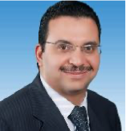

Presenting author details
Full name: Ahmed Mostafa Eid Desoky M.D
Prof. ophthalmology Mini University
And anterior segment consultant
Contact number: 00201144664400
Mail id: 61111
Category: oral video presentation
E mail: ahmedmostafa1966@yahoo.com

