Method applied to molecular structures, Spectroscopic parameters and Electronic properties of some new 4-Nitro- and 4-Allylamino-N-Phenyl-1,8-Naphthalimides in different solvents

Bénédicte TouogamTouolak, PhD
168 Taifeng St, Huainan 232001, China - Mobiltelefon:
(+86) 13162115468 - architectbenedicte@yahoo.fr
Skype-Adresse: architect_benedikkt
Anhui University of Science and Technology: Huainan,
Anhui, CN, ORCID Id 0000-0001-8838-355X
https://orcid.org/0000-0001-8838-355X
https://www.researchgate.net/profile/BenedicteTouogam-Touolak/publications

ABSTRACT:
In the present work, the analyses of molecular structures and spectroscopic parameters using quantum chemical computations at the B3LYP/6-311G(d,p) level of theory for the 4-nitro-N-phenyl1,8-naphthalimide and 4-allylamino-N-phenyl-1,8naphthalimide molecules as 1,8-naphthalimide derivatives have been successfully verified. In terms of bond lengths and bond angles, the closest values compared with the crystallographic data of the 1,8-naphthalimide ring seem to be obtained by the B3LYP method of theory. However, for the spectroscopic parameters values, the B3LYP method mostly gives better results. Furthermore, the calculated maximum electronic absorption wavelength values in MethylCycloHexane, Methanol, AceticAcid, Acetone, Acetonitrile, Chloroform, Dichloromethane, DiMethylSulfoxide, Ethanol, TetraHydroFuran, Toluene and Water solvents, also with 1H and 13C NMR chemical shift values in gaz phase, chloroform and ethanol solvents for the 4-nitro-N-phenyl1,8-naphthalimide and 4-allylamino-N-phenyl-1,8naphthalimide molecules can be built into a database for other 1,8-naphthalimide derivatives that will be synthesized or studied in the light of pharmacology, bio imaging and biologic activities.
KEYWORDS: Computational chemistry, Photophysics, Fluorescent copolymers, Polymerizable naphthalimides.

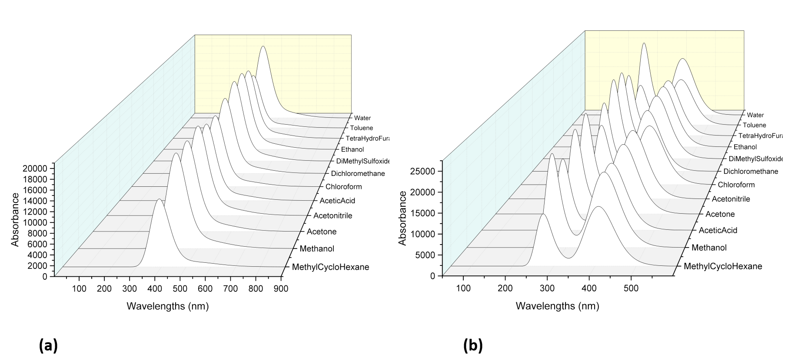
Fig. 1. The simulated UV-vis spectra in different solvents of (a) 4-nitro-N-phenyl1,8-naphthalimide and (b) 4-allylamino-N-phenyl-1,8naphthalimide

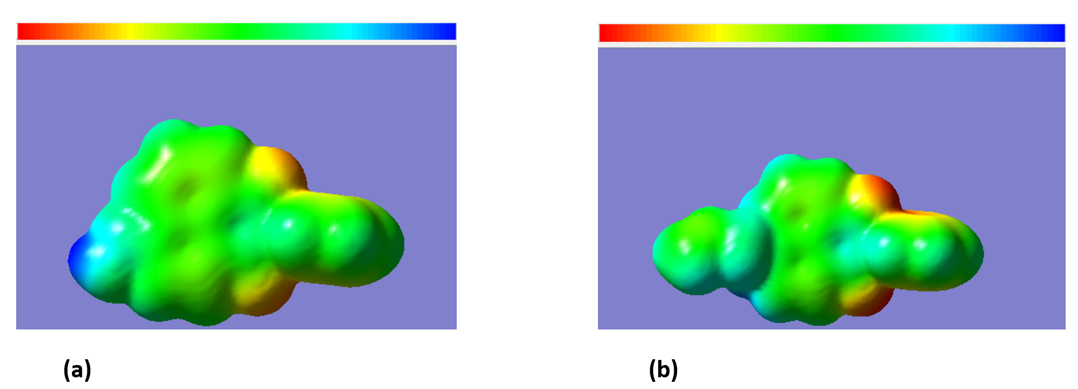
Fig. 2. Molecular electrostatic potential surface of (a) 4-nitro-N-phenyl1,8-naphthalimide and (b) 4-allylamino-N-phenyl-1,8naphthalimide obtained at the B3LYP level

