Elucidating the role of microRNA in Hydroxyurea mediated HbF induction in thalassemia patients

Indian council of medical research - National Institute of immunohematology
Dr. Anita Nadkarni, PhD, ICMR-NIIH, India

Abstract (300 word limit)
Statement of the Problem: Haemoglobinopathies are the commonest disorder in India. Hydroxyurea is known to be efficacious for patients through HbF induction, however, the mechanism is not elucidated. The role of microRNAs is well documented in regulating γ globin gene expression. Thus, we aimed to investigate the role of miRNAs in HU-mediated HbF induction in haemoglobinopathies patients. Methodology & Theoretical Orientation: The study enrolled 50 thalassemia major, 50 thalassemia intermedia and 50 healthy controls. Global miRNA microarray expression of 750 miRNAs was studied using Taqman array cards. Customized miRNA panel was designed comprising 59 differentially expressed miRNAs. Target genes of miRNAs were predicted using in silico tools. Functional validation of selected targets was studied by transfecting miRNAs in K562 cells and CD34+ cells. miRNA pathways were enriched using KEGG pathways and designed using StringDB and miRNet software. Findings: Microarray profile showed 42 upregulated and 17 downregulated miRNAs significantly after 3-and 6-months of hydroxyurea treatment (p<0.001). Customized miRNA profile showed similar results to that of the global microarray. Differentially expressed miRNAs expression was correlated with HbG2 gene and HbF levels in patients and interestingly found that 13 upregulated and 6 downregulated miRNAs significantly correlated with HbG2 expression and HbF levels in patients (p<0.001). In silico tools predicted the target genes of these 19 miRNAs and interestingly found that BCL11A, MYB, KLF1, GATA-1 are the most common targets shared by these miRNAs. The role of miRNAs was elucidated by transfecting miR-mimic and antimiRs K562 and CD34+ cells which revealed that these miRNAs induce HbG2 gene expression by modulating BCL11A, MYB, KLF1, GATA-1. (Figure 1) Conclusion & Significance: Thus, our study speculates the role of miRNAs responsible for regulation of γ globin and thereby ameliorating clinical severity in patients.

Image
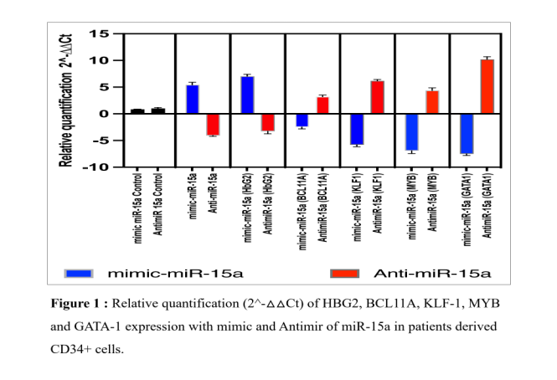
Recent Publications (minimum 5)
- Kargutkar N, Sawant-Mulay M, Hariharan P, Chandrakala S, Nadkarni A. Role of microRNA in hydroxyurea mediated HbF induction in sickle cell anaemia patients. Scientific Reports. 2023 Jan 7;13(1):1-2.
- Kargutkar N, Hariharan P, Nadkarni A. Dynamic interplay of microRNA in diseases and therapeutic. Clinical Genetics. 2022 Oct 30.
- Colaco S, Nadkarni A. Borderline HbA2 levels: Dilemma in diagnosis of beta-thalassemia carriers. Mutation Research/Reviews in Mutation Research. 2021 Jul 1;788:108387.
- Hariharan P, Gorivale M, Sawant P, Mehta P, Nadkarni A. Significance of genetic modifiers of hemoglobinopathies leading towards precision medicine. Scientific reports. 2021 Oct 22;11(1):1-0.
- Hariharan P, Nadkarni A. Insight of fetal to adult hemoglobin switch: genetic modulators and therapeutic targets. Blood Reviews. 2021 Sep 1;49:100823.



- Dr. Anita Nadkarni made outstanding contribution to the field of molecular genetics of thalassemia and other hemoglobinopathies. Carried out extensive research on, epidemiology, diagnosis, pathophysiology of thalassemia and sickle cell anemia. Overall, contributed immensely for the welfare of patients with thalassemia and other hemoglobin disorders in Indian society for last 35 yrs. Established a 1st newborn screening program in India for Sickle cell anemia. Has published more than 180 research papers in national / international scientific journals.
Email:anitahnadkarni@yahoo.com

Notes/Comments:

Presenting author details
Full name: Dr Anita Nadkarni
Contact number: + 91 9820175217
Session name/ number: Thalassemia , No 4
Category: Oral presentation

